Evaluating Garageband

“Learn How to Play”

Classical Piano Lessons

Freddi Rokaw, Purdue University

EDCI 57700 Dr. Victoria Walker

October 11, 2012

Table of Contents
Introduction 3
Description of Garageband “Learn How to Play” Lessons 3
Evaluation Goals and Scope 4
Description of Process 5
Description of Evaluation Instruments 6
Data Collection 6
Data Analysis 7
Report/Results 8
Recommendations 9
Appendix 11
Appendix A: Garageband Lesson Map Showing Evaluation Modules 11
Appendix B: Evaluation Plan 12
Appendix C: Gantt Chart 14
Appendix D: Level 1 Instrument – Reaction Evaluation Sheet 16
Appendix E: Level 2 Instrument - Learning Evaluation Post-test 18
Appendix F: Levels 3 & 4 Instrument – Behavior and Results 19
Appendix G: Executive Summary 20

Evaluation of GarageBand “Learn How to Play”

Classical Piano Lessons

Introduction
Apple has created a suite of native software for their desktop computers called “iLife” which is described as “digital content creation” software (Apple, Inc., 2012). iLife is a suite of software that includes iPhoto, iMovie and Garageband. This suite of software on a Mac is free and comes pre-installed as basic software on desktop Macs. Garageband’s music creation software can be used on Apple desktop computers, laptops, iPads, iPhones and the iPod touch. This evaluation will focus specifically on the 2011 desktop version of Garageband.

A little known part of Garageband includes a wonderful component that provides music lessons, called “Learn How to Play.” A user can learn how to play the guitar or piano by plugging in their instrument to their computer via USB cable or adapter and following along with pre-recorded lessons with an instructor. Unfortunately, most Apple users are not familiar with “Learn How to Play.” Oftentimes a user may be quite intimidated by the depth, breadth and seemingly complex initial interface of Garageband and not pursue the software further to the lessons.

This evaluation process seeks to determine whether Apple should continue to invest large quantities of money and labor to keep the program updated, make changes to the existing software, employ staff to maintain it’s usage or discontinue the “Learn How to Play” component of Garageband completely. Donald L. and James D. Kirkpatrick’s four level evaluation model (Kirkpatrick & Kirkpatrick, Evaluating Training Programs, 2006) has been selected as a framework for determining the degree of customer satisfaction, usage level, learning value, degree of behavioral change and impact (result) of the Garageband “Learn How to Play” software for its users. In addition, results will determine the impact of learning on future spending with company.

Description of Garageband “Learn How to Play” Lessons
The “Learn How to Play” series is divided into three categories: guitar, piano and artist lessons. The basic lessons for guitar and piano are free and downloadable from within the application itself. In addition to the free basics for guitar and piano, a user can pay for and download artist lessons from accomplished musicians like Sting, Norah Jones, Sarah McLaughlin, and bands like Death Cab for Cutie and Rush for the guitar or piano. Please see Appendix A: “Garageband Lesson Map Showing Evaluation Modules” for a detailed map of currently available software lessons.

This evaluation concentrates on two of the four free classical piano lessons in order to sample the customer usage of the Garageband “Learn How to Play” software: Mozart’s Minuet in F Major and Bach’s Musette in G Major. Within the Classical Piano lessons, there are three areas to explore: (1) Learn; (2) Practice; and (3) Play.

In the “Learn” section of the lesson, the instructor begins by introducing himself, and gives an overview of the lesson. Following the introduction, the instructor sets the expectations for the course (including specifying pre-requisites), explains the background and history of the composer and the composition, and then launches into the lesson which breaks down the techniques, elements and methods for mastering that specific piece of music. Cues are aural and visual. Visual cues are given by watching video of the instructor, showing fingerings on a keyboard, and following musical notation scroll by in real time. Lessons can be paused or made slower at any time. Users can look up terminology in a glossary, practice a section, and navigate backward or forward within the lesson. There are onscreen controls to adjust tempo/speed, change the volume mix and skip to different lessons.

The “Practice” area of the lesson allows the user to rehearse what they have learned at any time during their session or after completing the entire lesson. Visual cues are given concurrently in the form of keyboard fingerings, musical notation and two simultaneous camera angles on the instructor playing the piece. Aural cues are given through computer speakers of the user’s keyboard and the instructor’s playing.

The “Play” area of the lesson allows the user to perform the piece of music freely with their own interpretation while being accompanied by an orchestra. Tempo of the performance and volume levels may be adjusted for each component of the user’s performance. Using the record function in the “How Did I Play” section will save the user’s performance. This allows for immediate feedback by using visual cues such as color to show which notes were played correctly (green) or incorrectly (red), real-time audio, and an overall percentage rate of success/failure. Practice can be recorded repeatedly to compare improvement from one attempt to the next.

Evaluation Goals and Scope
Meetings will be held with corporate stakeholders and a select group of Creative Trainers at Apple. These stakeholders will determine what learning objectives need to be included in the evaluations for determining the value of data collected in regard to the future of the software program. The following list of objectives are expected to be assessed:

1. The degree of customer satisfaction and usage of the product;
2. The learning value of the training; and
3. Impact of learning on future customer spending.

Donald L. and James D. Kirkpatrick’s four level evaluation model (Kirkpatrick & Kirkpatrick, Evaluating Training Programs, 2006) has been selected as an assessment framework for this evaluation. The four levels that will be used to administer the evaluation and determine results will include:

- Level 1 – Reaction
- Level 2 – Learning
- Level 3 – Behavior
- Level 4 – Results

Audience and Context: Garageband users range in age from 10 to 90+. The majority of people in the population have never used the software before. In this field sample, participants will be using Garageband’s music lessons to learn a new skill or improve a current skill for performing music - specifically Mozart’s Minuet and/or Bach’s Musette. Garageband has many accessibility features that allow users with disabilities to navigate the software easily. Users with previous experience, as well as new users, learn at their own pace in an Apple retail store while participating in free workshops, during One-to-One training sessions with a Creative Trainer, or by learning at home. The field sample for this evaluation considers only the customers that choose to learn during One-to-One appointments in an Apple retail store with the assistance of a Creative Trainer (referred to henceforth as a “Creative”).

A control group will be used to compare results for Levels 2 and 4. Measuring the reaction of experienced users to new users will help determine the degree to which the current lessons are engaging. Being able to quantify the data relating to future spending will help to calculate Apple’s projected expenses in training maintenance or adaptation vs. customer spending, which will in turn assist in the calculation of overall return on investment.

Description of Process
Evaluation Plan (see Appendix B – Evaluation Plan Document):
The plan for evaluating Garageband “Learn How to Play” lessons is scheduled to be a one-year project. Evaluation planning and development will commence on January 2, 2013. Reports are to be disseminated by mid-January of 2014. The process will go through seven phases as follows: Planning Phase (total 6 days), Development Phase (total 2 weeks), Sample Field Training Time (total 3 months), Data Collection (total 5 months), Data Analysis (total 6 months), Interpretation and Recommendations (total 2 weeks) and Reporting (2 weeks if necessary). Phases overlap, especially while field training is occurring in order to maximize labor and minimize expenses. Please note that the Evaluation Plan also lays out stakeholder involvement in the process.

Gantt Chart (see Appendix C – Gantt Chart):
The Gantt chart lays out a sample timeline for the evaluation plan to take place. This chart shows time dependencies and relationships between the phases of evaluation. Some phases (for example, Creative Training) rely on the development and completion of such training as their predecessor in order to begin. These relationships and dependencies are indicated on the Gantt chart with small arrows between phases.

Description of Evaluation Instruments
Level 1 - Reaction (see Appendix D: Level 1 Instrument – Reaction Sheet)
The Level 1 Reaction sheet seeks to assess the degree to which customers are satisfied with the overall program as well as the details of the materials, method of delivery, motivation and level of confidence (Keller, 1987). The goal of this instrument is to use the results of the data collected to justify the continuation of the program. In the process, this evaluation may provide an added benefit of identifying materials or facilitation that show strength and/or weaknesses in the program. The resulting data will help to focus resources on specific issues that may need to be adjusted.

Level 2 - Learning (see Appendix E: Level 2 Instrument – Learning Post-Test Survey)
Because Garageband is a commercial product and users are paying customers, questions are general and few to ensure timeliness and motivation to respond. In addition, these post-training questions will refer to general musical terms and methods that are referred to in all lessons, so that separate questionnaires will not be necessary for each lesson. Data from users with no previous experience will be separated to provide data for the control group.

Levels 3 and 4 - Behavior and Results (see Appendix F: Level 3/4 – Behavior & Results)
Level 3 (Behavior) and Level 4 (Results) instruments are combined in one instrument. In order to evaluate whether a customer is benefiting from their lessons and applying their new knowledge and skills to future musical endeavors, this follow-up survey will be administered three months following the user’s first Garageband appointment. The three-month timeframe allows the customer to learn, practice and play one or more modules within the Garageband framework. This instrument pertains to current and future use of the product by asking the respondent to self-assess their current ability and also by asking them to project their perceived abilities for future musical challenges. Questions related to a customer’s intent to make future purchases are included in order to predict future spending with the company. These results will assist in making future decisions based on return on investment for the company. In the future this survey will be re-designed to be an e-survey that will allow subsequent questions to be presented based upon a respondent’s answer.

Data Collection
Creative Trainers will administer the evaluation forms during the One-to-One lesson in the Apple retail store environment. These instruments will be distributed and collected by Creative Trainers that have had specific training in the methods of administering the evaluations. Level 1 surveys will be completed by the user at the end of each 50 minute One-to-One Garageband session, and before the customer books their next appointment to ensure a 100% completion rate. The Level 2 instrument (Learning) may be completed by the customer following their second appointment in the store or completed at home and returned to the Apple Store at their next appointment. The Level 3-4 survey will be emailed to customers three months following their first booked appointment. Customers will be asked to return the survey to Apple electronically, through email. If no response is collected, a reminder email will be sent.

Customers who participate in the One-to-One program have already established their motivation to learn, which makes them an excellent source for baseline data. Part of a Creative Trainer’s existing skill is to find out what previous experience a customer has with the software. If the customer has no previous experience, the Creative Trainer will mark the forms as such in order to identify that customer as part of the control group. Level 1 and 2 evaluation instruments will be optionally anonymous. The level 3-4 instruments will require personal information as to the customer’s name and whether they have an existing iTunes account.

Data Analysis
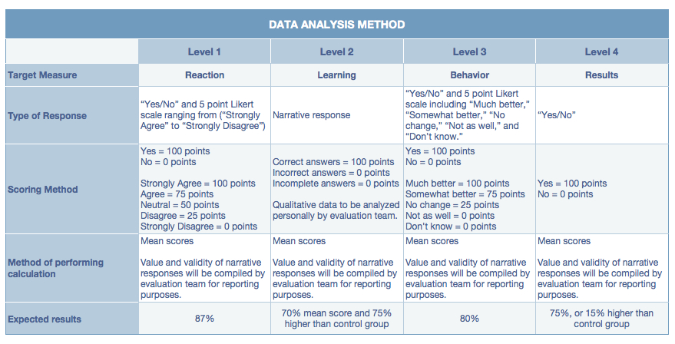

Table 1.1 Data Analysis Method

Level 1 - Reaction: The evaluation team will analyze responses from the “Reaction Sheet” instrument to answer the first objective of the evaluation that addresses customer satisfaction and usage. To control other factors that might influence the evaluation process, Creatives will allow sufficient time in the lesson for completion and respect the customer’s privacy by temporarily engaging in other Apple business.

Sections using Yes/No answers will carry a point value of 100 and 0 respectively. Sections using Likert scales will determine the degree of satisfaction by calculating the average mean of total points. Please refer to Table 1.1 for details and point values.

Results will be completed after the data has been compiled and analyzed. Assuming the response rate is 100%, the goal to justify the continuation of the program is to reach an overall level of 87%, as Apple, Inc.’s standards for customer satisfaction are, and have always been extremely high, as is evidenced in their existing (company confidential) evaluation criteria.

Level 2 - Learning: To determine the degree of learning as put forth in the second objective of the evaluation, responses from the Level 2 post-training questionnaire will be compiled and compared to those of the control group. To control other factors that might influence the evaluation process, customers will be encouraged to complete the form at home and be sent an email reminder to bring the form to their next appointment. Creatives will not be permitted to assist customers in the completion of this post-test.

Rates will be calculated as follows: Correct answers = 100 points, incorrect/incomplete answers = 0 points. Please refer to Table 1.1 for details. Results will be completed after the data has been compiled and analyzed. The program is considered a success if 80% of the respondents score 75% higher than the control group that takes the same test. The evaluation team will read and analyze narrative responses to determine validity and value for reporting purposes.

Levels 3 and 4 – Behavior and Results: To determine the value of learning as put forth in the second objective of the evaluation, data will be compiled from this instrument to assess whether users have been motivated and empowered to use their new skills in other musical endeavors and the degree to which those skills are being used.
The point values of customer responses represent the impact of the learning objectives on the overall results. This allows the results to be calculated by using the level of success with failure heavily impacting the total. Non-answers (“No change” and "Don't know") will not count toward the total result. The expectation for success is a mean average score of 80%. Results will be completed after the data has been compiled and analyzed. Data from experienced users will be compared to customers in the control group that have indicated that they have had no previous experience with Garageband. Please refer to Table 1.1 for details.

A note about “Return on Investment”: With an expectation that this evaluation will continue beyond the scope of this summary, the Level 3 and 4 instrument asks if the customer is planning to purchase further lessons. This instrument is not anonymous, in order for the analysis team to track the respondent’s current and future spending related to the product. The number of “Yes” responses will be compared to “No” answers to determine what percentage of customers will be spending in the future, and compared to the control group. Apple expects a positive response rate of 75% in order to consider the program a success for this objective. A 75% mean score from the experienced participants is expected to be 15% higher than the control group. The resulting data will assist in future calculations of Apple’s return on their investment.

Report/Results
This evaluation will commence on January 2, 2013. The expected key findings are related to the initial evaluation objectives initially stated, which are:

1. The degree of customer satisfaction and usage of the product;
2. The learning value of the training; and
3. Impact of learning on future customer spending.

Based on the above evaluation goals, expected key findings may include the following:

Customer Satisfaction: It is expected that customer satisfaction will be rated extremely high, as Apple’s products meet exceptional standards in the industry. Production value, accessibility, clarity and user-friendliness have always been paramount to the corporate identity.

Usage: It is expected that usage of the specific product – “Learn How to Play” will be very low. As stated earlier, most Apple users are intimidated by the depth, breadth and seemingly complex initial interface of Garageband. Results will most likely show that users are so intimidated by the initial interface that they will not pursue the software further in order to arrive at the “Learn How to Play” component.

Learning value: Because Garageband is a commercial product and users are paying customers of the One-to-One program used for this evaluation, the motivation to retain information and apply it will be less than expected. Any rewards for learning may be very personal and intrinsic. It is also expected that the customers that are motivated to learn beyond the selected training modules will be more confident with their abilities and likely to expand their skill set further – within and outside of Garageband.

Future spending: It is expected that future customer spending for artist lessons will be minimal – even for experienced users in comparison to the control group. As the idiom says, “Why buy the cow when you can get the milk for free?” In other words, why pay for more lessons when there are a multitude of progressive lessons already available for free? This information will most likely create a conundrum for stakeholders when making decisions as to the future of the program.

Recommendations
Because the customer satisfaction is expected to be very high, it is recommended that Apple continue to maintain and keep existing lessons available for general use. Once customers become engaged, they are inspired by the enrichment these lessons offer. Because the initial interface is intimidating, however, this presents a barrier for first-time users. Re-design of the user interface is not an option, as it is prohibitively expensive, labor intensive and disruptive. Recommendations for overcoming this obstacle may be to use existing advertising methods (blast emails to Apple customers and especially One-to-One members) to call attention to the features and benefits of the product. Depending on the results of a future evaluation to calculate return on investment, it may be recommended that the budget may include a short video introduction to the product. The return on investment evaluation is highly recommended at a future date to determine actual costs involved in producing additional free lessons to expand the program. It is expected that the results of this future evaluation will show that most customers will not be paying for artist lessons and it is recommended that a decision be made to halt all future productions that feature highly-paid artists.

References

Apple, Inc. (2012). iLife '11. Retrieved September 26, 2012, from Apple iLife: http://www.apple.com/ilife/

Apple, Inc. (2012). Learn to Play Music. Retrieved September 2012, 2012, from Garageband: http://www.apple.com/ilife/garageband/what-is.html#learn

Apple, Inc. (2012). What is Garageband? Retrieved September 26, 2012, from iLife: http://www.apple.com/ilife/garageband/what-is.html

Keller, J. (1987). Development and use of the ARCS model of instructional design. Journal of Instructional Development , 10 (3), 2-10.

Kirkpatrick, D., & Kirkpatrick, J. (2006). Evaluating training programs (3rd Edition ed.). San Francisco, CA: Berrett-Koehler Publishers, Inc.

Kirkpatrick, D., & Kirkpatrick, J. (2007). Implementing the four levels. San Francisco, CA: Berrett-Koehler Publishers, Inc.

Newby, T. (n.d.). Dow model of systematic evaluation. Retrieved 08 27, 2012, from
Purdue University Blackboard: https://mycourses.purdue.edu/webapps/
portal/frameset.jsp?tab_tab_group_id=_2_1&url=%2Fwebapps%2Fblackboar
d%2Fexecute%2Flauncher%3Ftype%3DCourse%26id%3D_27234_1%26url
%3D

Smartsheet. (2012). Smartsheet. Retrieved 10 06, 2012, from Manage Projects and
Collaborate Online : http://www.smartsheet.com

Trochim, W. M. (2006). Research methods knowledge base. Retrieved 09 14, 2012,
from Likert Scaling: http://www.socialresearchmethods.net/kb/scallik.php

Appendix

Appendix A: Garageband Lesson Map Showing Evaluation Modules

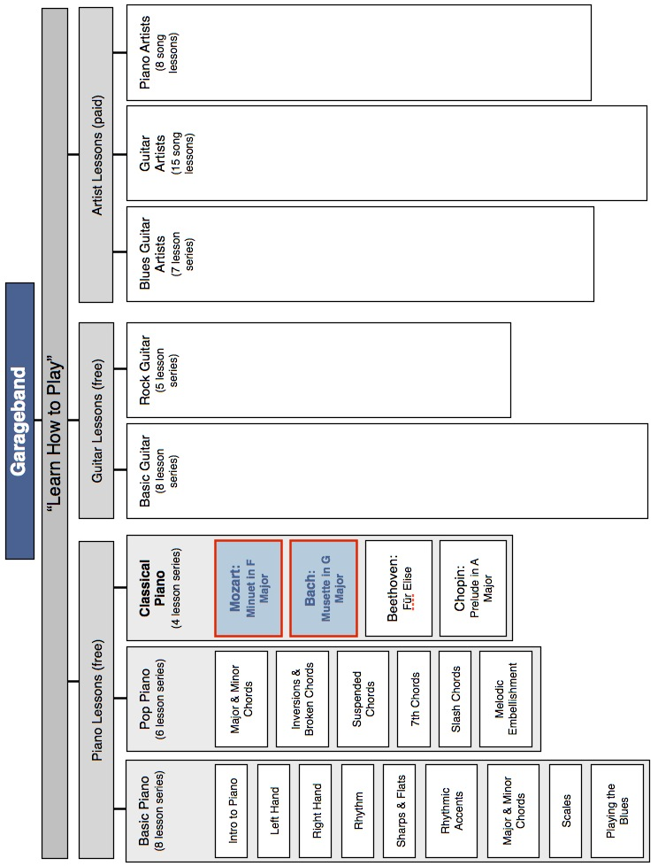

Appendix B: Evaluation Plan

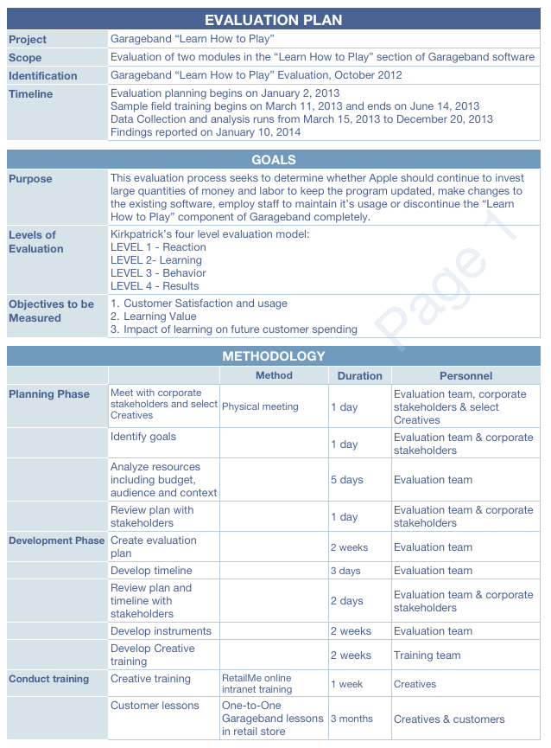

Appendix B: Evaluation Plan (continued)

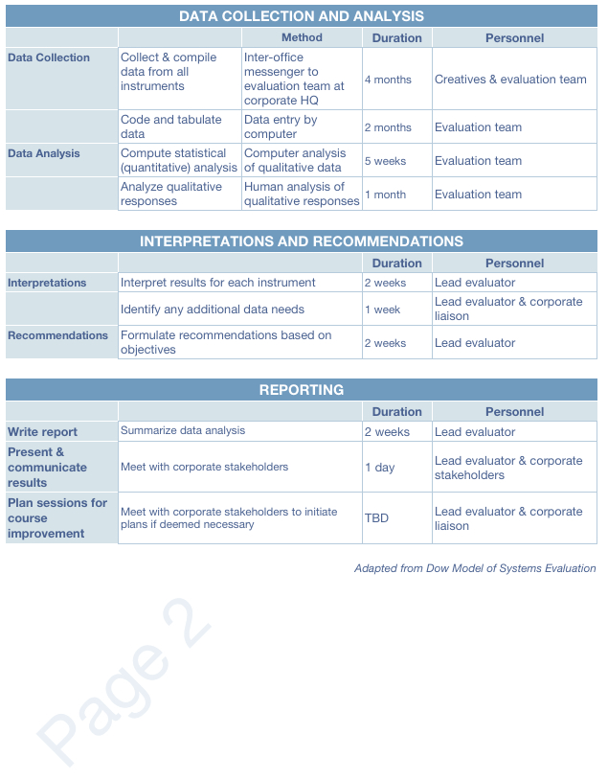

Appendix C: Gantt Chart
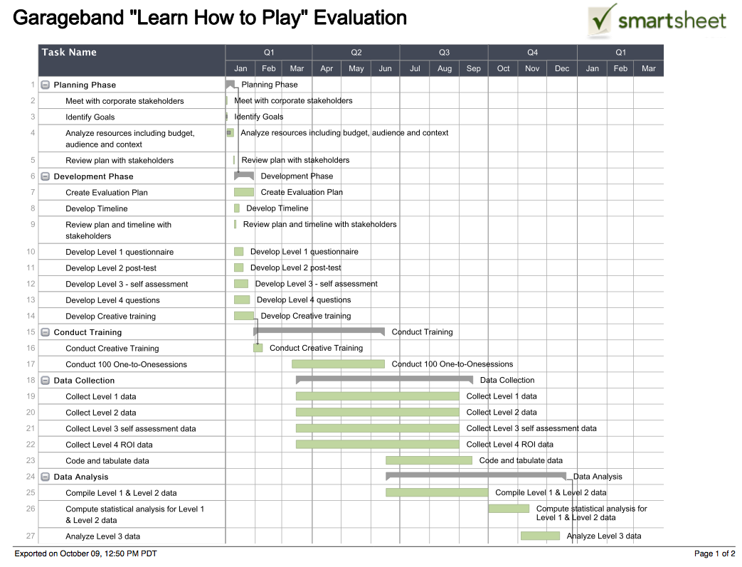
Appendix C: Gantt Chart (continued)

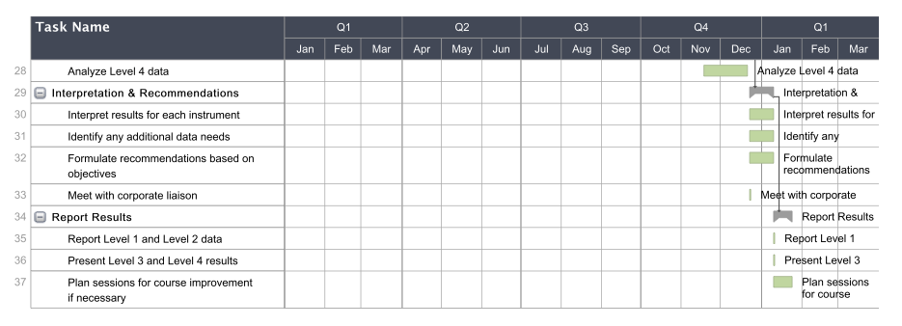

*This Gantt chart was created with cloud-based Smartsheet software. Please click on: https://www.smartsheet.com/b/publish?EQBCT=9393275dace14048ad1703c741f11492&embed=true to view details and a larger image.

Appendix D: Level 1 Instrument – Reaction Evaluation Sheet

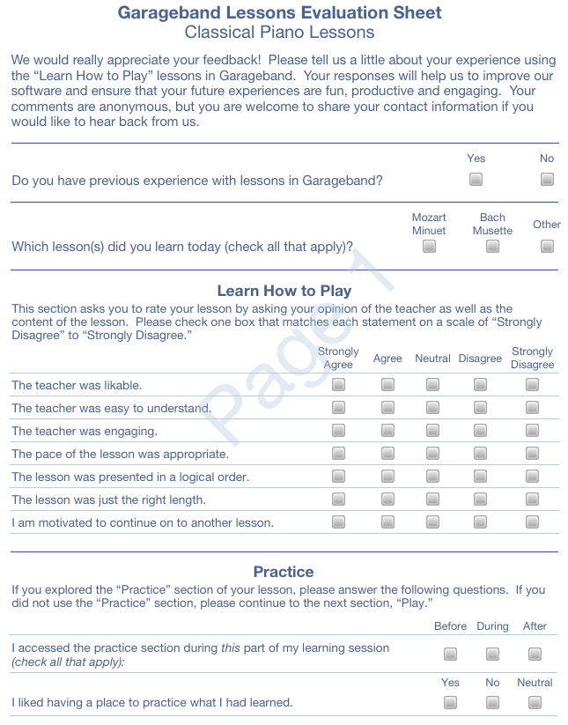

Appendix D: Level 1 Instrument – Reaction Evaluation Sheet (continued)

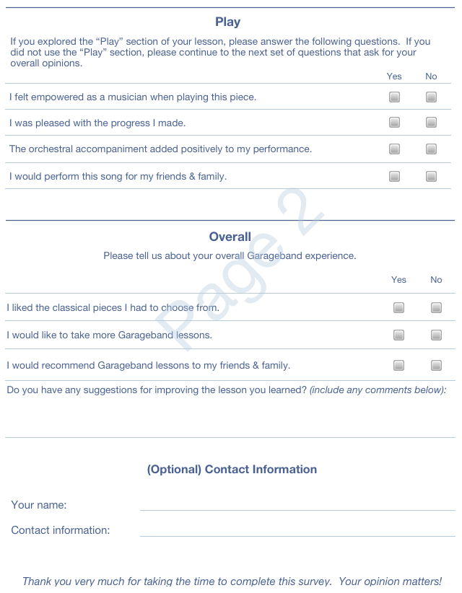

Appendix E: Level 2 Instrument - Learning Evaluation Post-test

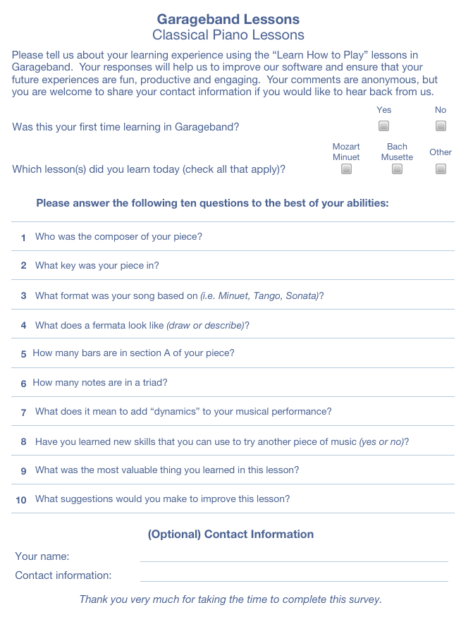

Appendix F: Levels 3 & 4 Instrument – Behavior and Results

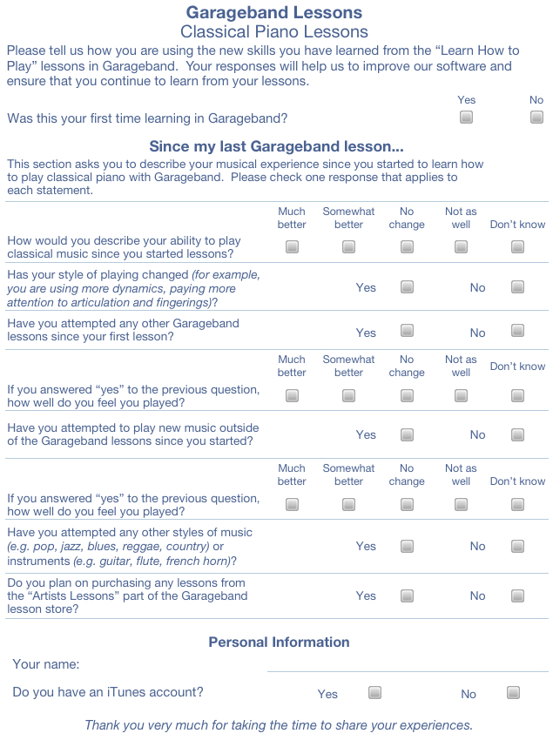

Appendix G: Executive Summary

Executive Summary
Description
Apple’s Garageband software is a wonderful product that is part of the iLife suite of digital content creation software. Garageband includes a wonderful component that provides music lessons, called “Learn How to Play.” Unfortunately, most Apple users are not familiar with “Learn How to Play.” It has come to the attention of Apple executives that its customers are quite intimidated by the depth, breadth and seemingly complex initial interface of Garageband and are questioning whether to pursue further production of this component of Garageband.
Objectives
This evaluation process seeks to determine whether Apple should continue to invest large quantities of money and labor to keep the program updated, make changes to the existing software, employ staff to maintain it’s usage or discontinue the “Learn How to Play” component of Garageband completely. Results will also determine the impact of learning on customers’ future spending with Apple. Donald L. and James D. Kirkpatrick’s four level evaluation model (Kirkpatrick & Kirkpatrick, Evaluating Training Programs, 2006) has been selected as a framework for this evaluation process. The following list of objectives are expected to be assessed:
- The degree of customer satisfaction and usage of the product;
- The learning value of the training; and
- Impact of learning on future customer spending.
Processes and Timeline
The plan for evaluating Garageband “Learn How to Play” lessons is scheduled to be a one-year project. Evaluation planning and development will commence on January 2, 2013. Reports are to be disseminated by mid-January of 2014. The process will go through seven phases as follows: Planning Phase (total 6 days), Development Phase (total 2 weeks), Sample Field Training Time (total 3 months), Data Collection (total 5 months), Data Analysis (total 6 months), Interpretation and Recommendations (total 2 weeks) and Reporting (2 weeks if necessary). Phases overlap, especially while field training is occurring in order to maximize labor and minimize expenses.
Data Collection & Analysis
The evaluation team will analyze responses from the Level 1“Reaction Sheet” instrument to answer the first objective of the evaluation that addresses customer satisfaction and usage. As Apple’s standards for customer satisfaction are extremely high, the goal to justify the continuation of the program will be in line with the company’s existing evaluation criteria. To determine the degree of learning, responses from the Level 2 post-training questionnaire will be compiled and compared to those of the control group. To determine the value of learning, data will be compiled from the Level 3 questions to assess whether users have been motivated and empowered to use their new skills in other musical endeavors and the degree to which those skills are being used. Data from

Appendix G: Executive summary (continued)

experienced users will be compared to customers in the control group that have indicated that they have had no previous experience with Garageband.
Expected Key Findings
Customer Satisfaction: It is expected that customer satisfaction will be rated extremely high, as Apple’s products meet exceptional standards in the industry. Production value, accessibility, clarity and user-friendliness have always been paramount to the corporate identity.

Usage: It is expected that usage of the specific product – “Learn How to Play” will be very low. As stated earlier, most Apple users are intimidated by the depth, breadth and seemingly complex initial interface of Garageband. Results will most likely show that users are so intimidated by the initial interface that they will not pursue the software further in order to arrive at the “Learn How to Play” component.

Learning value: Because Garageband is a commercial product and users are paying customers of the One-to-One program used for this evaluation, the motivation to retain information and apply it will be less than expected. Any rewards for learning may be very personal and intrinsic. It is also expected that the customers that are motivated to learn beyond the selected training modules will be more confident with their abilities and likely to expand their skill set further – within and outside of Garageband.

Future spending: It is expected that future customer spending for artist lessons will be minimal – even for experienced users in comparison to the control group. As the idiom says, “Why buy the cow when you can get the milk for free?” In other words, why pay for more lessons when there are a multitude of progressive lessons already available for free? This information will most likely create a conundrum for stakeholders when making decisions as to the future of the program.
Expected Recommendations
Because the customer satisfaction is expected to be very high, it is recommended that Apple continue to maintain and keep existing lessons available for general use.

A recommendation for overcoming the intimidation factor of Garageband is to use existing advertising methods (blast emails to Apple customers and especially One-to-One members) to call attention to the features and benefits of the product.

The return on investment evaluation is highly recommended at a future date to determine actual costs involved in producing additional free lessons to expand the program. It is expected that the results of such an evaluation would show that most customers will not be paying for artist lessons and it is recommended that a decision be made to halt all future productions that feature highly-paid artists.
References
Kirkpatrick, D., & Kirkpatrick, J. (2006). Evaluating training programs (3rd Edition ed.). San Francisco,
CA: Berrett-Koehler Publishers, Inc.

