Instructional Design Activity 1: Learning Context Analysis

“Opera is not a Four-Letter Word!”

Preliminary Context

This is a new course in Opera Appreciation that will be conducted as a continuing education Extension Class offered by the Department of Music at Happy Valley Community College. Most of the individuals taking this course are 55 years or older who wish to broaden and enrich their cultural experiences.

Content will be based on existing information from general music appreciation classes but will be designed specifically for the musical genre of opera. The course is designed in modules based on individual operas. The course will begin with the most familiar and popular operas and building in complexity throughout the 16-week semester. The first four-week session of this course is a module focusing on the opera “Tosca” which is the unit to be explored in this activity.

Because of its modular format, this class may be “personalized” to include local content. Operas being performed by the local opera company for the current season may be included or substituted within the 16-week semester.

Instructional Goals

Instructional goals by priority | Reasons for importance
1. Develop and enhance appreciation for opera.  2. Gain a deeper understanding of this complex art form.  3. Gain a different perspective of opera by exploring its relationship to the “real world.”  4. Promote the art form. | Expand cultural horizons. Make the genre more accessible to the general public. Overcome any barriers to the enjoyment of opera.  Learn the components that go into making an opera – story telling, acting, music, language, sets, costumes, etc.  Learn the connections between an art form and current social, economic and political culture.  Build audiences in order to ensure this art form survives. Supports the arts.

Learning Environment

The Instructional Environment
Because of their age, the majority of students are more comfortable learning from home rather than on the school campus for a variety of reasons. Night driving, large distances and accessibility issues are their main concerns. The course is offered online with local references based on current performance seasons. The instructor will offer organized, local field trips to performing arts sites that are optional. Media will include images, videos and audio. There will be a chat room called “The Foyer” where participants can discuss any performances they have seen locally. There will also be a discussion group in the form of a chat room called “Tosca’s Cafe” for students to participate in. “Tosca’s Cafe” is for social interaction only and will not be graded.

The Support Environment

The course will begin with a large database of operas but has the potential to be modified based on the season performances of the local opera company(s). Thus, a database will continue to grow as repertoire is created that can be reused on an “as-needed” basis. The staff and faculty at Happy Valley Community College will provide management, maintenance and technical support of the database and delivery system. Faculty will deliver and contribute to content.

Students will need a computer with access to the Internet. The computer will possibly be at home, at a public library or senior center. No other materials will be required. Computer support for the students will be provided using the channels already in place in their homes or remote locations that could include friends, family, staff or telephone support. The instructor, through online discussions or on-campus LMS technical support, will provide instructional support.

Instructional Design Activity 2: Learner Analysis

General

Age Group: Mostly 55 years and older

Racial/ethnic background: Mixed

Socioeconomic background: Retirees with pension income

Familial Situation: Grown children and grandchildren. Limited responsibilities.

Accessibility Issues (if any): Possible (probable) hearing, eyesight and mobility issues.

Level of computer/Internet experience: Very little.

Previous online course experience: Little to none.

Access to technology, high speed Internet: Home or public library (requirement for the course).

Cognitive

General aptitudes: Highly motivated, willingness to learn, positive attitude, excellent focus, intellectual.

Specific aptitudes: Highly developed listening skills, ability to focus for long periods of time, willing and able to share opinions.

Developmental level: More adept at abstract concepts as opposed to concrete tasks (which is an important consideration to take into account for this course).

Language development level: Proficient in reading, writing and speaking English.

Reading level: At least high school level.

Level of visual literacy: Generally excellent, but depends on physical audio and visual challenges.

Cognitive processing styles: Depending on age factor, cognitive abilities may range greatly, which will be an important factor to consider. Long-term and short-term memory may be deficient based on age and must be taken into account.

Learning strategies: Casual, note taking, discussion based.

General world knowledge: Vast knowledge and previous experience to draw from. This group of learners has an abundance of life experience to refer to and contribute.

Specific prior knowledge: Varied prior knowledge based on world travel, previous cultural experiences with music, dance and other performing arts, an historic view of politics and social culture.

Affective

Interests: Music, Art, Dance, Travel.

Motivations to learn: Active learners that want to keep their minds active and broaden their experiences.

Attitude toward learning: Enthusiastic, positive attitude, motivated and willing to learn.

Attitude toward subject matter: Previously intimidated, unsure of subject matter.

Attribution of success: Able to discuss and analyze current operas with others in social and academic situations.

Social

Relationships to peers: Participants might already know each other from the community. The majority of participants are women.

Feelings toward authority: Respectful and questioning.

Tendencies toward cooperation or competition: Very co-operative and rarely competitive.

Instructional Design Activity 3: Conducting the Content Task Analysis

“Opera is not a Four-Letter Word!”

- Learning Goal

Title: Opera is not a Four-Letter Word
Objective: Learners will be able to develop and enhance their appreciation for opera.
Module 1: Develop an understanding and appreciation for the opera Tosca by Giacomo Puccini

Learning Goals (Purpose & Objective):
- Students will gain a deeper understanding of opera by describing and discussing the components that make up the art form.
- Students will gain a different perspective of opera by exploring its relationship to current social, economic and/or political scenarios.
- Students will promote the arts by attending live or pre-recorded events.

- Types of learning reflected by learning goals
(Based on Bloom’s Taxonomy http://www.odu.edu/educ/roverbau/Bloom/blooms_taxonomy.htm
and Gagne's Types of Learning Outcomes http://tip.psychology.org/gagne.html)

Learning Goal 1:
Based on Gagne’s Learning Outcome of Intellectual Skill – specifically discrimination and concrete concepts, students will gain a deeper understanding of opera by describing, distinguishing and discussing the components that make up the art form.

Learning Goal 2:
Based on Gagne’s Learning Outcome of Cognitive Strategy, students will gain a different perspective of opera by exploring and writing about its relationship to current social, economic and/or political scenarios.

Learning Goal 3:
Based on Gagne’s Learning Outcomes of Verbal Information and Attitude, students will attend live or pre-recorded events to develop, critique and present their own informed opinions of opera.

- Identification of Learning Tasks

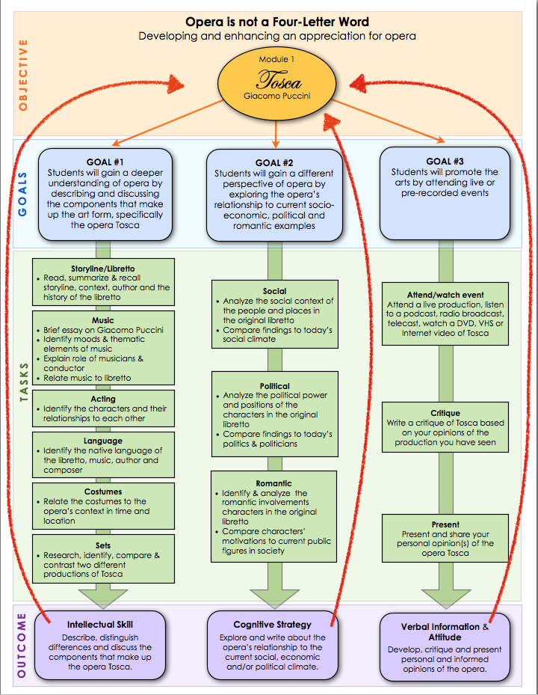

*I used Pages (from Apple’s iWork suite) to create this visual.
- Pre-requisite Skills

Basic pre-requisite skills for this class (and therefore assumed) are:
- Basic computer skills including the ability to use a mouse and keyboard/track pad
- Basic typing including ability to use editing functions like copy and paste
- Excellent reading comprehension
- Good command of English
- Ability to focus and listen well for up to 1.5 hours at a time

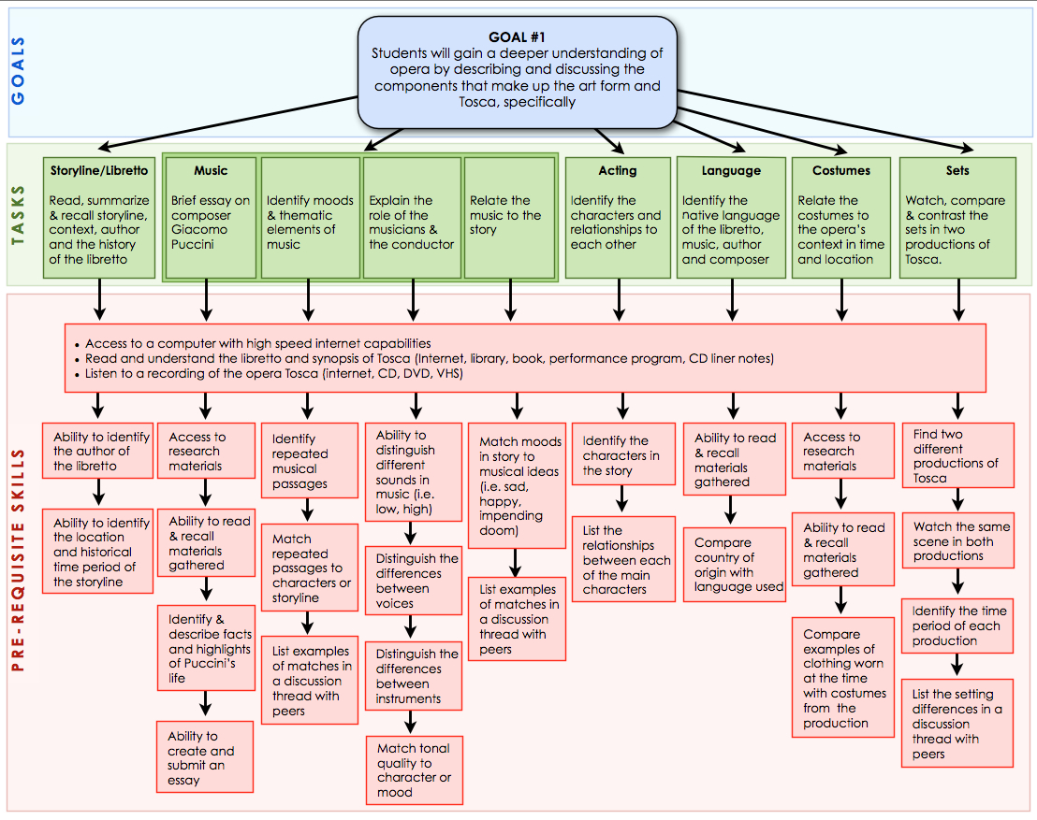
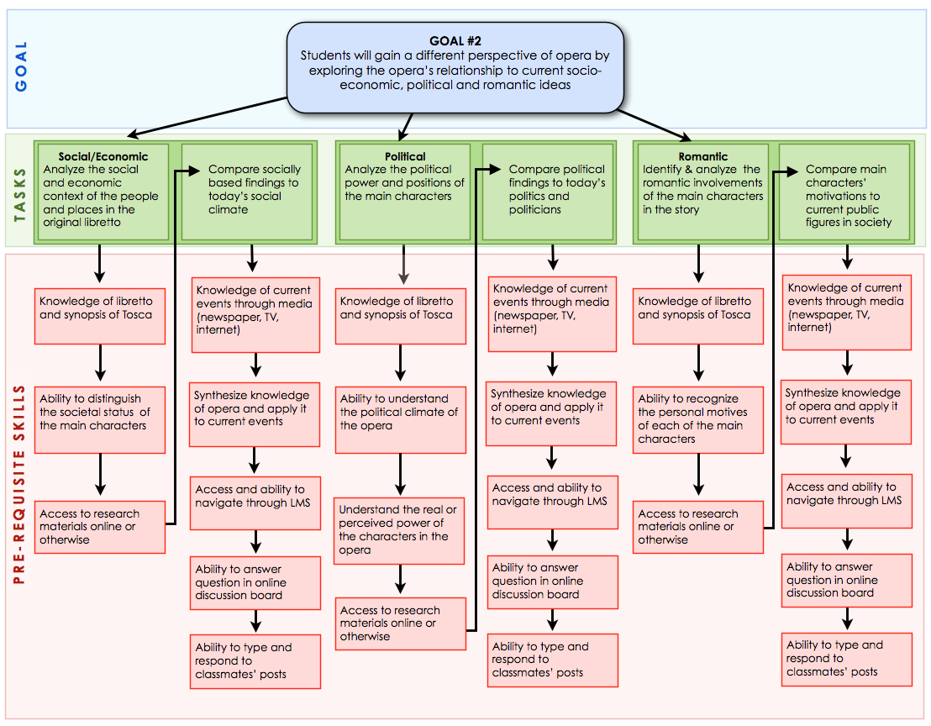

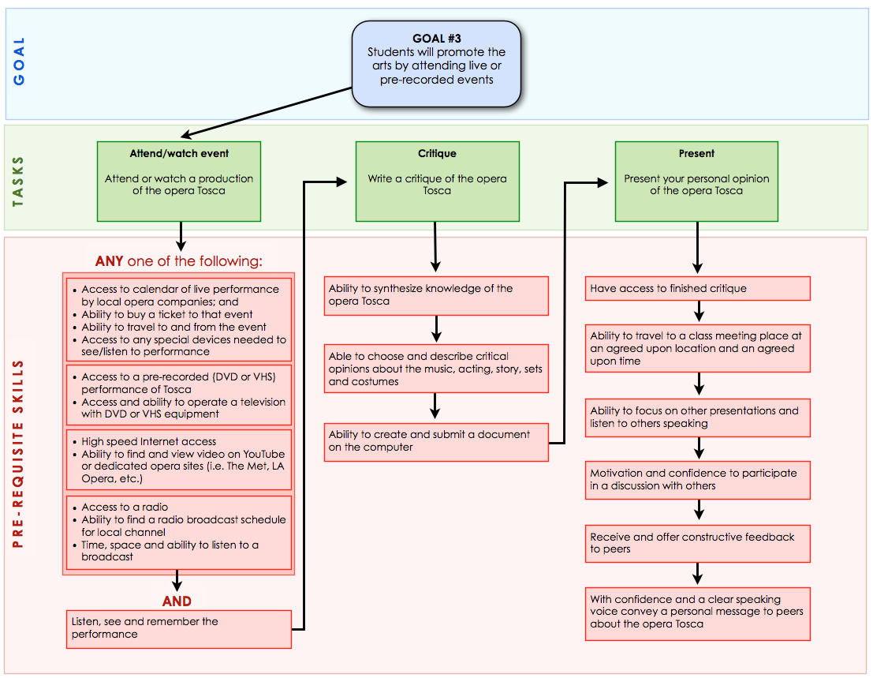

- Learning Objectives

Learning Objective #1:
Learners will be able to identify, describe and discuss the components (story, music, acting, language, costumes and sets) of opera in order to gain a deeper understanding of the art form.

Learning Objective #2:
Learners will be able to synthesize the relationships between current events and the social/economic, political and romantic story elements in order to formulate a different perspective of the opera Tosca.

Learning Objective #3:
Learners will be able to promote the arts by attending live or pre-recorded opera(s), writing a critique and presenting their personal opinion of the opera Tosca to peers.

Instructional Design Activity 4: Planning the Content

Instructional Strategy Chart – Learning Objective #1
Objective | Introduction | Body | Conclusion | Assessment
Learning Objective #1:  Given the components of the opera, Tosca (libretto, music, acting, sets, language, costumes), learners will be able to identify, describe and distinguish the building blocks of opera to gain a deeper understanding of the art form. | Gain Attention:  Dramatic video of the final aria at the end of the dramatic storyline will be presented first to spark the learner’s interest. | Prior Knowledge:  - No previous knowledge of opera required  - Learners have basic computer skills, can type and navigate the internet  - Command of the English language (writing, reading, speaking, listening & understanding) | Summarize & Review:  Learners will be able to deconstruct, discuss and identify the components that go in to making the whole art form of opera in general. | Assess Performance:  - Weekly grades will be given for participation and quality of responses in discussion forums.  - Quizzes will be used throughout the course to identify correct vs. incorrect samples for each component to assess learner accuracy and knowledge.  - An overall grade will be given for this objective based on the learner’s knowledge and ability to identify and discuss components. The test will occur at the end of the topic.
 | Explain Purpose/Preview:  The idea is to lure the learner into the intrigue of the story and motivate their curiosity to find out who the characters are and how the story develops. | Information & Examples:  - Read, summarize & recall the storyline  - Identify moods in the music & themes  - Compare costumes to modern dress in Rome in the 1800’s | Transfer:  Given the identification of all the components of an opera, learners will be able to distinguish the unique qualities of each component as it relates specifically to the opera Tosca. | Feedback/Remediation:  Feedback will be given from the instructor at the end of each week of relevant instruction.
Learning Objective #1 (cont’d) | Interest/Motivation:  Presenting the dramatic end of the storyline first will heighten intrigue and curiosity. (Spoiler alert: everyone dies in the end!) | Attention:  Attention will be gained and maintained by incorporating visual and musical examples that relate to the storyline. | Re-motivate/Close:  Given the knowledge of the components of an opera, learners will be able to compare unique and similar qualities between two or more different productions of the same opera.
Learning Strategies:
By using inquiry-based collaborative knowledge construction, learners will identify and contribute written and/or visual descriptions of their findings to an OperaWiki, building an online database of components accessible to the entire class for the duration of the course.
Practice:
- Learners will write and submit a paper on the composer
- Read the storyline
- Watch and/or listen to the opera
- Identify characters, musical themes & moods

Learning Objective #1 (cont’d) |  | Feedback:  Ongoing feedback will be given from the instructor and peers within the week of relevant instruction.

Instructional Strategy Chart – Learning Objective #2
Objective | Introduction | Body | Conclusion | Assessment
Learning Objective #2:  Given the social/economic, political and romantic story elements of the opera Tosca, learners will be able to identify, analyze, compare and synthesize the relationships between those elements and current events in order to formulate a different and more complete perspective of opera in general. | Gain Attention:  Dramatic video of Scarpia’s aria that passionately elucidates this powerful man’s thirst for power, lust for Tosca and lack of scruples. | Prior Knowledge:  - Prior knowledge of the storyline and libretto of Tosca  - Able to identify the characters in the story  - Knowledge of current affairs | Summarize & Review:  - Differentiate the motivations of each of the characters in discussion  - Apply knowledge of character motivation to compare with examples in today’s current events and public figures | Assess Performance:  Learners will conduct a self assessment at the end of the module based on their ability to identify, analyze, compare and synthesize their knowledge of the social, economic, political and romantic elements of Tosca.
 | Explain Purpose/Preview:  The use shock factor will create intrigue, show unscrupulousness of characters and spark curiosity as to what actions the characters (specifically Scarpia) might take to get what he wants. | Information & Examples:  - Discuss the motivations of the characters in the opera  - Recognize and discuss the interplay between characters based on their personal motives and socio-economic status  - Compare similarities and differences in today’s political climate in the U.S. with that of Europe in the 1800’s | Transfer:  Learners will be able to successfully compare and contrast examples of people in today’s society with characters in the opera. | Feedback/Remediation:  Feedback will be given from the instructor at the end of each week of relevant instruction.
Learning Objective #2 (cont’d) | Interest/Motivation:  - Discover the internal passions and motivation of each of the characters, their values, passion for power and romantic ideals.  - Learn the interplay between these values and relationships what affect they have on each other | Attention:  - Predict the fate of each of the characters  - Applying their varied life experience in matters of love, power and beliefs will allow learners to compare their own values to the scenarios of characters in the opera | Re-motivate/Close:  Learners will be able to create a fictional new ending for the opera and share it with their peers in a discussion.
Learning Strategies:
- By using inquiry-based learning to create discussions, the learners will discuss how they might personally deal with similar situations as the characters (role-play)
- Using the Constructive and CIP learning theories, the instructor will build scenarios for learners to synthesize their knowledge of character motivation with personalities in today’s current events

Learning Objective #2 (cont’d) |  | Practice:  - Discuss the characters in the opera and predict their fate at the end of the story  - Recall and summarize the political history and economic climate of Rome in the early 1800’s
Feedback:
Specific feedback and coaching will be given from the instructor during the discussions during the relevant week of instruction.

Instructional Strategy Chart – Learning Objective #3
Objective | Introduction | Body | Conclusion | Assessment
Learning Objective #3:  Given the experience of attending a live or pre-recorded performance of Tosca, learners will be able to write a critique, present and discuss their personal opinions of the opera who will have gained the interest and desire to continue being supportive patrons of the arts. | Gain Attention:  Anecdotes from live performances of Tosca throughout the years. (Spoiler alert: specifically, a famous performance when Tosca jumps off the castle wall at the end of the opera and, being rather large, visibly bounces back up from the safety net placed behind the set much to the shock of the audience!) | Prior Knowledge:  - Knowledge of the setting and storyline of the opera Tosca  - Knowledge of the characters, their motivations, social status and romantic entanglements | Summarize & Review:  - Review the printed program  - Discuss personal opinions with classmates that have attended the same or other versions of Tosca | Assess Performance:  - A grade will be given for the participation in discussions with others and quality of challenges made  - An overall grade will be given to assess the written critique of the opera  - Extra points will be given to those that show research and a plan to attend or watch another opera
 | Explain Purpose/Preview:  Anything can happen during a live performance - good or bad. No matter what performance they choose, the situation will be unique to every production and every audience. | Information & Examples:  - Find and choose a live, broadcast or pre-recorded performance to attend  - Compare actual performance to previous expectations  - Present a critique of personal impressions of the performance the learner attended | Transfer:  - Recall the highlights and key moments in the performance plus any unexpected occurrences  - Able to create personal opinions based on the identification of specific elements in the performance | Feedback/Remediation:  Feedback will be given from the instructor at the end of each week of relevant instruction.
Learning Objective #3 (cont’d) | Interest/Motivation:  This is the culmination of the learning that has gone on from the beginning of the course, where learners can apply their knowledge to an actual performance. Whatever happens, the learner will own that experience personally. | Attention:  - Listen for musical themes and moods, languages and singing.  - Identify highlights and key points of acting, stage direction, costumes, sets and venue (if applicable).  - Remember the above plus storyline deviations, setting and audience reactions. | Re-motivate/Close:  - Explore availability of other operas to attend/watch  - Create a plan to attend/watch another opera
Learning Strategies:
- The Constructivist theory of learning will be used because the learners will be creating their own experience while attending a performance and sharing their critique with classmates.

- The Behaviorist theory will be used to teach the learners how to exhibit appropriate behavior during a live performance

Learning Objective #3 (cont’d) |  | Practice:  - Practice learning how to be an audience (i.e. when to applaud, behavior during a performance, timing, what to expect, what to bring, etc.)  - Clarify what to listen for, look for and remember  - Write a critique  - Present to class  - Discuss in real-time
Feedback:
Specific feedback and coaching will be given from the instructor during the discussions during the relevant week of instruction.

Instructional Design Activity 5: Planning for Assessment and Evaluation
“Opera is Not a Four-Letter Word”

Planning for Assessment

- Identify the purpose of the assessment.

The purpose of this assessment is to determine if the learner can gain a deeper understanding of the art form of opera. Much of the criteria for assessment beyond actual testing will be subjective because of the nature of the topic. The overall objective of this course is to gain an appreciation of the art form. This objective is highly personal and requires self-assessment to determine success.

- List the kinds of assessment that are necessary (e.g., entry-level skills, pre-instruction, during instruction, and post-instruction) and when they should occur in the instructional strategy.

Pre-requisite skills
- Basic computer skills (operation, navigation, connectivity)
- Good language skills (reading, writing, speaking English)

Entry-level skills
- Multiple choice quiz to reveal previous knowledge of opera and performing arts in general
- Self-assessment to determine and reveal any accessibility issues related to hearing, sight or memory loss that would require a need for the instructor to include additional forms of media

During instruction
- Weekly subjective grades will be given for participation and quality of discussions in discussion forums based on given rubric
- Identification quizzes to assess learner’s intellectual skill based on accuracy, knowledge and recall of concrete concepts
- Self-assessment to judge cognitive strategy and ability to identify, analyze, compare and synthesize knowledge of topic components
- Extra points will be given to those who research and plan to attend another opera

After instruction
- Learner will have the ability to identify, synthesize, critique, personalize and discuss the topic of opera (intellectual skill, cognitive strategy, verbal information and attitude)

- Complete the Assessment Item Specification Chart for your learning module. Additional objectives reflected in the chart will be enabling objectives (lesson-level) for the unit (Refer to Smith & Ragan, pp. 103-106).

Assessment Item Specification – Learning Objective #1:
Given the components of the opera, Tosca (libretto, music, acting, sets, language, costumes), learners will be able to identify, describe and distinguish the building blocks of opera, with at least 70% accuracy, in order to gain a deeper understanding of the art form.

Assessment Form | Sample Item | Question Characteristics | Response Characteristics | Criteria
- Weekly subjective grades will be given for participation and quality of responses in discussion forums based on a given rubric  - Learners will be given true/false, fill in the blank and multiple choice quizzes to identify and distinguish between correct vs. incorrect samples for each component (story, music, acting, sets, language & costumes)  - An overall subjective grade will be given based on the learner’s knowledge and ability to orally identify and discuss components | - Which image typifies the setting of the opera Tosca?  - Which of these two images describes the feelings Scarpia has for Tosca?  - Which of these professions does Cavaradossi practice?  - How does the music change when Tosca finds out her true love really IS dead?  Sample discussion question:  - What effect did Angelotti’s decision to hide in the church have on the rest of the storyline? | - Identification of elements by distinguishing and comparing correct and incorrect samples  - Knowledge and recall of topic will be shown by the connections between components.  - Multiple-choice questions will have one correct answer. Fill in the blank quizzes will have one answer.  - All quizzes will have feedback that will give the correct answer and additional information to add interest. | - Choosing the correct image will identify the learner’s recognition and knowledge of the component. Feedback will come from final quiz score  - Knowledge and recall of topic will be shown by developing connections between the components  - Specific (private) feedback will be provided by the instructor on an on-going basis throughout the week of instruction through grading system, video chat and/or email. Public feedback may be given within the discussion forum | - Quiz will have at least two sample pairs of images in each component of story, music, acting, sets, language and costumes.  - Mastery would be possible with a successful quiz percentage of 70-100%  - Subjective grades for discussions will range from 70-100% based on participation and quality of responses (nobody fails)

Assessment Item Specification – Learning Objective #2:
Given the social/economic, political and romantic story elements of the opera Tosca, learners will be able to identify, analyze, compare and synthesize the relationships between those elements and current events in order to formulate a different and more complete perspective of opera in general.

Assessment Form | Sample Item | Question Characteristics | Response Characteristics | Criteria
- Weekly subjective grades will be given for participation and quality of responses in discussion forums based on a given rubric  - Learners will conduct a guided self assessment test at the end of the module based on their ability to identify, analyze, compare and synthesize their knowledge of the social, economic, political and romantic elements of the opera Tosca | Sample discussion questions:  - What would an example be in today’s politics of a public figure that has broken the law to get the power they seek? How does that compare to Scarpia’s motives in the opera?  - What is Tosca’s motivation for killing Scarpia and what events led up to his stabbing?  - How has society changed within the last 50 years in regard to the tolerance of honesty and deceit for personal gain?  - To what extent would you be willing to bend or break the law to advance or impede a political cause? | - Questions will allow the learners to respond in a realistic and experientially based fashion  - The learner will be able to use specific instances in the opera and discuss how they relate to contemporary society  - The learner will be able to use specific instances in the opera and personalize the experience | - Learners will recognize the motivations of the characters in the response to the questions  - Learners will distinguish the relationships between the main characters. Guiding questions will aid in discovering any missing information  - With guiding questions, learners be able to apply the motivations of the characters to real-world or personal scenarios  - Specific (private) feedback will be provided by the instructor on an on-going basis throughout the week of instruction through grading system, video chat and/or email. Public feedback may be given within the discussion forum | - Subjective grades for discussions will range from 70-100% based on participation and quality of responses (nobody fails)  - Questions will consist of topics from each element (social/economic, political and romantic)

Assessment Item Specification – Learning Objective #3:
Given the experience of attending a live or pre-recorded performance of Tosca, learners will be able to write a critique, present and discuss their personal opinions of the opera. Learners will have gained the interest and desire to continue being supportive patrons of the arts.

Assessment Form | Sample Item | Question Characteristics | Response Characteristics | Criteria
- Learners will attend a live, broadcast or pre-recorded performance of Tosca  - Weekly subjective grades will be given for participation and quality of responses in discussion forums  - Learners will write a personal critique of the opera  - Learners will research a plan to attend another performance | - Learner will show a ticket stub, url or other evidence that they watched or attended a performance of Tosca  - A written critique of the opera will include personal opinions based on expectations and previous knowledge of the opera  - Evidence will be shown of the next opera the learner plans to attend (where, when, reason for choice)  Sample discussion questions:  - What were the highlights of the performance? How did the performance compare to your expectations? | - Questions should guide the learner to use their personal experience to critique the opera  - Foster confidence to present and share personal opinions in discussions  - Questions should incorporate previous knowledge from the course in their critique  - Questions should motivate learner to continue attending events | - They will use their personal experience and new knowledge to share their opinions of the opera  - Learners will receive feedback from their peers in the form of discussion after the presentation of their critique  - Specific (private) feedback will be provided by the instructor on an on-going basis throughout the week of instruction through grading system, video chat and/or email. Public feedback may be given within the discussion forum | - Subjective grades for discussions will range from 70-100% based on participation and quality of responses (nobody fails)  - A grade will be given for the written critique based on clarity, connections to opera, personal experience and engagement. Mastery will come with a grade of 70% or higher  - Extra points will be given to those that show interest and evidence to attend, watch or listen to another opera performance or musical event

Planning for Evaluation

Formative Evaluation Planning Worksheet
Lesson Objective: By discovering its components, exploring opera’s relationship to the real world and attending a performance, learners will develop an understanding and appreciation for the opera Tosca by Giacomo Puccini.
Who | What | When | How
Experts:  Instructor, peer(s) | Experts will evaluate the accuracy, and instructional design of the information presented in the lesson, check for typographical or spelling errors, appropriate level of knowledge, flow of information, clearly stated objectives, depth, | Pre-course release, midway through the course and post-course evaluations. | - Expert will provide specific constructive feedback on preliminary written design activities and analytics  - Navigation through beta site as an enrolled student
Learners:  One-on-one | Learners will evaluate the quality of information, interface, presentation, availability of help, ease of use, navigation of resources, satisfaction, interest level, quantity and quality of interaction, amount learned. | Ongoing from one week before class officially begins for orientation to one week after class ends. | - As an enrolled student during the course through direct questions and anonymous surveys  - As a survey post-course  - Learners are encouraged to give suggestions for improvement with probing questions from instructor
Learners: Small group | Learners will specifically evaluate the quality and ease of interactions between instructor/student, student/student and student/resources, satisfaction and clarity of group activities, | Ongoing specific feedback throughout the course until one week after class ends. | - As an enrolled student during the course through direct questions and anonymous surveys  - As a survey post-course
Learners:  Field test | Determine the effectiveness of the revisions made during previous evaluations (Smith and Ragan, Instructional Design, 3rd Ed., 2005, p. 337), administrative problems. | Ongoing specific feedback throughout the course until one week after class ends. | - As an enrolled student during the course through direct questions and anonymous surveys  - As a survey post-course

Instructional Design Activity 6: Media Selection

The objective of this activity is to determine the appropriate instructional media to use during each event of instruction. Reiser and Gagne define instructional media as "the physical means by which an instructional message is communicated" (1983, p. 5). Thus, a movie, television program, printed text, overhead projector, computer program, animation, and an instructor's lecture are all considered media.

For media selection, you should consider the limiting conditions for both development and implementation in terms of time, costs, skills, and resources available. Another important factor is to determine whether you are designing individual or group instruction. Refer to Smith & Ragan (pages 286-291) for details relating to media attributes and the selection process.

Using the lesson(s) described in the Instructional Strategy Chart, complete the Media Analysis Worksheet. Be sure to address how the event will be carried out in the Prescription column (HINT: this information can come from your Instructional Strategy Chart!) and the rationale for your media choice.

Keep in mind that the Final Media Choices should be weighed against "ideal" media, taking into account time and resources—especially the issue of downloading times. You are encouraged to take risks with media and strategies. Let your creative juices flow!

Media Analysis Worksheet
“Opera is not a Four-Letter Word”
Lesson Objective #1:
Given the components of the opera, Tosca (libretto, music, acting, sets, language, costumes), learners will be able to identify, describe and distinguish the building blocks of opera to gain a deeper understanding of the art form.

Instructional  Events | Prescription/Instructional Strategy | Final Media Choice | Rationale for Media Choice
Attention | Dramatic video of the final aria at the end of the dramatic storyline will be presented first to spark the learner’s interest. | Embedded (?) YouTube video of final scene of Tosca with Angela Gheorghiu & Alagna: http://www.youtube.com/watch?v=n6kTmWYIAcw&feature=youtube_gdata_player  AND  Embedded (?) YouTube video of final scene of Tosca with Domingo & Kabaivanska:  http://www.youtube.com/watch?v=8XBGeXVnfNA | - It’s only 4 minutes long to avoid cognitive overload  - Dramatic, romantic and well produced, so easy to identify personalities of character  - Classic production, sets and costumes for easy identification of elements  - Beautiful people, superior acting and singing for intrigue & drama, so it should motivate the learner to watch (and not scare them)  - Domingo version has the subtitles for those not familiar with the opera  - The Domingo version setting is authentic – filmed at the actual Castel Sant'Angelo  - Domingo version is also available for purchase as a DVD for offline viewing
Purpose of attention getter | To lure the learner into the intrigue of the story and motivate their curiosity to find out whom the characters are and how the story develops. | See above | See above
Interest/motivation | Presenting the dramatic end of the storyline first will add intrigue and heighten curiosity. (Spoiler alert: everyone dies in the end!) | See above | See above
Preview | - Read, summarize & recall the storyline  - Identify moods in the music & themes  - Compare costumes to modern dress in Rome in the 1800’s | - A downloadable .pdf and a graphic image in LARGE PRINT with the storyline and actual words from the libretto (to follow along with the video)  - Link to http://www.metoperafamily.org/metopera/history/stories/synopsis.aspx?id=25 for the Met’s opera synopsis  - CD or DVD liner notes | - .pdf documents can be printed, highlighted and images of documents can be made large for learners that might have vision loss  - The printed word will be a supplement to any aural issues with the video  - Printed libretto will show characters and their related dialogue in multiple languages and organized as the music is  - Synopsis gives a general overview of the story line – usually only read once
Prior Knowledge | - No previous knowledge of opera required  - Learners have basic computer skills, can type and navigate the internet  - Command of the English language (writing, reading, speaking, listening & understanding) | Getting started on Blackboard Learn? Perhaps links to the Blackboard help, but hopefully more organized and tailored to the learners’ needs. Icons must make sense and be universal. | Help functions need to be accessible from all levels of the LMS. It will be important that the different KINDS of help can be differentiated – based on representative icons
Information & Examples | - Read, summarize & recall the storyline  - Identify moods in the music & themes  - Compare costumes to modern dress in Rome in the 1800’s | - Links to online & downloadable versions of libretto & synopsis http://www.metoperafamily.org/metopera/history/stories/synopsis.aspx?id=25  - Links to resources (i.e. http://www.metoperafamily.org/metopera/index.aspx)  - Suggested reading list of textbooks (list):  - Opera for Dummies by David Pogue  - 100 Great Operas And Their Stories: Act-By-Act Synopses by Henry W. Simon  - OPERA: Composers. Works. Performers by Ullman | - .pdf documents can be printed, highlighted and images of documents can be made large for learners that might have vision loss  - The printed word will be a supplement to any aural issues with the video  - Printed libretto will show characters and their related dialogue in multiple languages and organized as the music is  - Synopsis gives a general overview of the story line – usually only read once  - Books, textbooks and etextbooks can be used asynchronously, kept for reference and annotated.
Attention | Attention will be gained and maintained by incorporating visual and musical examples that relate to the storyline. | - .mp3 sound bites that are related to the characters’ themes  - Images of costumes and maps in 1800’s Rome  - .mp3 samples of moods – horror, love, power, religion, death  - Guest artist musician by video conference (live and recorded for later reference) – Steve Piazza, bass clarinet Los Angeles Opera | - One of the most prominent elements of opera is the music. Sound bites from .mp3 files are most accessible and are the best way to realize an aural experience  - Chunking the audio samples into specific “bites” avoids cognitive and aural overload  - An interview with a guest artist will add the reality and localization to interaction for motivational effect.
Learning Strategies | By using inquiry-based collaborative knowledge construction, learners will identify and contribute written and/or visual descriptions of their findings to an OperaWiki, building an online database of components accessible to the entire class for the duration of the course. | Blackboard Learn’s Wiki pages | - Bb’s wiki pages are already within the established learning environment – just another component  - All have access  - Collaboration is implicit
Summarize & Review | Learners will be able to deconstruct, discuss and identify the components that go in to making the whole art form of opera in general. | Discussion forum on Blackboard Learn’s LMS | - To learn from peers  - Ongoing feedback from peers  - Guided instruction and inquiry from facilitator  - Asynchronous interaction opportunities
Transfer | Given the identification of all the components of an opera, learners will be able to distinguish the unique qualities of each component as it relates specifically to the opera Tosca. | Discussion forum on Blackboard Learn’s LMS | - To learn from peers  - Ongoing feedback from peers  - Guided instruction and inquiry from facilitator  - Asynchronous interaction opportunities
Remotivate/ Close | Given the knowledge of the components of an opera, learners will be able to compare unique and similar qualities between two or more different productions of the same opera. | Any two of the following videos, or whatever resources the learner already has on hand (DVD, broadcast, etc.), has accessibility to (an actual full performance) or can find:  http://www.youtube.com/watch?v=tj_SDOAM3_A  http://www.youtube.com/watch?v=n6kTmWYIAcw&feature=youtube_gdata_player  http://www.youtube.com/watch?v=8XBGeXVnfNA  http://www.youtube.com/watch?v=ePf-oaAlZwI (at 3:50)  http://www.youtube.com/watch?v=IhDGlNG_Fow  http://www.youtube.com/watch?v=dIwdILRjSgM | - Found resources can be shared  - Different videos of various productions will present unique artistic styles, direction, acting, singing, costumes, sets, and even languages (one of the videos is in English and one has Japanese sub-titles)
Assess Performance | - Weekly grades will be given for participation and quality of responses in discussion forums.  - Quizzes will be used throughout the course to identify correct vs. incorrect samples for each component to assess learner accuracy and knowledge.  - An overall grade will be given for this objective based on the learner’s knowledge and ability to identify and discuss components. The test will occur at the end of the topic. | - Online quiz through Blackboard learn  - Discussion forums  - Test online | - The quizzes and tests on Blackboard Learn are already within the established learning environment – just another component  - Already incorporated into the existing grading system
Feedback/ Remediation | Feedback will be given from the instructor at the end of each week of relevant instruction. | Feedback from the instructor will be provided through the grading center in Blackboard, video chats or email, depending on what the learner prefers and is most comfortable with. | Giving the learner options as to the method of feedback adds to the ownership experience of the learner and puts them more at ease.

Media Analysis Worksheet
“Opera is not a Four-Letter Word”
Lesson Objective #2:
Given the social/economic, political and romantic story elements of the opera Tosca, learners will be able to identify, analyze, compare and synthesize the relationships between those elements and current events in order to formulate a different and more complete
Instructional  Events | Prescription/Instructional Strategy | Final Media Choice | Rationale for Media Choice
Attention | Dramatic video of Scarpia’s aria that passionately elucidates this powerful man’s thirst for power, lust for Tosca and lack of scruples. | Embedded (?) YouTube video of scene in which Scarpia lusts over Tosca while in the church. The dichotomy of his evil while the music of the catholic mass is taking place is a wonderful and intriguing contrast in emotions.  Domingo & Kabaivanska version: http://www.youtube.com/watch?v=jeEbVnsY4MQ  Or the Gheorghiu version:  http://www.youtube.com/watch?v=jm02AkKkCcs&feature=results_video&playnext=1&list=PL025F1B4594F7679C  AND:  .mp3 file of the aria that will be embedded on the website. This aural only version will be less distracting and more pure in form to the video version. The sounds of church organs in the church background while Scarpia plans and describes how he will have his way with Tosca is actually quite disturbing. | - Videos are four minutes long to avoid cognitive overload  - Same productions as the ones from objective #1, so learners are familiar with the production, actors, etc.
Purpose | The shock factor of the aria will create intrigue, show unscrupulousness of characters and spark curiosity as to what actions the characters (specifically Scarpia) might take to get what he wants. | See above | See above
Interest/ motivation | - Discover the internal passions and motivation of each of the characters, their values, passion for power and romantic ideals.  - Learn the interplay between these values and relationships what affect they have on each other | - A downloadable .pdf and a graphic image in LARGE PRINT with the storyline and actual words from the libretto (to follow along with the video and music)  - .pdf and link to: http://www.metoperafamily.org/metopera/history/stories/synopsis.aspx?id=25 for the Met’s opera synopsis  - Synopsis can also be obtained from any other source available to the learner  - Liner notes from CD or DVD | - pdf documents can be printed, highlighted and images of documents can be made large for learners that might have vision loss  - The printed word will be a supplement to any aural issues with the video  - Printed libretto will show characters and their related dialogue in multiple languages and organized as the music is  - Synopsis gives a general overview of the story line – usually only read once
Preview | - Discuss the characters in the opera and predict their fate at the end of the story  - Recall and summarize the political history and economic climate of Rome in the early 1800’s | Discussion forum on Blackboard Learn’s LMS | - To experience many different perspectives & ideas  - Ongoing feedback from peers  - Guided instruction and inquiry from facilitator  - Asynchronous interaction opportunities
Prior Knowledge | - Prior knowledge of the storyline and libretto of Tosca  - Able to identify the characters in the story  - Knowledge of current affairs | - Reference back to previous discussions and course content through LMS  - Current affairs to be obtained through whatever media are most comfortable and accessible to the learner. Traditional newspaper, digital news, Internet, radio, television or conversation. | Ownership of previous knowledge and collaborative construction based on information database built by class from previous week(s) of discussions and OperaWiki
Information & Examples | - Discuss the motivations of the characters in the opera  - Recognize and discuss the interplay between characters based on their personal motives and socio-economic status  - Compare similarities and differences in today’s political climate in the U.S. with that of Europe in the 1800’s | Discussion forum on Blackboard Learn’s LMS | - Interactivity with and learning from peers  - Any place, any time asynchronous learning  - Guided discussion questions  - Feedback from instructor  - Feedback, questions and further discussion topics from peers
Attention | - Predict the fate of each of the characters  - Applying their varied life experience in matters of love, power and beliefs will allow learners to compare their own values to the scenarios of characters in the opera | - I don’t know if there is a way, but I would like to have jigsaw-like pieces of a puzzle, an interactive flow chart, e-book or movie that would allow the learner to pick pieces of a story and re-arrange them into a complete storyline for each character  - Guided discussion with given questions in the LMS discussion forum | - This would be a completely interactive, but still guided in that the “pieces” would be provided, but the final arrangement would be a creation of the learner. It would open possibilities for their creativity  - Discussion forums would provide asynchronous interactivity with from peers  - Opportunity to learn from and be inspired by peers  - Feedback in discussion
Learning Strategies | - By using inquiry-based learning to create discussions, the learners will discuss how they might personally deal with similar situations as the characters (role-play)  - Using the Constructive and CIP learning theories, the instructor will build scenarios for learners to synthesize their knowledge of character motivation with personalities in today’s current events | - Specific discussion questions for teams divided by characters in the opera to have an online debate in the LMS discussion forum regarding their personal judgments and opinions  - Discussion forum in Blackboard LMS to apply character motivation with today’s public personalities | - Collaboration between peers to create a body of experiences (database) based on personal opinion and life-experience  - Discussion forum will allow learners to provide real-world examples to each other, which will create connections with characters and storylines in the opera
Summarize & Review | - Differentiate the motivations of each of the characters in discussion  - Apply knowledge of character motivation to compare with examples in today’s current events and public figures | Discussion forum on Blackboard Learn’s LMS | - To learn from peers  - Ongoing feedback from peers  - Guided instruction and inquiry from facilitator  - Asynchronous interaction opportunities
Transfer | Learners will be able to successfully compare and contrast examples of people in today’s society with characters in the opera. | Discussion forum in Blackboard LMS | - Discussion forum will allow learners to provide real-world examples to each other, which will create connections with characters and storylines in the opera
Remotivate/ Close | Learners will be able to create a fictional new ending for the opera and share it with their peers in a discussion. | In the LMS discussion thread, the learners would thread together a new story - by alphabetically (for example) writing about an event, then someone taking over for the next person to tie together the next event. | Collaborative, intrigue, surprise, dependency on each other, motivation, peer pressure.
Assess Performance | Learners will conduct a self assessment at the end of the module based on their ability to identify, analyze, compare and synthesize their knowledge of the social, economic, political and romantic elements of Tosca. | Reflective essay submitted to the assignments area of the LMS to recall what has been learned and describing the highlights and surprises in the learning experience | Time to think about and reflect offline while writing a reflective essay  Time and notice will be given to learner to ensure responsibility for accuracy and ownership of information
Feedback/ Remediation | Feedback will be given from the instructor at the end of each week of relevant instruction. | Feedback from the instructor will be provided through the grading center in Blackboard, video chats or email, depending on what the learner prefers and is most comfortable with. | Giving the learner options as to the method of feedback adds to the ownership experience of the learner and puts them more at ease.

Media Analysis Worksheet
“Opera is not a Four-Letter Word”
Lesson Objective 3:
Given the experience of attending a live or pre-recorded performance of Tosca, learners will be able to write a personal critique to present to their peers in order to share their interest in opera and show their desire to continue being supportive patrons of the arts.
Instructional  Events | Prescription/Instructional Strategy | Final Media Choice | Rationale for Media Choice
Attention | Anecdotes from live performances of Tosca throughout the years. (Spoiler alert: specifically, a famous performance when Tosca jumps off the castle wall at the end of the opera and, being rather large, visibly bounces back up from the safety net placed behind the set much to the shock of the audience!) | Links to readings on the internet:  http://www.coc.ca/PerformancesAndTickets/1112Season/Tosca/EssaysAndFurtherReading/ActionPackedTosca.aspx  http://opera.stanford.edu/Puccini/Tosca/backgd.html  http://operaspoofa.wordpress.com/opera-anecdotes/  http://blog.al.com/entertainment-press-register/2011/03/tosca_mobile_opera_stages_pucc.html  Sources can also come from textbooks on suggested reading list and found sources | The best we can do is to read about the experiences other people have reported for accidents that have happened during production. No videos publicly exist for mistakes in production (out-takes, bloopers).
Purpose | Anything can happen during a live performance - good or bad. No matter what performance they choose, the situation will be unique to every production and every audience. | See above. | See above.
Interest/ motivation | This is the culmination of the learning that has gone on from the beginning of the course, where learners can apply their knowledge to an actual performance. Whatever happens, the learner will own that experience personally. | - Attendance of a live performance of Tosca  - And/or watching an entire performance on DVD, in a movie theatre, on TV or listening to a CD or radio broadcast | Will be individual, based on learner’s ability to attend a performance
Preview | - Identify the qualities of a respectful audience  - Clarify what to listen for, look for and remember  - Write a critique  - Present critique to class  - Discuss in real-time | - How to behave at an opera: http://www.ehow.com/how_2050029_behave-opera.html  - What to expect: http://listverse.com/2007/11/03/top-10-tips-for-your-first-opera-or-ballet/  - Classical audience etiquette: http://www.camasb.org/yad/yad-etiquette.shtml  http://www.operapacifica.org/pg_oracle.htm  http://bryce-westervelt.suite101.com/opera-etiquette-101-a12243  - Discussion forum on LMS  - Assignment folder on LMS  - Face-to-face or recorded presentation of critique  - Video conference chat for post-critique discussion http://www.skype.com/ | - Website links are for reference only  - Use LMS for threaded discussion and for submission of critique assignment  - This meeting will be the final meeting of the course and an opportunity for summarization, real interaction and feedback  - Video conference (Skype) or face-to-face discussions for real-time conversations
Prior Knowledge | - Knowledge of the setting and storyline of the opera Tosca  - Knowledge of the characters, their motivations, social status and romantic entanglements | Based on previous knowledge and resources from the course – notes, databases, discussions, books, CD, DVD, etc. | Previous knowledge provides for ownership of learning, familiarity with content and connections
Information & Examples | - Find and choose a live, broadcast or pre-recorded performance to attend  - Compare actual performance to previous expectations  - Present a critique of personal impressions of the performance the learner | - Written notes and critique in essay form to be submitted through the Assignments on LMS  - Face-to-face or video conferenced presentation of critique | - Assignment module on LMS is connected to the grading system  - Face-to-face and video conferencing environments are real time, highly interactive and conducive to giving and receiving feedback
Attention | - Listen for musical themes and moods, languages and singing.  - Identify highlights and key points of acting, stage direction, costumes, sets and venue (if applicable).  - Remember the above plus storyline deviations, setting and audience reactions. | - Attendance at a live performance of Tosca  - And/or watching an entire performance on DVD, in a movie theatre, on TV or listening to CD or radio broadcast | Live attendance is best because the experience is unique to the learner – learner owns the experience.
Learning Strategies | The Constructivist theory of learning will be used because the learners will be creating their own experience while attending a performance and sharing their critique with classmates. | Discussion after presentation of critiques will build indirect experiences for all learners | Collaboratively build a collection of information from the experience of others
Summarize & Review | - Review the printed program  - Discuss personal opinions with classmates that have attended the same or other versions of Tosca | Face-to-face meeting or video conferencing with Skype: http://www.skype.com/ | Collaboratively build a collection of information from the experience of others
Transfer | - Recall the highlights and key moments in the performance plus any unexpected occurrences  - Able to create personal opinions based on the identification of specific elements in the performance | Live summary discussions | Face-to-face and video conferencing environments are real-time, highly interactive and conducive to giving and receiving feedback
Remotivate/ Close | - Explore availability of other operas to attend/watch  - Create a plan to attend/watch another opera | Local opera websites for season calendars (for example): http://www.laopera.com/tickets/pdf/12-13_calendar.pdf  http://www.nsopera.org/season.asp  http://www.metoperafamily.org/metopera/season/calendar.aspx)  Live HD Movie broadcast schedules:  http://www.metoperafamily.org/metopera/liveinhd/LiveinHD.aspx  Viewing on demand:  http://www.metoperafamily.org/ondemand/index.aspx  Satellite Radio:  http://www.siriusxm.com/metropolitanopera  Radio Broadcasts:  http://www.metoperafamily.org/metopera/broadcast/hd_events_template.aspx?id=16946 | - Choices of viewing/listening options based on accessibility, interest and availability.  - Incentive to explore different productions, costs and choices of venues
Assess Performance | - A grade will be given for the participation in discussions with others and quality of challenges made  - An overall grade will be given to assess the written critique of the opera  - Extra points will be given to those that show research and a plan to attend or watch another opera | - LMS Grading system for critique assignments and overall grades  - Email or phone for more specific details if needed/desired | - Learner can view grades any time, any place  - Flexibility of private and public feedback for student and facilitator
Feedback/ Remediation | Feedback will be given from peers during the week of instruction and from the instructor at the end of each week. | Feedback from the instructor will be provided through the grading center in Blackboard, video chats or email, depending on what the learner prefers and is most comfortable with. | Giving the learner options as to the method of feedback adds to the ownership experience of the learner and puts them more at ease.

