Objectives and Assessment Report
Social Media Workshop: Mastering Google+: Creating an Event in Google+

1. Introduction
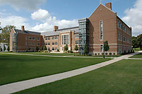
Figure 1: LightBulb High School
LightBulb High School, specializing in science and technology, has 1,000 students in grades 9-12. The faculty has decided to use social media to create an online networking and knowledge sharing space for all four grades. LightBulb High School has selected Google+ to share news and scholastic resources, promote student achievements and success stories, collaborate on extracurricular course activities and provide a social network that strengthens student-teacher relationships. This “Objectives and Assessment” report will define specific performance goals, learning objectives, methods and assessment criteria for the steps to be taken in creating a “hangout” event in Google+. The overarching goal for this module is to elucidate ways that social media can build stronger relationships, enhance motivation and enrich the learning experience for students.

Background: Some of the students in Dr. Pauling’s 11th grade class are not scoring well on their chemistry tests while others are doing very well. In order to close the gap in the understanding of basic chemistry concepts and to enhance their motivation to learn, the students have been instructed by the teacher to form study groups to learn from their peers, mentor each other and share successful study habits. Students live in disparate parts of the city and are unable to physically gather outside of school hours. Student feedback from past course evaluations also suggests that students would benefit from additional collaboration time outside of the normal school day. With the school’s adoption of Google Apps for EDU, students now have access to a full suite of integrated, collaborative software. The use of Google + Hangouts and the shareable features of Google Apps for EDU are seen as primary means for student teams to coordinate and carry out the creation of events to invite peers to study groups that have the potential to improve the quality and effectiveness of learning, and consequently enhance individual student performance in the class.

Instructional goal: The student will generate an event in Google+ inviting fellow classmates to discuss their study topics, compare class notes and share best practices in study methods.

Goal/Task Analysis: Students will create an “online hangout” event inviting their classmates to review class notes and ask questions of each other. They will discuss and compare notes in order to grasp difficult concepts. This is an intellectual as well as a psychomotor skill that requires both mental planning and physical execution.
2. Performance Objectives

Main Instructional Goal | Terminal Objective
The student will generate an event in Google+ inviting fellow classmates to discuss their study topics, compare class notes and share best practices in study methods. | Given a computer and the procedures outlined in the Google+ Workshop: Event module, students will generate an “online hangout” event in Google+ inviting fellow classmates to discuss study topics, compare class notes and share best practices in study methods.

Main Step in Instructional Goal #1
1.0 Determine a date to conduct a study group
 | Subordinate Skills | Subordinate Objectives
1.1 | Identify test date from instructor | By listening and/or speaking to the instructor, the student will write down the date of the next test in order to recall it for use in the Google+ event invitation.
1.2 | Select a date prior to test | Given the date of the next test, the student will select a date by counting back 3-7 days from that date in order to provide time to study.
1.3 | Look up availability on personal calendar | Given the information from step 1.2, the student will check his/her availability by identifying the absence of any other activities on that date in order to confirm the day and time for a study group.
Assessment: Identify the test date and subject matter from the information provided by Mr. Pauling. Provide a study group date that is 3-7 days prior to that date.

Main Step in Instructional Goal #2
2.0 Obtain email addresses from peers
 | Subordinate Skills | Subordinate Objectives
2.1.a | Ask peers for email addresses | By meeting with peers, the students will ask and obtain email addresses for use as an invitee list for the event.
2.1 | Make list of addresses for use in step 7.1 | From the email addresses obtained in step 2.1.a, the student will create a list on paper or electronically that can be used for data entry in step 7.1.
Assessment: Provide a list of names and corresponding email addresses for peers able and willing to participate in the study group “hangout event.” Name a minimum of two and maximum of five peers that have agreed to participate in the event.

Main Step in Instructional Goal #3
3.0 Log in to Google+
 | Subordinate Skills | Subordinate Objectives
3.1 | Connect to the Internet | Given a functional computer, the student will automatically or manually connect to the internet using an Ethernet or Wi-Fi connection in order to proceed with all following steps.
3.2 | Launch browser | The student will open (launch) Safari, Firefox, Internet Explorer, Chrome or other internet browser in order to navigate to Google+.
3.3 | Type URL in address bar | By typing https://plus.google.com/, the student will be able to connect to Google+ in order to proceed with all following steps.
3.4 | Enter User ID | Given a previously determined User ID (from previous module in workshop: “An introduction to Google+), the student will enter the given User ID to begin the process of logging on to the Google+ workspace.
3.5 | Enter password and press “enter” | Given a previously determined password (from previous module in workshop: “An introduction to Google+), the student will enter the given password and press the “enter” key to log in to the Google+ workspace.
Assessment: The student will be able to name the browser they are using to connect to the Internet and to list two pieces of information needed to log on to Google+.

Main Step in Instructional Goal #4
4.0 Create an event
 | Subordinate Skills | Subordinate Objectives
4.1 | Click on “Event” | Once logged on to the Google+ workspace (steps 3.1-3.5), the student will identify the “Event” option from the vertical list on the left side of the window and click on it to begin creating an event.
4.2 | Click on “Create Event” | Once the student is in the event workspace from step 4.1, the student will identify the red “create event” button at the top left of the window and click on it to begin creating an event.
4.3 | Click on “hangout event” option | The student will choose the “hangout event” option by navigating to “event options > advanced” and clicking on “Google+ Hangout” in order to choose the type of collaborative event to be initiated.
Assessment: The student will be able to distinguish the differences and explain the benefits of a Google+ “hangout” event and other types of events offered by Google+.

Main Step in Instructional Goal #5
5.0 Enter date and time for the event
 | Subordinate Skills | Subordinate Objectives
5.1 | Click on calendar | The student will click on the calendar icon to reveal the monthly calendar image in order to begin selecting the month and day for the event.
5.2 | Navigate to pre-determined month (from step 1.2) | If necessary, the student will click on the forward arrow at the top right corner of the month image and advance to the pre-determined month chosen for the event date in step 1.2.
5.3 | Click on pre-determined date (from step 1.2) | By navigating to the pre-determined month identified in step 1.2 and selected in step 5.2, the student will click on the pre-determined day (from step 1.2) in order to select the day for the event.
5.4 | Click on time field | Once the date has been selected (steps 5.1-5.3), the student will place cursor in the time field to the left of the date in order to begin assigning a time to the event.
5.5 | Scroll to desired time and click to select | Given the list of times displayed in a drop-down menu, the student will select the desired time by clicking on it.
Assessment: The student will send an invitation to him/herself as confirmation that the event has been scheduled on the date and time intended.

Main Step in Instructional Goal #6
6.0 Add peers as invitees
 | Subordinate Skills | Subordinate Objectives
6.1 | Type first email address (from step 2.1) in invitee field | By clicking on the invitee space in the event details window, the student will type the first email address listed from step 2.1 in order to begin the list of peers to be invited to the event.
6.2 | Type a “comma” | After typing the first email address, the student will type a “comma” from the keyboard in order to enter the first address and prepare to submit subsequent email addresses.
6.3 | Type subsequent email addresses | Given the first email submission and a comma, the student will type the second name on the email list created in step 2.1 in order to invite a list of peers.
6.4 | Repeat steps 6.1 to 6.3 until all desired names are included | Given the list of peer email addresses created in step 2.1, the student will repeat steps 6.1-6.3 in order to invite all peers to the event.
Assessment: Student will be able to compare names and email addresses from the original list created from step 2.1 to the names and email addresses of invited peers from the Google+ event window. These lists should correspond exactly. If they do not, a reason must be given.

Main Step in Instructional Goal #7
7.0 Send invitation
 | Subordinate Skills | Subordinate Objectives
7.1 | Click on “invite” box | Once the date, time, type of event and invitees have been entered into the event workspace, the student will click on the green “invite” button to initiate the invitation by email to his/her peers.
Assessment: Student will be able to compare the invitation status of peers to the list of people on the event page of Google+. The list will keep a running count of the invitees who have responded to the invitation and who have not. This list should correspond with the original list created from step 2.1.

3. Assessment Instruments

Assessment Plan: The overall goal for assessment and evaluation is based on the final objective: “The student will generate an event in Google+ inviting fellow classmates to discuss their study topics, compare class notes and share best practices in study methods.”

The final assessment will confirm that the student has successfully created an event for a study group session in which the group discussed study topics, compared class notes and shared best practices in study methods.

Final assessment will be produced by analyzing the comparison of latest test results to those of previous tests throughout the year. No improvement or a backwards trend in results will constitute a grade of D. An improvement of 5-10% will be considered a grade of C, 11-50% a grade of B, and finally, an improvement of more than 50% will earn a grade of A.

Design Evaluation Chart:

Objective | Assessment | Assessment Instrument
1.0  Determine a date to conduct a study group | Identify the test date and subject matter from the information provided by Mr. Pauling. Provide a study group date that is 3-7 days prior to that date. | Cognitive Assessment, goal-centered, Short Answer Questionnaire.  Sample questions:  1. What is the date of the test?  2. What is the date of your event?  3. At what time will you be meeting?  4. How many days before the test is your event?
2.0  Obtain email addresses from peers | Provide a list of names and corresponding email addresses for peers able and willing to participate in the study group “hangout event.” Name a minimum of two and maximum of five peers that have agreed to participate in the event. | Psychomotor Assessment, goal-centered, Completion Checklist.  Sample instrument:  Name Email  1. __________ __________  2. __________ __________  3. __________ __________  4. __________ __________  5. __________ __________
3.0  Log in to Google+ | The student will be able to name the browser they are using to connect to the Internet and to list two pieces of information needed to log on to Google+. | Cognitive Assessment, goal-centered, Short Answer.  Sample questions:  - Name the browser you used to connect to the Internet.  - What two pieces of personal information do you need in order to log on to Google+ and why are they important?
4.0  Create an event | The student will be able to compare the differences and benefits of Google+ “hangout” events with other types of events offered by Google+. | Cognitive Assessment, learner-centered, essay response.  Sample questions:  - What are the different kinds of events you can create with Google+  - What makes a “hangout” event different from the others?  - What are the benefits of a “hangout” event?  - Why is a “hangout” event best for your study group?
5.0  Enter date and time for the event | The student will send an invitation to him/herself as confirmation that the event has been scheduled on the date and time intended. | Psychomotor Assessment, goal-centered, completion checklist.  Sample instrument:  Completed:  - Month  - Date  - Time
6.0  Add peers as invitees | Student will be able to compare names and email addresses from the original list created from step 2.1 to the names and email addresses of invited peers from the Google+ event window. These lists should correspond exactly. If they do not, a reason must be given. | Cognitive Assessment, goal-centered, checklist/questionnaire.  Given the list of names from your initial list of invitees, were there any discrepancies?  Yes ____ (or) No ____  What were the discrepancies, if any (please list)?
7.0  Send invitation | Student will be able to compare the invitation status of peers to the list of people on the event page of Google+. The list will keep a running count of the invitees who have responded to the invitation and who have not. This list should correspond with the original list created from step 2.1. | Cognitive Assessment, learner-centered, questionnaire.  Sample questions:  - How many people have responded to your invitation?  - Of those that have responded, how many are planning to participate?  - How many people have responded that they will not be able to participate?  - Of those that will not participate, did they provide an explanation as to why?  - What was the reason for their decline of your invitation?

4. Instructional Strategy

Summary
Goal
Students will generate an “online hangout” event in Google+ inviting fellow classmates to discuss study topics, compare class notes and share best practices in study methods. This is an intellectual as well as a psychomotor learning objective and contains sub-steps that are cognitive and intellectual in nature as well.

Context
The initial instruction and validation of goals will take place in class. The final goal of the instruction will take place outside of class and outside of school hours. Total in-class instruction, set-up and follow-through should be completed in one hour.

The concept of collaboration in the classroom will be very familiar and appealing to the students, as they have already been doing so. For this specific training module, collaboration will take place in a virtual environment, so learners need to be technically savvy, which they are. The goal is to mirror the authentic collaboration in the classroom in a virtual environment in order to maintain the students’ motivation for learning.

Pre-instructional activities
Motivation
The instructor will introduce this module of the Google+ workshop as the module that allows them to start interacting with their friends and peers. The instructor will discuss the reason why they are learning to create a Google+ “hangout” event. An example of a hangout event with President Obama regarding his 2012 State of the Union address will be shown during this time (http://www.whitehouse.gov/photos-and-video/video/2012/01/30/president-obama-s-google-hangout). The motivation should come from this example that is relevant and prescient to 11th grade students. Hopefully the students will understand that if Google+ hangouts are a medium that their President uses, it must be valuable and important. The concept of a hangout in virtual space will also mirror the authentic collaboration that already exists in the classroom and will maintain the students’ motivation for learning.

Objectives
The creation of a Google+ hangout event will be detailed. The learners will be walked through the procedure during class so they will understand how to create one for their study group and any future events that will take place (academic and personal).

Entry Skills
Entry skills for this instruction include the ability to use a computer. Students will be able to enter information (typing or voice-to-text) as input into the computer. Students will have the ability to read. Learners will have already taken the module in the workshop that provides them with a User ID and password for Google+. They will have access to their peers in order to ask them for email addresses for inclusion in their study group. Students will also have access to a valid school or personal planner to determine availability for a study group. Support has been provided and agreed to by school administration, faculty and parents (forms were sent home with students to confirm parental support).

Student Grouping and Media Selections
Instructor led to the entire group. Instruction will be delivered throughout the hour along with hands-on use of a computer. Students will group themselves for study groups by choosing at least one peer that has a higher grade than them and one that has a lower grade in the class for the purpose of gathering invitees for the event. Group size will range from 3-6 students, including the learner.

The instructor will distribute two procedural worksheets: One for lists of names and addresses to be collected and used as a worksheet for objective 2.0, and one for a list of procedures to follow that may be used for reference only. The instructor will mirror his/her computer while showing examples of Google+ hangouts during the beginning of instruction and welcome. The class will be supported and supervised by the instructor during this one-hour exercise.

Assessment
Pre-tests
There will be no formal pretests for this instruction as all members of the target population are already proficient in how to use a computer, have Google+ User ID’s and passwords, and have the ability to communicate with their peers.

Post-tests
The post-test for this instruction will take place after each student has successfully sent out invitations for study groups to their peers. The final assessment will confirm that the student has successfully created an event for a study group session in which the group discussed study topics, compared class notes and shared best practices in study methods. The instructor will make final assessments after analyzing the comparison of latest test results to those of previous tests throughout the year.

Student Grouping and Media Selections
Learners will be able to collaborate during the instruction, but all assessments will be submitted individually. The assessments will be submitted either on paper or in the form of a computer file.

Follow-through Activities
Memory Aid
Alerts will be set up in Google+ calendars to notify students of the event that they created or have been invited to participate in by email.

Transfer
Students will have successfully created an event for a study group session in which the group will have discussed study topics, compared class notes and shared best practices in study methods. The results of the transfer will be apparent during the final assessment of grades that analyze previous and current test scores.

Student Grouping and Media Selections
Students will be grouped in study group sessions as selected in step 2.0. The media selection will include computers and class notes.

Content Presentation and Learner Participation

Student Grouping and Media Selection
The instructor will lead the introduction for the entire class. Most work will be done individually on computers. There will be a worksheet and a reference sheet distributed at the beginning of the hour. Students will be encouraged to ask questions, share discoveries and collaborate with one another during the course of the instructional hour.

Content Presentation
Instructor will explain, supervise and validate the process of creating a “hangout” event in Google+ for the purposes of initiating a study group. The learners will be encouraged to ask questions and share examples as the group moves through the instruction.

Examples
Examples of other Google+ hangouts will be provided during instruction. One example to be used is that of a hangout event with President Obama regarding his 2012 State of the Union address from January 30, 2012.

5. Appendix

(Revised) Goal Analysis from Initial Analysis Report chart (dated July 8, 2012):

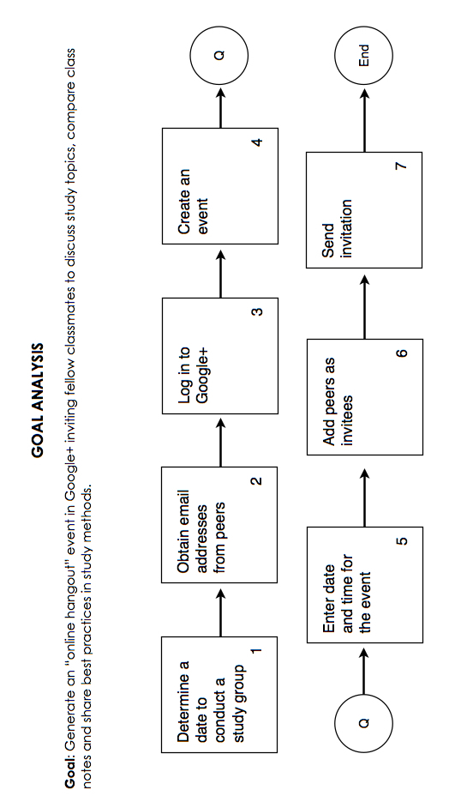

(Revised) Subordinate and Entry Level Skills chart from Initial Analysis Report (dated July 8, 2012):

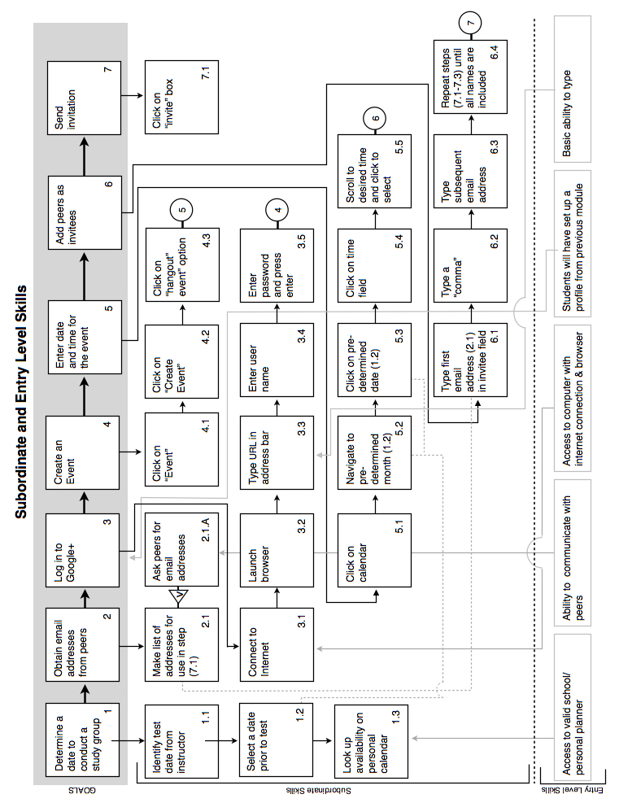

6. Resources

References

Dick W., C. L. (2009). The systematic design of instruction (7th ed.). Upper Saddle River, NJ: Pearson.

Google+. (n.d.). Retrieved July 20, 2012, from Google+: https://plus.google.com/

The White House. (n.d.). Retrieved July 20, 2012, from The White House President Barak Obama: http://www.whitehouse.gov/photos-and-video/video/2012/01/30/president-obama-s-google-hangout

