Opera is not a Four-Letter Word
Instructional Plan and Paper Prototype

Freddi Rokaw, Purdue University
EDCI 56900, Dr. Victoria Walker

Table of Contents
1. CONTEXT DESCRIPTION AND LEARNING OBJECTIVES 4
CONTEXT DESCRIPTION 4
Introduction and Rationale 4
Context 4
Target Learners 4
Conditions 6
LEARNING OBJECTIVES 7
Terminal Goal 7
Learning Objectives 7
2. SITE MAPS 10
OVERVIEW 10
MODULES 11
Tosca Module 11
Carmen Module 11
Overall Comparison Module 11
Getting Started 12
Other Resources 12
Possible Future Modules 12
3. STORYBOARDS 13
General 13
Tosca 16
Carmen 31
Overall Comparison 46
Other 48
4. CONTENT 51
TASK CHARTS 51
CONTENT SPECIFICATIONS 55
Content Specifications for Learning Objective #1: 55
Content Specifications for Learning Objective #2: 60
Content Specifications for Learning Objective #3: 64
Content Specifications for Learning Objective #4: 68
Content Specifications for Learning Objective #5: 73
Content Specifications for Learning Objective #6: 77
Content Specifications for Learning Objective #7: 81
ASSESSMENTS 84
Planning for Assessment 84
Task Assessment Specifications 85
Assessment Items for Learning Objective #1 85
Assessment Items for Learning Objective #2: 86
Assessment Items for Learning Objective #3: 87
Assessment Items for Learning Objective #4: 88
Assessment Items for Learning Objective #5: 89
Assessment Items for Learning Objective #6: 90
Assessment Items for Learning Objective #7: 91
Planning for Formative Evaluation 92
5. MERRILL’S FIVE STAR RATING SYSTEM 93
PROBLEM 93
ACTIVATION 94
DEMONSTRATION 95
APPLICATION 96
INTEGRATION 97
APPENDIX 98
SITE MAPS 98
Overall Site Map 98
Tosca Module Site Map 99
Carmen Module Site Map 100
TASK CHARTS 101
Task chart 1 101
Task chart 2 102
Task chart 3 103
Task chart 4 104
Task chart 5 105
Task chart 6 106
Task chart 7 107
Syllabus 108
Course Orientation 113
Glossary 116
Audience Etiquette 121
INDEX 123
List of Figures 123
List of Tables 124
REFERENCES 125
Additional Resources 126
CD’s: 126
DVD’s: 126

OPERA IS NOT A FOUR-LETTER WORD

1. CONTEXT DESCRIPTION AND LEARNING OBJECTIVES

CONTEXT DESCRIPTION

Introduction and Rationale
This is an online course in opera appreciation that will be offered as a continuing education extension e-Learning class by the department of music at DiVa Community College. This course is important in that it intends to make the genre more accessible to the general public, expand the cultural horizons of the learners and overcome any barriers that might dampen the enjoyment the art form.

Students will learn about the components that comprise an opera, including: storytelling, acting, music, language, sets and costumes. Learners will also make connections between the art form and current social, economic, political culture and beliefs. Finally, the intent of this course is to build audiences in order to ensure the survival of the performing arts by gaining support in the form of appreciation and participation.

Context
The course is designed in modules based on individual operas. The content of this course will be based on existing information specifically relating to opera. Because of its modular format and ever-growing database of information, this online course may be “personalized” by a facilitator to include local content if so desired. Curriculum can be organized and delivered in varied ways. The course can be delivered in a way that builds in complexity throughout the duration of the entire course, by using modules that correlate to operas being performed by local performance companies, synchronized with live/pre-recorded broadcasts, presented chronologically by composition, or used as a stand-alone, self-paced e-Learning course. The intent of this course is to create an environment where the overarching goals of opera appreciation are captured by facilitating connections and relationships between any of the modules.

Two opera lessons (modules) will be represented in this project: Tosca and Carmen. In the future, there will be an ever-expanding database of resources and operas. There is also a General module that will contain just-in-time resources such as glossaries, audience information, instructor information, support tutorials, reference materials, anecdotes, a common meeting area, syllabus, and grading rubrics.

Target Learners
A learner analysis was conducted based on the knowledge of learners enrolled in the “Lifelong Learning” extension class at DiVa community college. Based on this research, the following describes the target learners for this course.

Learner Analysis
General | - Age Group: Mostly 55 years and older  - Racial/ethnic background: Mixed  - Socioeconomic background: Retirees with pension income  - Familial Situation: Grown children and grandchildren. Limited responsibilities.  - Accessibility Issues (if any): Possible (probable) hearing, eyesight and mobility issues.  - Level of computer/Internet experience: Very little.  - Previous online course experience: Little to none.  - Access to technology, high speed Internet: Home or public library (requirement for the course).
Cognitive | - General aptitudes: Highly motivated, willingness to learn, positive attitude, excellent focus, intellectual.  - Specific aptitudes: Highly developed listening skills, ability to focus for long periods of time, willing and able to share opinions.  - Developmental level: More adept at abstract concepts as opposed to concrete tasks (which is an important consideration to take into account for this course).  - Language development level: Proficient in reading, writing and speaking English.  - Reading level: At least high school level.  - Level of visual literacy: Generally excellent, but depends on physical audio and visual challenges.  - Cognitive processing styles: Depending on age factor, cognitive abilities may range greatly, which will be an important factor to consider. Long-term and short-term memory may be deficient based on age and must be taken into account.  - Learning strategies: Casual, note taking, discussion based.  - General world knowledge: Vast knowledge and previous experience to draw from. This group of learners has an abundance of life experience to refer to and contribute.  - Specific prior knowledge: Varied prior knowledge based on world travel, previous cultural experiences with music, dance and other performing arts, an historic view of politics and social culture.
Affective | - Interests: Music, Art, Dance, Travel.  - Motivations to learn: Active learners that want to keep their minds active and broaden their experiences.  - Attitude toward learning: Enthusiastic, positive attitude, motivated and willing to learn.  - Attitude toward subject matter: Previously intimidated, unsure of subject matter.  - Attribution of success: Able to discuss and analyze current operas with others in social and academic situations.
Social | - Relationships to peers: Participants might already know each other from the community. The majority of participants are women.  - Feelings toward authority: Respectful and questioning.  - Tendencies toward cooperation or competition: Very co-operative and rarely competitive.
Pre-requisites | - Have access to a computer with a working and reliable internet connection.  - Have the ability to type, speak, read and write in English.  - Have access to research materials.  - Have access and ability to navigate through a learning management system.  - Possess the ability to create and submit a document on the computer.  - Be able to hear audio, see visual material and/or read printed documents.  - Ability to receive and offer constructive feedback.  - Ability to focus for a period of at least 1.5 hours.  - Have access to a calendar of live or recorded performances.  - Be able to listen or see the performance and remember it.
Table 1.0 - Learner Analysis

Conditions
The Instructional Environment: Because of their age, the majority of students are more comfortable learning from home rather than on the school campus for a variety of reasons. Night driving, large distances and accessibility issues are their main concerns. The course is offered online and can be re-configured to correlate with current and local performances. Media will include images, videos and audio. There will be a chat room called “The Foyer” where participants can discuss any performances they have seen locally. There will also be a discussion group in the form of a chat room called “Tosca’s Cafe” for students to participate in. “Tosca’s Cafe” is for social interaction only and will not be graded.

The Instructional Description: Coursesites will be used for building the course for use in the Blackboard learning management system. Users will create a student username and password to gain access to the course and its modules. Elements will be built using iMovie, Garageband from Apple’s iLife software and Pages, Numbers and Keynote from Apple’s iWork suite of for Mac. Other possible technology to be used in creation may include YouTube, Adobe Captivate, Prezi, Xtranormal and other software if deemed appropriate and/or necessary.

The Support Environment: The course will begin with a large database of operas but has the potential to be modified based on the season performances of the local opera company(s). Thus, a database will continue to grow as repertoire is created that can be reused on an “as-needed” basis. The staff and faculty at DiVa Community College will provide management, maintenance and technical support of the database and delivery system. Faculty will deliver and contribute to content.

Online Resources: In addition to the opera modules, general information will be available at all times including: Instructor information, Announcements, General Orientation for the Site, Class Roster, Glossary, Foyer, Anecdotes, Syllabus, Course Support, Pre-performance Research Links, and Navigation Support.

Pre-requisites for the Learning Environment: Students will need a computer with access to the Internet. The computer will possibly be at home, at a public library or senior center. No other materials will be required. Computer support for the students will be provided using the channels already in place in their homes or remote locations that could include friends, family, staff or telephone support. The instructor, through online discussions or on-campus technical support, may provide some limited instructional support.

LEARNING OBJECTIVES

Terminal Goal
The overarching goal of this course is to develop an appreciation for opera by gaining a deeper understanding of this complex art form. The hope is that learners will continue to attend the performing arts, which will build audiences and ensure the survival and support of the arts.

Learning Objectives
Based on a combination Horton’s “learning objects” (Horton, 2012, p. 285) and Mager’s “Instructional Objectives” (Mager, 1997, p. 3), these learning objectives have been developed to relate to specific tasks and learning objects, the intended outcome of such tasks, are specific and measurable and written from the point of view of the learner.

(Module 1 - Tosca)
Learning Objective #1 (The Elements): Learners will identify each of the components (story, music, acting, language, costumes, sets) of Tosca in order to gain a deeper understanding of the art form as a whole.

Sub-Objective 1.1 (Story): After reading the synopsis and libretto of Tosca, learners will be able to discuss origins of and the difference between the two forms of storyline.
Sub-Objective 1.2 (Music): Given the audio of an aria, learners will be able to identify moods and thematic elements of the music with 80% accuracy.
Sub-Objective 1.3 (Acting): Given a the storyline, learners will be able to describe the relationships between the three main characters of Tosca.
Sub-Objective 1.4 (Sets): Given visual examples and maps of locations, learners will be able to identify where scenes from Tosca are located with 80% accuracy.
Sub-Objective 1.5 (Costumes): Given visual examples of costumes, learners will be able to match characters to their appropriate attire in the opera Tosca with 80% accuracy.

Learning Objective #2 (The People): Given knowledge of the storyline of Tosca, learners will be able to demonstrate personal viewpoints of Tosca by discussing the relationships between current events and social/economic, power and class systems, political climate and romantic elements of Tosca.

Sub-Objective 2.1 (Political): Given familiarity of the three main characters, learners will be able to discuss the political motives of one of the characters from Tosca and relate it to current events in today’s society.
Sub-Objective 2.2 (Romantic): Given familiarity of the three main characters, learners will be able to discuss the romantic relationships in the storyline and write fictional outcomes.
Sub-Objective 2.3 (Socio-economic): Given knowledge of the three main characters, learners will be able to identify the social status of one of the characters and discuss its effect on relationships with others.

Learning Objective #3 (The Show): By attending a live or pre-recorded performance of Tosca, learners will present their personal opinion to their peers.

Sub-Objective 3.1 (Audience Etiquette): Based on a document outlining audience etiquette, learners will be able to demonstrate appropriate audience behavior for a live opera performance of Tosca.
Sub-Objective 3.2 (Finding a Performance): By choosing from a list of live and pre-recorded productions, learners will attend a performance of Tosca within a given timeframe.
Sub-Objective 3.3 (Critique): Given attendance of a performance of Tosca, learners will write and share a personal critique of the specific production attended.

(Module 2 - Carmen)
Learning Objective #4 (The Elements): Learners will identify each of the components (story, music, acting, dance, and costumes) of Carmen in order to gain a deeper understanding of the art form as a whole.

Sub-Objective 4.1 (Story): After reading the synopsis and libretto of Carmen, learners will be able to discuss origins of and the difference between the two forms of storyline.
Sub-Objective 4.2 (Music): Given the audio of an aria, learners will be able to identify moods and thematic elements of the music with 80% accuracy.
Sub-Objective 4.3 (Acting): Given a the storyline, learners will be able to describe the most outstanding traits of the two main characters of Carmen.
Sub-Objective 4.4 (Dance): Given visual examples, learners will be able to identify two different kinds of dances performed in Carmen with 80% accuracy.
Sub-Objective 4.5 (Costumes): Given visual examples of costumes, learners will be able to match characters to their appropriate attire in the opera Carmen with 80% accuracy.

Learning Objective #5 (The People): Given knowledge of the storyline of Carmen, learners will be able to demonstrate personal viewpoints of Carmen by discussing elements in the opera with personal and political beliefs.

Sub-Objective 5.1 (Political): Learners will identify the moral beliefs of both Carmen and Don Jose and compare these ideas with their own feelings of personal freedom and responsibility.
Sub-Objective 5.2 (Romantic): Given familiarity of the two main characters, learners will be able to write a fictional outcome for the plot if the romantic interests were to change.
Sub-Objective 5.3 (Socio-economic): Given knowledge of the two main characters, learners will be able to identify the social status of one of the characters and discuss the effect that status has on the decisions that character makes in the story.

Learning Objective #6 (The Show): By attending a live or pre-recorded performance of Carmen, learners will present their personal opinion to their peers.

Sub-Objective 6.1 (Audience Etiquette): Based on a document outlining audience etiquette, learners will be able to demonstrate appropriate audience behavior for a live opera performance of Carmen.
Sub-Objective 6.2 (Finding a Performance): By choosing from a list of live and pre-recorded productions, learners will attend a performance of Carmen within a given timeframe.
Sub-Objective 6.3 (Critique): Given attendance of a performance of Carmen, learners will write and share a personal critique of the specific production attended.

(Overall Comparison)
Learning Objective #7 (Overall Comparison): After having completed at least two modules of the course, learners will be able to compare and contrast two operas in order to demonstrate a more general knowledge of the entire musical genre.

Sub-Objective 7.1 (Components): Given the study of two different operas, learners will be able to discuss the common and missing elements between two operas with their peers.
Sub-Objective 7.2 (Politics): Given the study of two different operas, learners will be able to identify at least two common themes between two operas.
Sub-Objective 7.3 (Present): Learners will be able to present the differences in creative decisions made by the producers and artistic directors of two different opera productions (same or different operas).

2. SITE MAPS

OVERVIEW

Following is a top-level site map to visualize the instructional flow of the entire course:

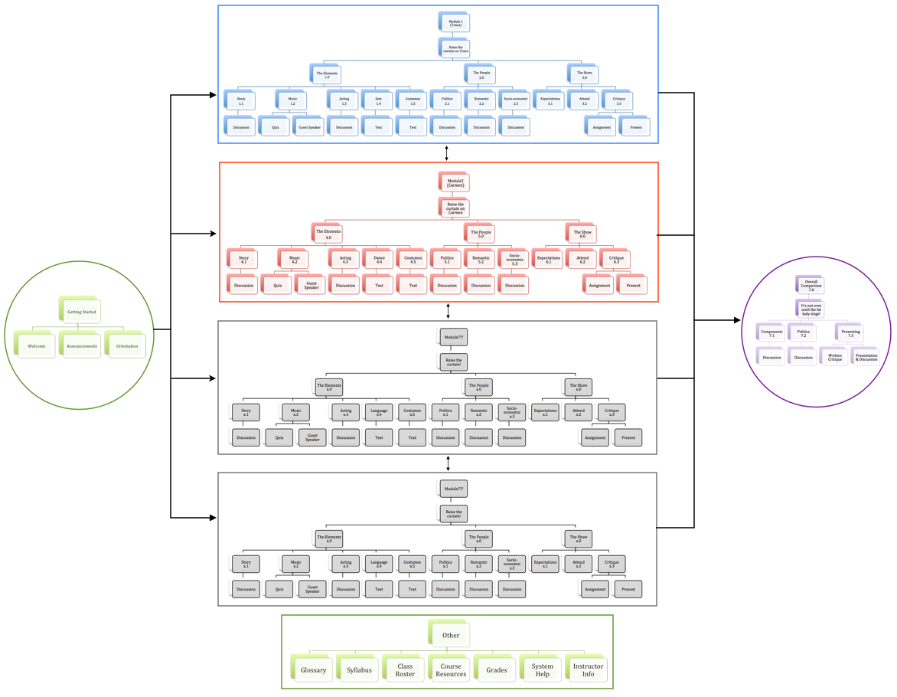
Figure 2.0 - Top Site Map (see appendix for full-sized map)

MODULES

Tosca Module
This map shows the flow of the first module, Tosca, with its associated sub-objectives:
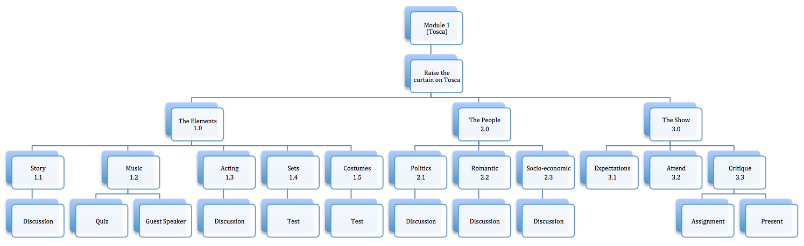
Figure 2.1 - Module 1 (Tosca) Map (see appendix for full-sized map)

Carmen Module
This map shows the flow of the second module, Carmen, with its associated sub-objectives:

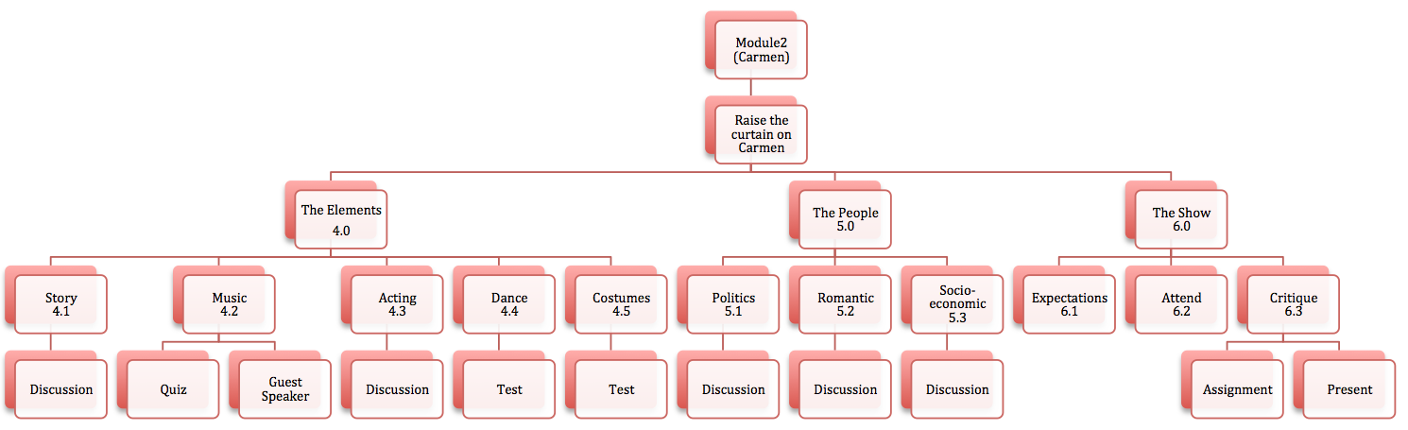
Figure 2.2 - Module 2 (Carmen) Map (see appendix for full-sized map)

Overall Comparison Module
This map shows the flow of the general overview module with its associated sub-objectives:

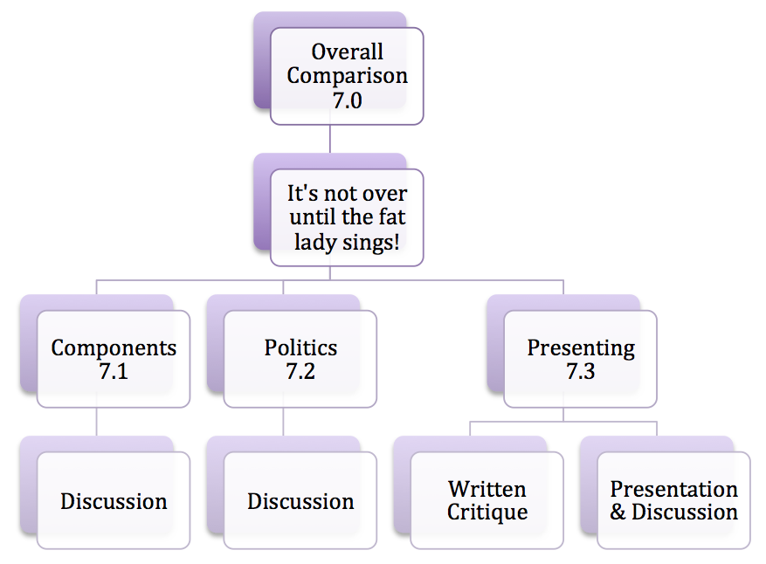
Figure 2.3 - Overall Comparison Map (see appendix for full-sized map)

Getting Started
This map shows the flow of the getting started module with its associated sub-objectives:
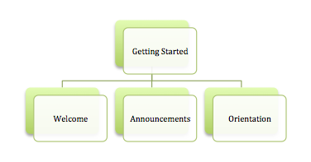
Figure 2.4 - Getting Started Map

Other Resources
This map shows the flow of the resources available to the learners at all times:
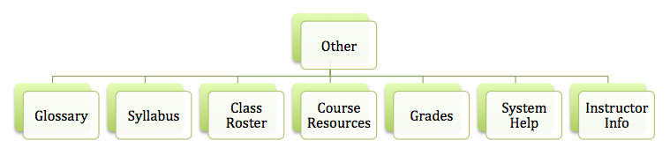
Figure 2.5 - Resources Map

Possible Future Modules
This map shows the flow of possible future modules with associated sub-objectives:
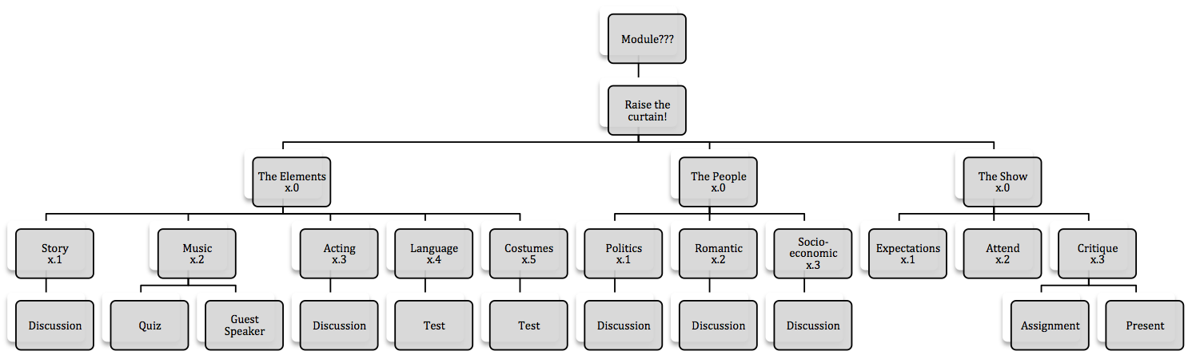
Figure 2.6- Possible Future Modules Map (see appendix for full-sized map)

3. STORYBOARDS

General
The opening page for the course is the Announcement page. This page has a banner, sidebar and content zones. The first thing to be seen is the opening welcome video. Next is the instruction to use Firefox as the browser if the video doesn’t play. There is a link to the mozilla website where learners can download Firefox for free. Next is a welcome statement that urges the user to proceed immediately to the “Course Orientation” page. Finally, an explanation and link to the class roster is provided.
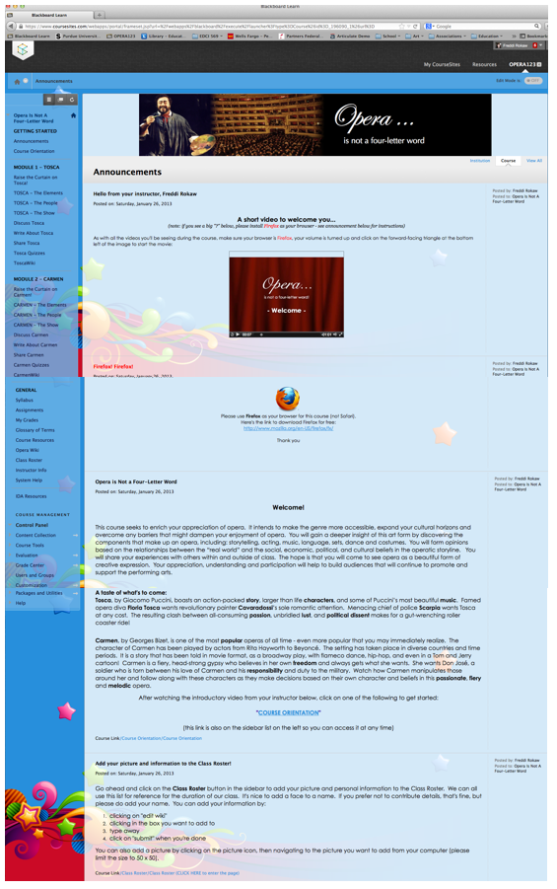
Figure 3.0 - Opening Page
The sidebar contains a complete list of all top-level elements for the entire course. The sidebar remains the same no matter where the learner navigates. This provides for good zoning (Horton, online Ch. 14, p. 28).
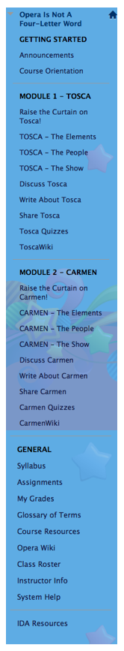
Figure 3.1 - Sidebar

The Course Orientation page provides the learner with a map of Blackboard’s user-interface and how it relates to the context of this course. This page allows users to see the entire content of the orientation guide by scrolling on the screen. Learners may also download the .pdf file to save for later use.

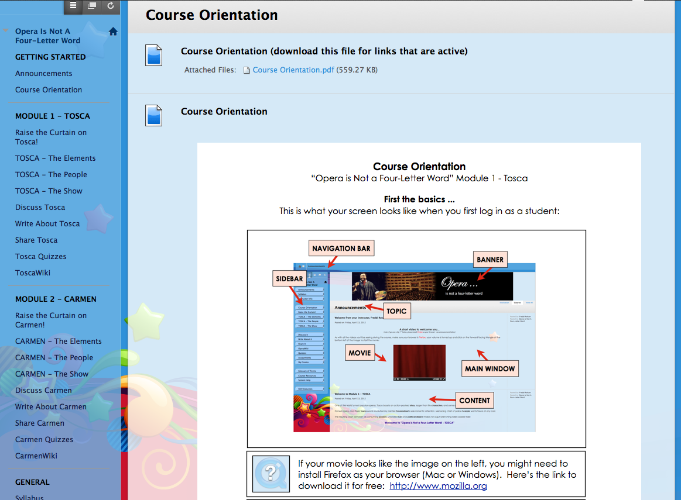
Figure 3.2 - Course Orientation Page

Tosca
The Raise the Curtain on Tosca! home page gives an introduction to the opera Tosca. It serves to lure the learner into the melodramatic opera by encouraging them to read the story, look at the video of the final act (where Tosca jumps to her death), and listen to the dramatic final aria. All files for these activities may be downloaded from the links provided on this page. There is also a request to learners to provide personal background information by emailing the instructor using the provided direct email link.

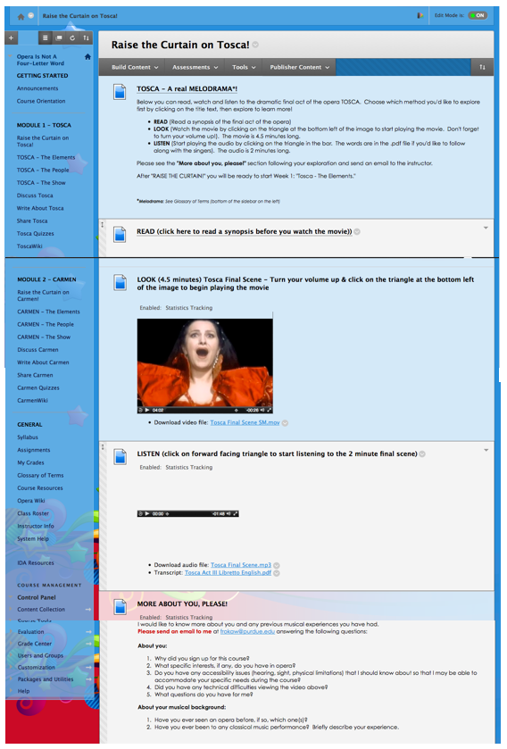
Figure 3.3 - Raise the Curtain on Tosca! page

Tosca - The Elements home page gives an introduction to the opera and sparks the interest right away with a video of the opening scene. The introduction text gives instructions for how to proceed with the elements section and states the learning objective. All of the components (Story, Music, Acting, Sets, and Costumes) are accessed from this page. This page aligns with Learning Objective 1.0.

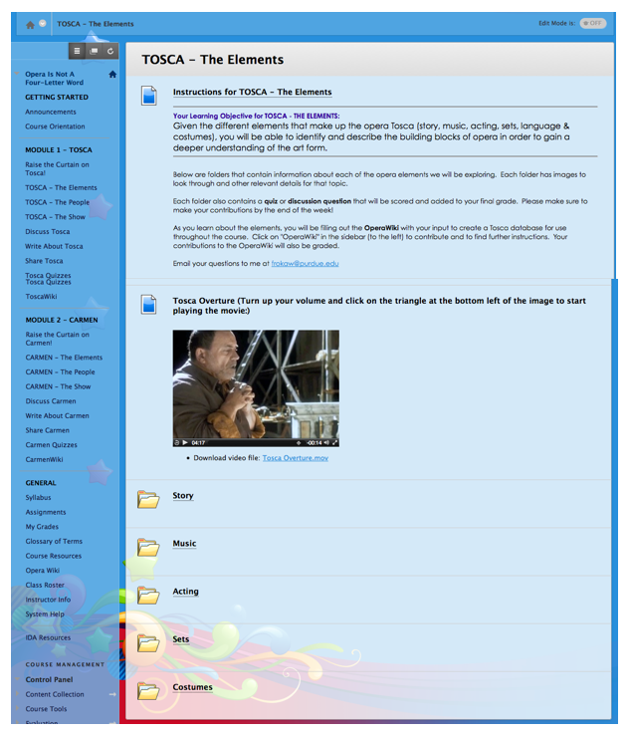
Figure 3.4 - Tosca - The Elements Home Page

Tosca - The Story main page gives instructions for downloading the synopsis and libretto documents, what to read and what to discuss. These instructions align with sub-objective 1.1. Subsequent pages are shown here - the “Synopsis & Libretto Files” page and the discussion forum that will be used for assessment of this sub-objective 1.1.

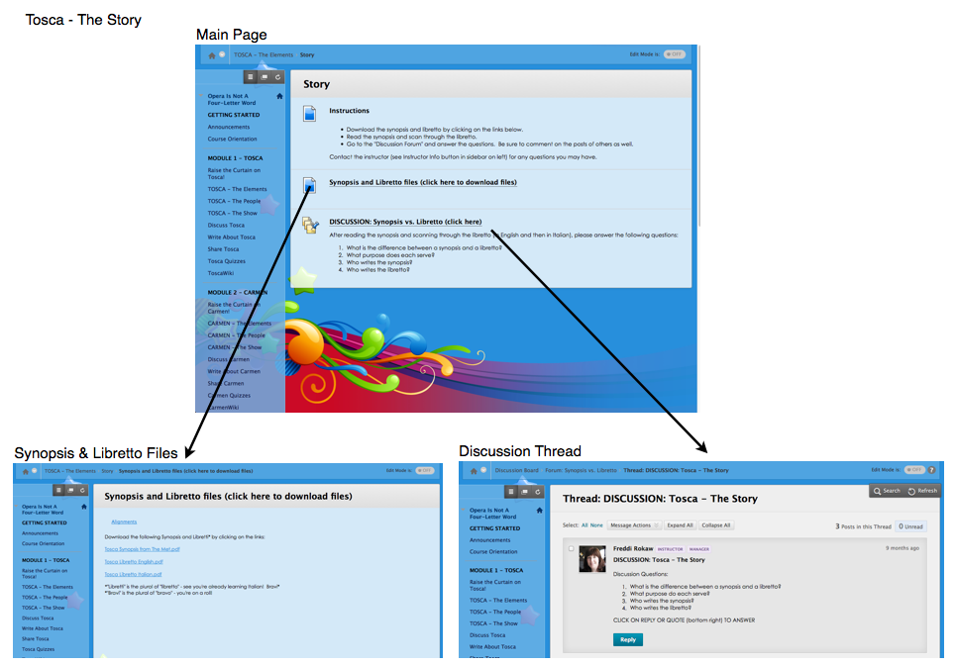
Figure 3.5 - Tosca - The Story Main page, Synopsis & Libretto page, and Discussion Thread page.

Tosca - The Music main page gives instructions for downloading the libretto to read, listening to the audio, downloading the transcript of the audio, and for taking the music quiz. There is also a link to the biography of the current guest speaker. These instructions align with sub-objective 1.2. Subsequent pages are shown here - the “Audio Transcript” document, Guest Speaker Biography and instructions and test for the “Music of Tosca quiz” which will be used for assessment of this sub-objective 1.2.

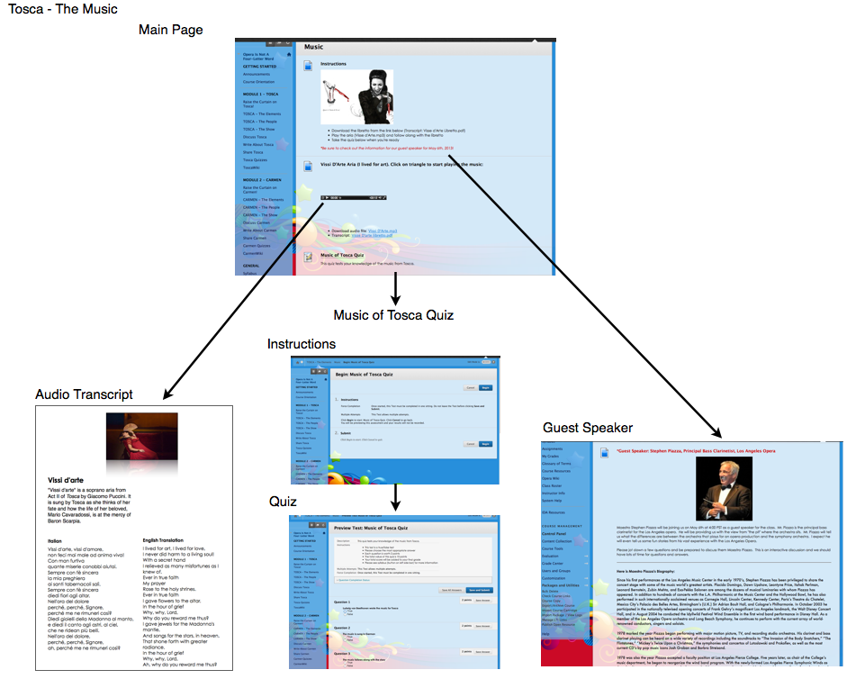
Figure 3.6 - Tosca - The Music Main page

Tosca - The Acting main page gives instructions for watching the acting slideshow, researching famous actors and participating in the discussion forum for this objective. These instructions align with sub-objective 1.3. Subsequent pages are shown here - the page with the acting slideshow and the discussion thread “What makes an actor great?”, which will be used for assessment of this sub-objective 1.3.

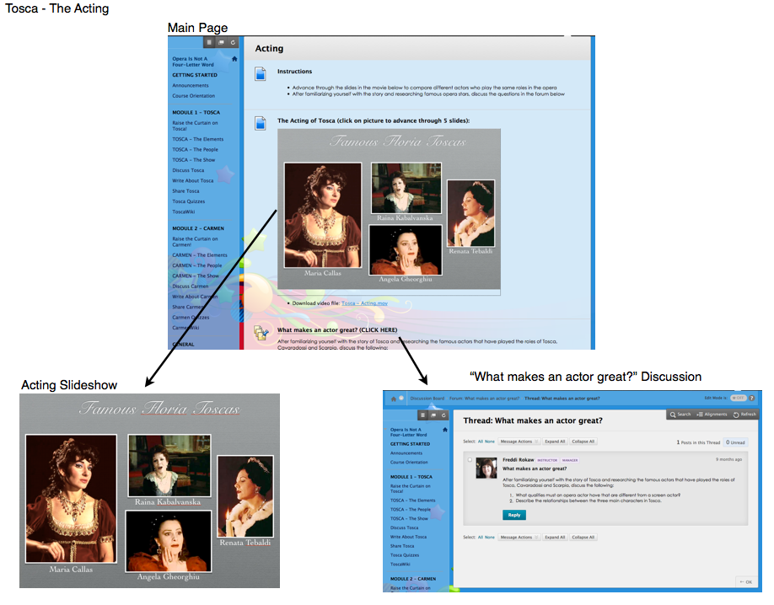
Figure 3.7 - Tosca - The Acting Main page, Acting Slideshow page and Discussion Thread

Tosca - The Sets main page gives instructions for watching the sets slideshow, researching locations in Rome from the opera and taking the sets test for this objective. These instructions align with sub-objective 1.4. Subsequent pages are shown here - the page with the sets slideshow, instructions for the test and the actual test which will be used for assessment of this sub-objective 1.4.

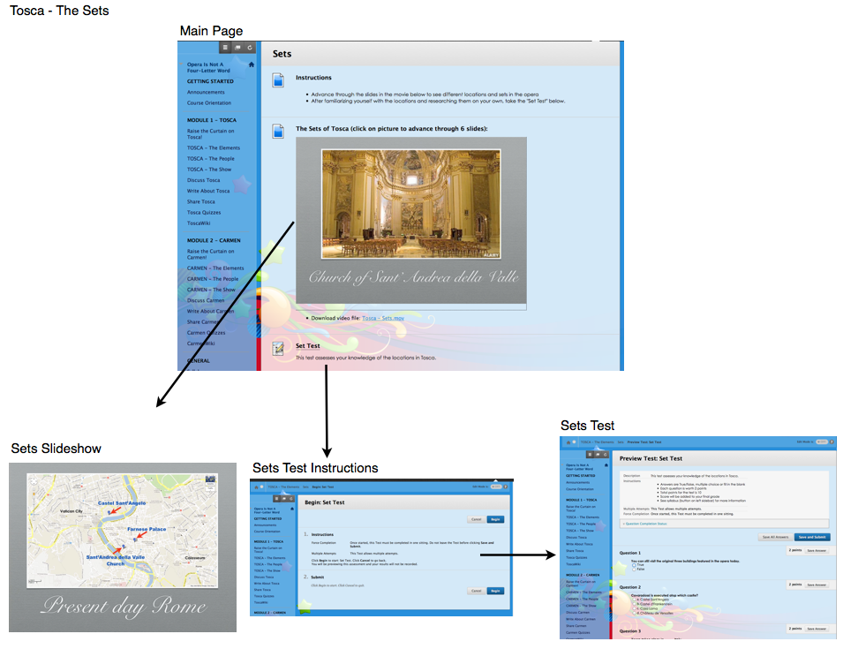
Figure 3.8 - Tosca - The Sets Main page, Sets Slideshow, Instructions for test, Sets Test

Tosca - The Costumes main page gives instructions for watching the costumes slideshow, researching costumes from different productions of Tosca and taking the costumes test for this objective. These instructions align with sub-objective 1.5. Subsequent pages are shown here - the page with the costumes slideshow, instructions for the test and the actual test, which will be used for assessment of this sub-objective 1.5.

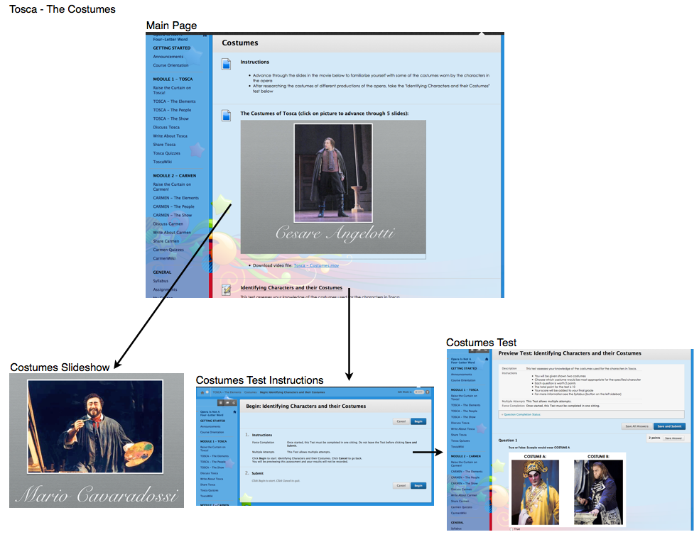
Figure 3.9 - Tosca - The Costumes Main page, Costumes Slideshow, Instructions for test, Costumes Test

Tosca - The People home page gives an introduction to the character, Scarpia in the opera and sparks the interest right away with a video of Scarpia’s evil scene where he plots to make Tosca his. The introduction text gives instructions for how to proceed with the “people” section and states the learning objective. All of the components (Politics, Romantic, and Socio-Economic) are accessed from this page. This page aligns with Learning Objective 2.0.

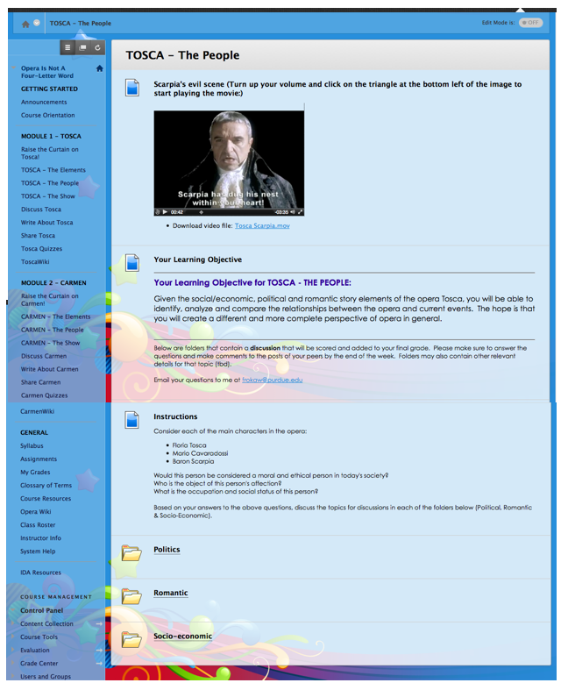
Figure 3.10 - Tosca - The People Home Page
Tosca - The Politics main page gives instructions for considering a political look at the characters in Tosca. These instructions align with sub-objective 2.1. A subsequent page for the discussion forum is shown here, which lays out instructions for replies. This discussion thread will be used for the assessment of this sub-objective 2.1.

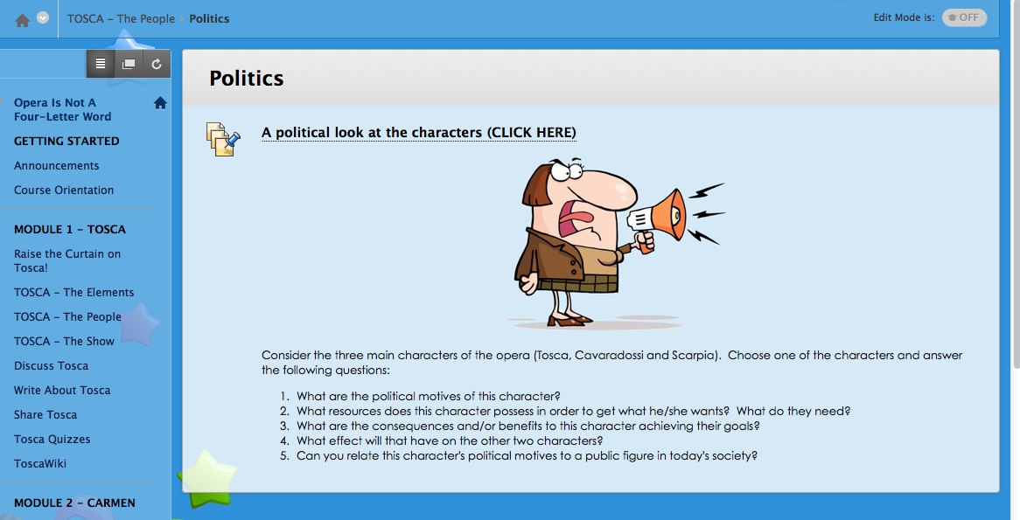
Figure 3.11 - Tosca - The Politics Home Page

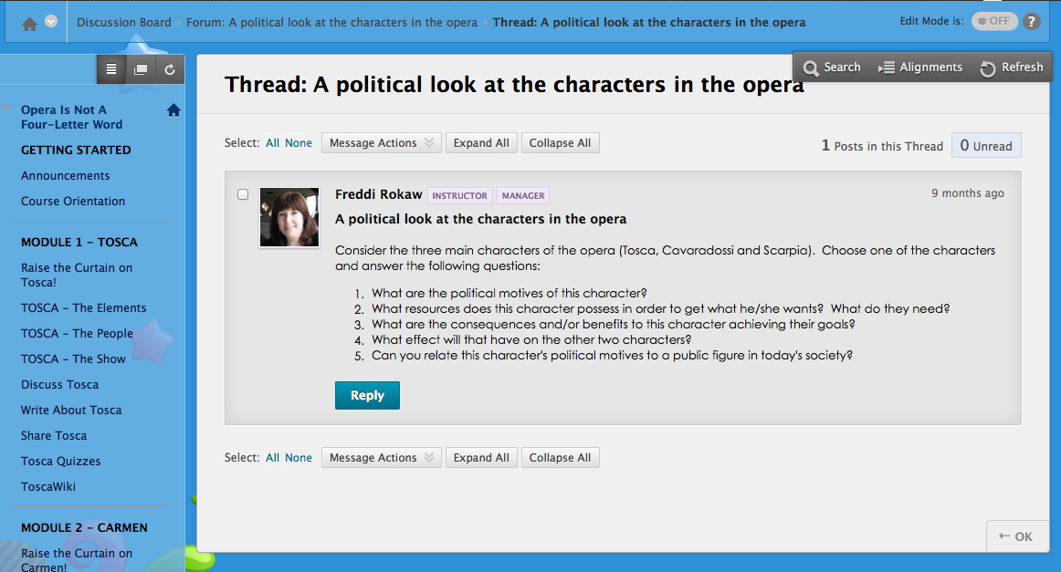
Figure 3.12 - Tosca - The Politics Discussion Thread

The Tosca - Romantic main page gives instructions for considering a romantic look at the three main characters in Tosca. These instructions align with sub-objective 2.2. A subsequent page for the discussion forum is shown here, which lays out instructions for replies which involve roleplaying one of the three main characters. This discussion thread will be used for the assessment of this sub-objective 2.2.

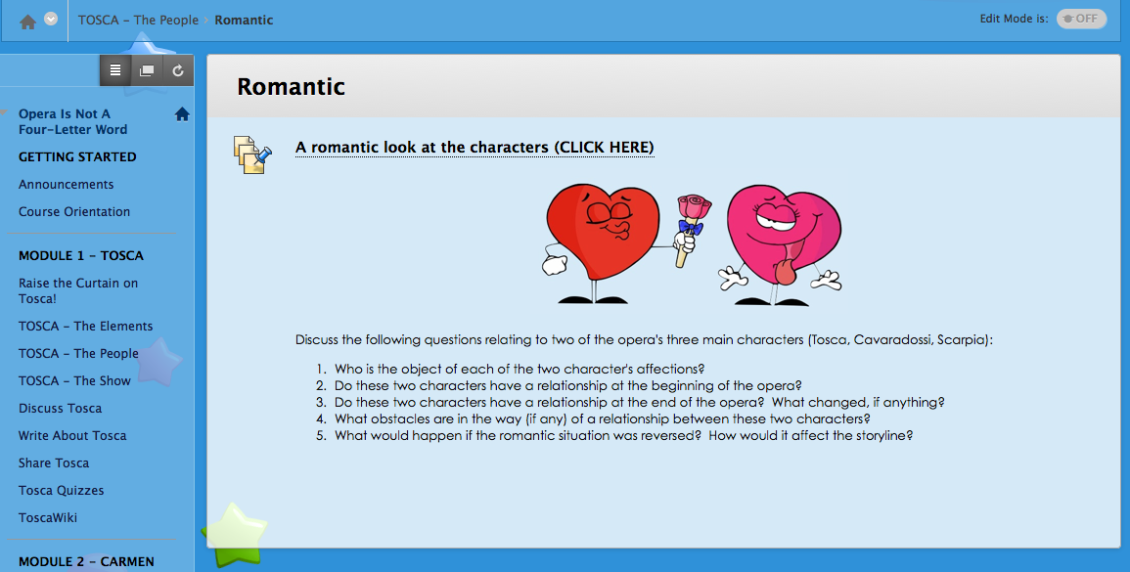
Figure 3.13 - Tosca - Romantic Home Page

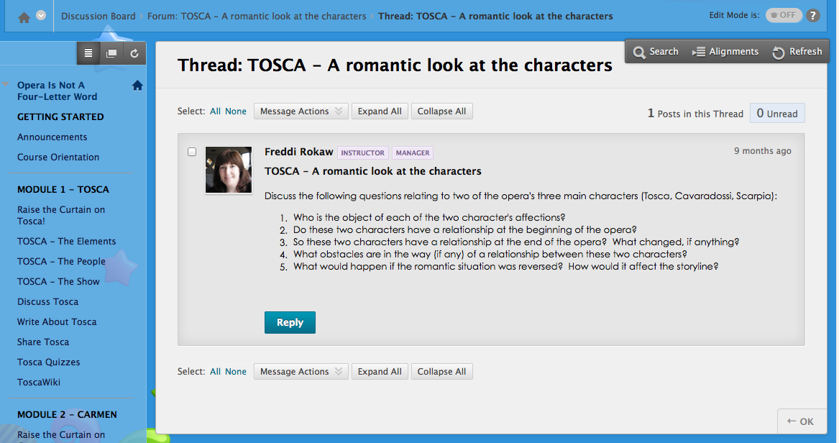
Figure 3.14 - Tosca - Romantic Discussion Thread

The Tosca - Socio-economic main page gives instructions for considering a socio-economic look at the three main characters in Tosca. These instructions align with sub-objective 2.3. A subsequent page for the discussion forum is shown here, which lays out instructions for replies which involve roleplaying one of the three main characters. This discussion thread will be used for the assessment of this sub-objective 2.3.

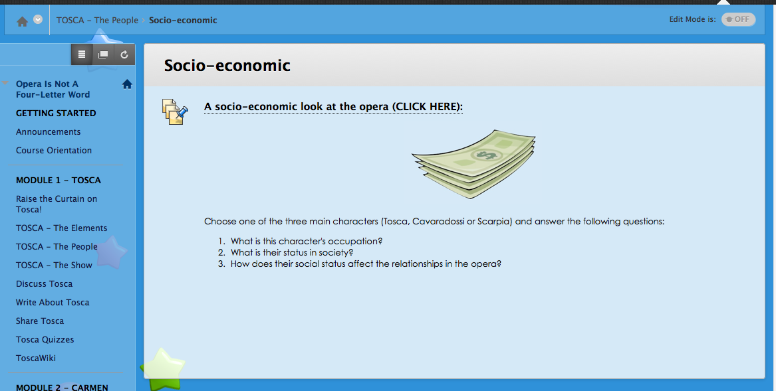
Figure 3.15 - Tosca - Socio-economic Home Page

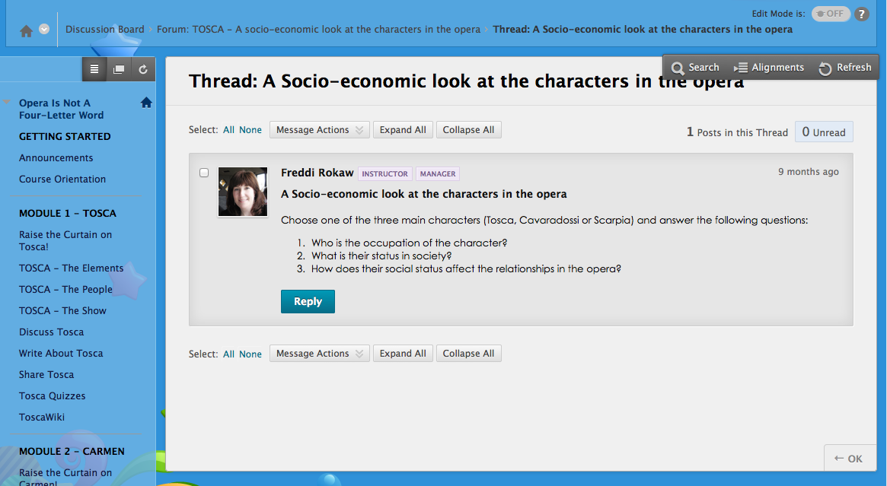
Figure 3.16 - Tosca - Socio-economic Discussion Thread
Tosca - The Show home page provides introduction text giving instructions for how to proceed with the “show” section and states the learning objective. All of the components (Audience Etiquette, Finding a Performance, and Critique) are accessed from this page. This page aligns with Learning Objective 3.0.

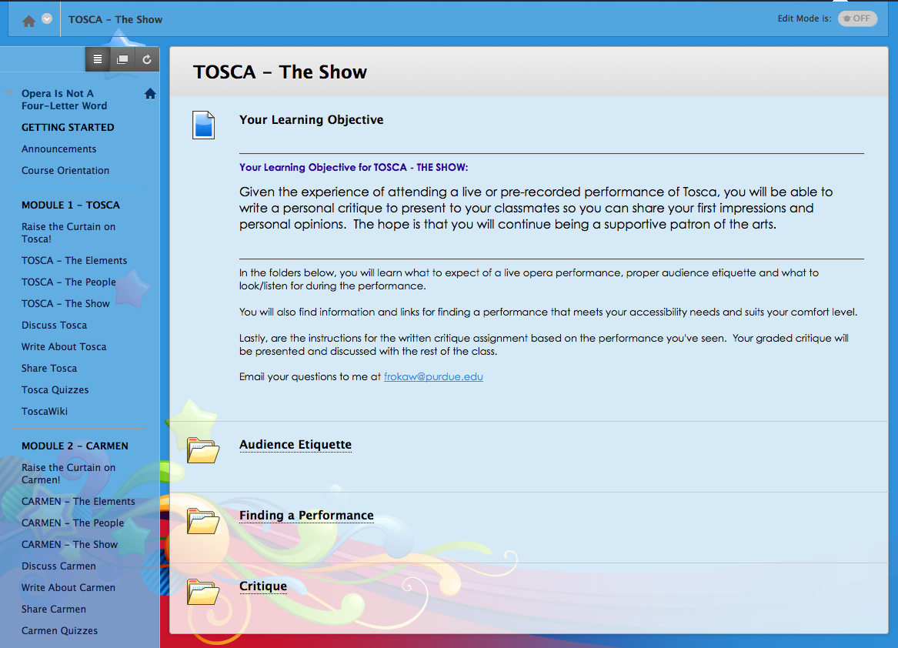
Figure 3.17 - Tosca - The Show Home Page

The Tosca - Audience Etiquette page gives instructions appropriate behavior that is expected when attending a live performance of Tosca. These instructions align with sub-objective 3.1. The assessment for this component is based upon the adherence to these rules of etiquette if they are applicable to the learner’s attendance experience, which aligns with sub-objective 3.1.

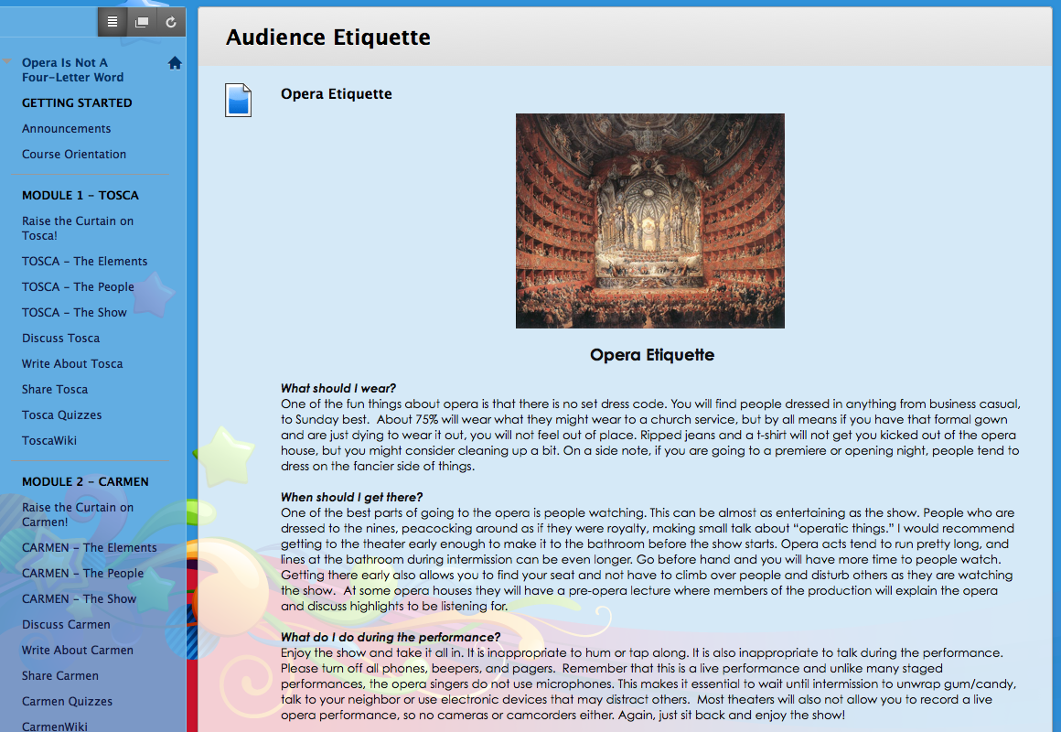
Figure 3.18 - Tosca - Audience Etiquette

The Tosca - Finding a Performance page provides a list of links to famous opera companies where learners can find information about live performances, video on demand, and opera screenings of Tosca. These links will provide information about attending these performances, which is a requirement of the course. These instructions align with sub-objective 3.2. The assessment for this component is based upon the attendance of a performance of Tosca, which aligns with sub-objective 3.2.

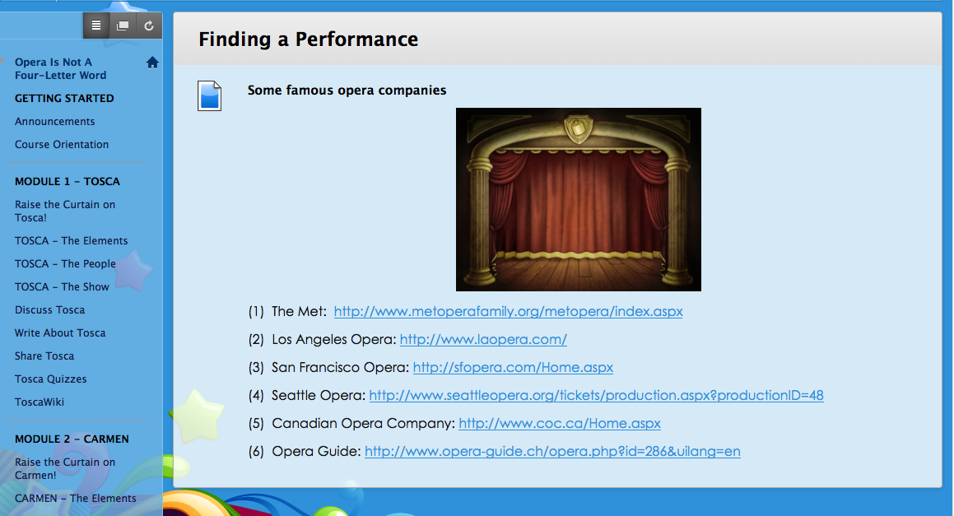
Figure 3.19 - Tosca - Finding a Performance
The Tosca - Critique page provides instructions for the assignment “Write a Critique of Tosca”. These instructions align with sub-objective 3.3. The assessment for this component is based upon the presentation of this critique of Tosca to peers, which aligns with sub-objective 3.3.

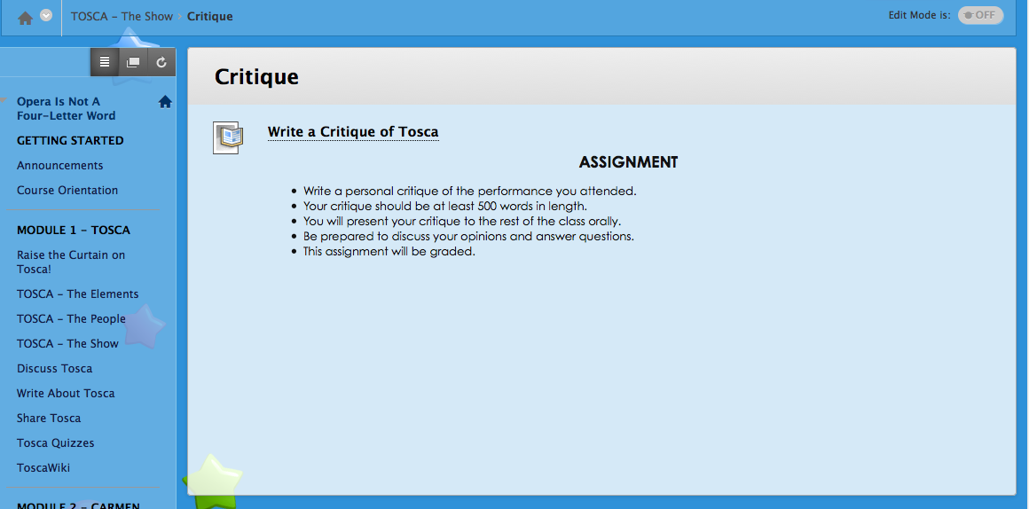
Figure 3.20 - Tosca - Critique page

In addition to the above pages, there will be pages where the learner can centrally access all of the discussions and quizzes for the Tosca Module:
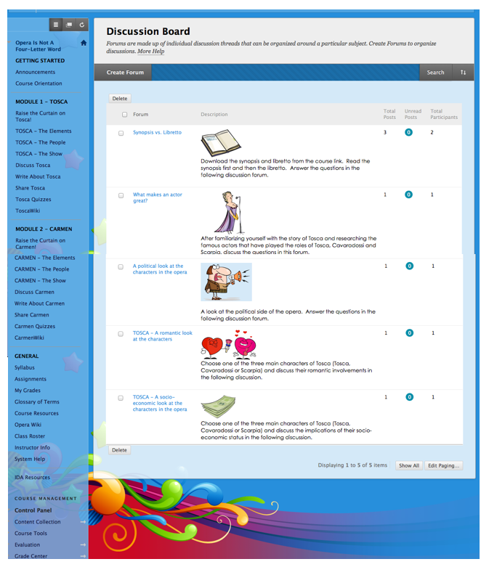
Figure 3.21 - Tosca - Central Discussion Board
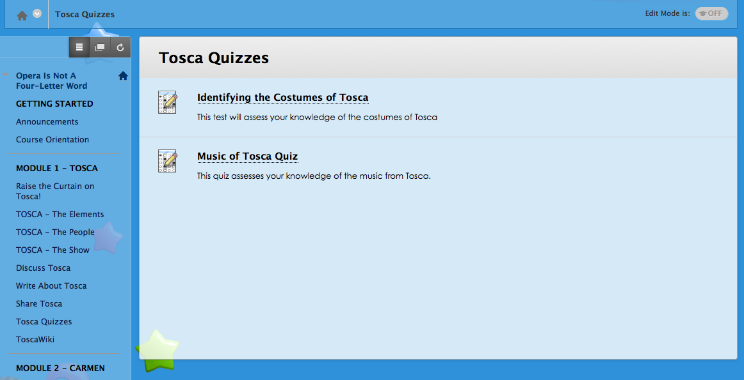
Figure 3.22 - Tosca - Tosca Quizzes page

Lastly, there will be a “ToscaWiki” page. Based on the knowledge they have constructed throughout the course, the students will construct this page. This ToscaWiki will serve as an on-going resource for the course and will not be graded.

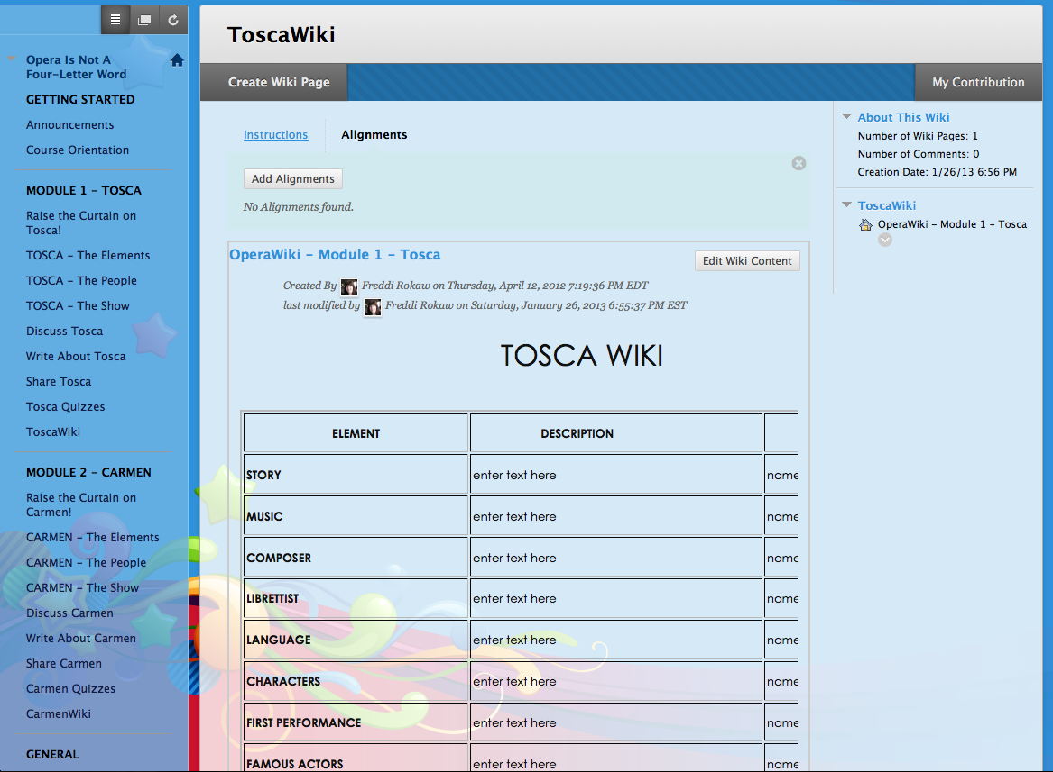
Figure 3.23 - Tosca - ToscaWiki

Carmen
The Raise the Curtain on Carmen! home page gives an introduction to the opera Carmen. It serves to lure the learner into the dramatic opera by encouraging them to read the story, look at a video of the enticing Carmen, and listen to her charming first aria. All files for these activities may be downloaded from the links provided on this page. There is also a request to learners to provide personal background information by emailing the instructor using the provided direct email link.
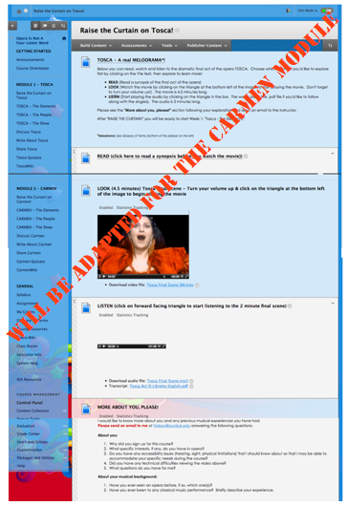

Figure 3.24 - Raise the Curtain on Carmen! page

Carmen - The Elements home page gives an introduction to the opera and sparks the interest right away with a video of the opening scene where the character of Carmen is introduced in the opera. The introduction text gives instructions for how to proceed with the elements section and states the learning objective. All of the components (Story, Music, Acting, Dance, and Costumes) are accessed from this page. This page aligns with Learning Objective 4.0.

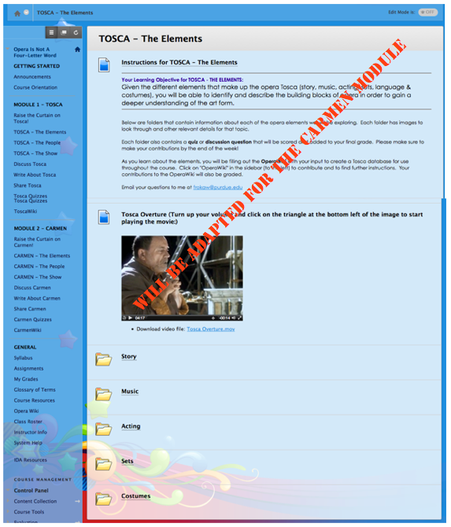
Figure 3.25 - Carmen - The Elements Home Page

Carmen - The Story main page gives instructions for downloading the synopsis and libretto documents, what to read and what to discuss. These instructions align with sub-objective 4.1. Subsequent pages are shown here - the “Synopsis & Libretto Files” page and the discussion forum, which will be used for assessment of this sub-objective 4.1.

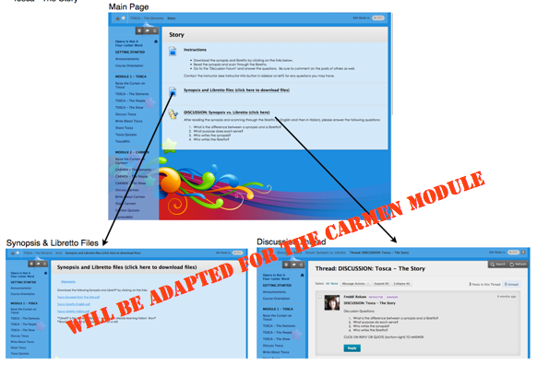
Figure 3.26 - Carmen - The Story Main page, Synopsis & Libretto page, and Discussion Thread page

Carmen - The Music main page gives instructions for downloading the libretto to read, listening to the audio, downloading the transcript of the audio, and for taking the music quiz. There is also a link to the biography of the current guest speaker. These instructions align with sub-objective 4.2. Subsequent pages are shown here - the “Audio Transcript” document, Guest Speaker Biography and instructions and test for the “Music of Carmen quiz” which will be used for assessment of this sub-objective 4.2.

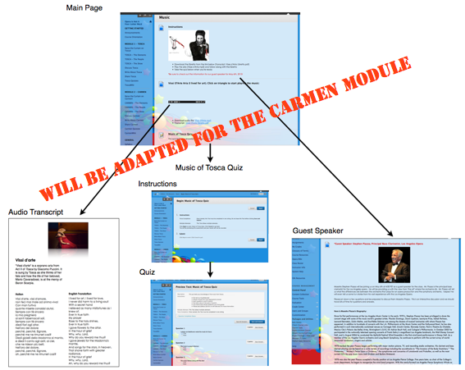
Figure 3.27 - Carmen - The Music Main page

Carmen - The Acting main page gives instructions for watching the acting slideshow, researching famous actors and participating in the discussion forum for this objective. These instructions align with sub-objective 4.3. Subsequent pages are shown here - the page with the acting slideshow and the discussion thread “What makes an actor great?” which will be used for assessment of this sub-objective 4.3.

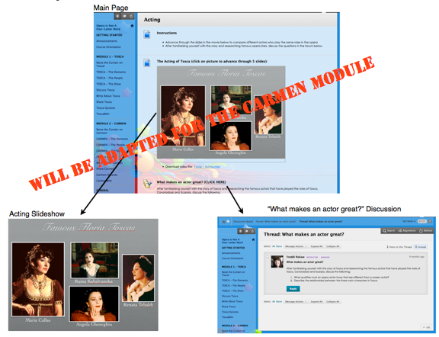
Figure 3.28 - Carmen - The Acting Main page, Acting Slideshow page and Discussion Thread

Carmen - The Dance main page gives instructions for watching the dance movies, researching different kinds of dance used in the opera and taking the dance test for this objective. These instructions align with sub-objective 4.4. Subsequent pages are shown here - the page with the dance movies, instructions for the test and the actual test, which will be used for assessment of this sub-objective 4.4.

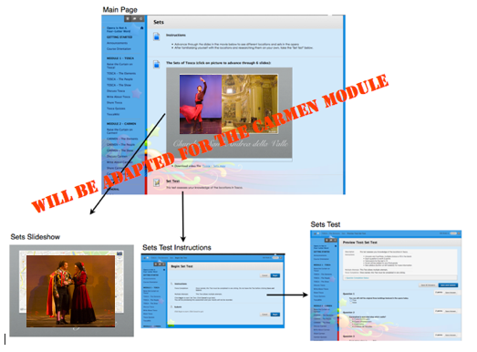
Figure 3.29 - Carmen - The Dance Main page, Dance Movies, Instructions for test, Dance Test

Carmen - The Costumes main page gives instructions for watching the costumes slideshow, researching costumes from different productions of Carmen and taking the costumes test for this objective. These instructions align with sub-objective 4.5. Subsequent pages are shown here - the page with the costumes slideshow, instructions for the test and the actual test, which will be used for assessment of this sub-objective 4.5.

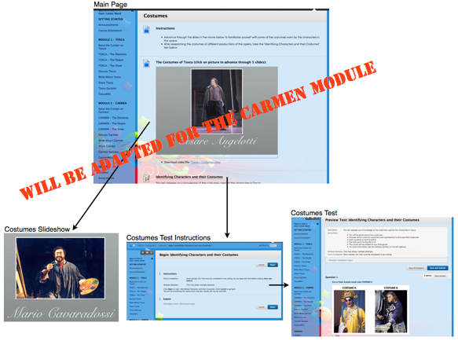
Figure 3.30 - Carmen - The Costumes Main page, Costumes Slideshow, Instructions for test, Costumes Test

Carmen - The People home page gives an introduction to the main character, Carmen, and sparks interest by showing the aria that has her describing her own personal beliefs. The introduction text gives instructions for how to proceed with the “people” section and states the learning objective. All of the components (Politics, Romantic, and Socio-Economic) are accessed from this page. This page aligns with Learning Objective 5.0.

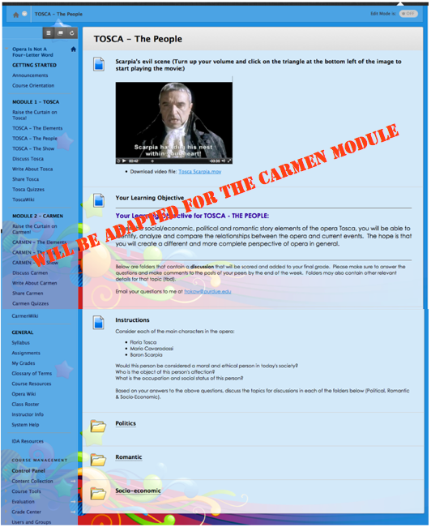
Figure 3.31 - Carmen - The People Home Page

Carmen - The Politics main page gives instructions for considering the moral beliefs of both Carmen and Don Jose. These instructions align with sub-objective 5.1. A subsequent page for the discussion forum is shown here, which lays out instructions for replies. This discussion thread will be used for the assessment of this sub-objective 5.1.

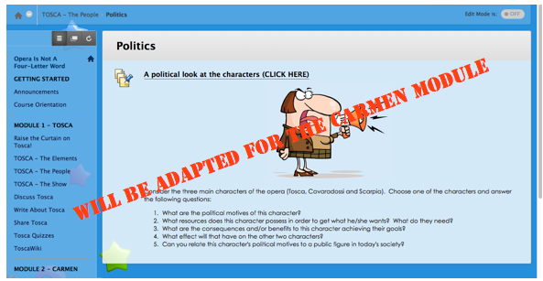
Figure 3.32 - Carmen - The Politics Home Page

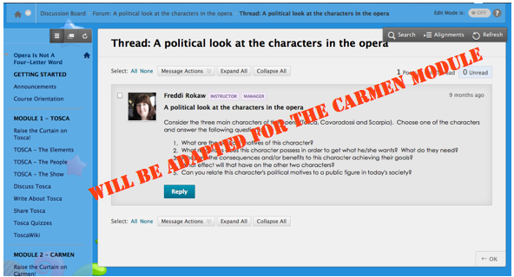
Figure 3.33 - Carmen - The Politics Discussion Thread

The Carmen - Romantic main page gives instructions for considering a romantic look at the main characters in Carmen. These instructions align with sub-objective 5.2. A subsequent page for the discussion forum is shown here, which lays out instructions for replies which involve re-writing the romantic intentions for one of the three main characters. This discussion thread will be used for the assessment of this sub-objective 5.2.

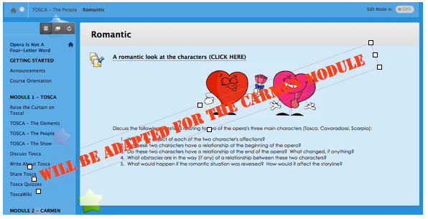
Figure 3.34 - Carmen - Romantic Home Page

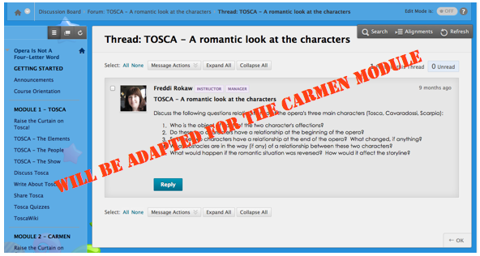
Figure 3.35 - Carmen - Romantic Discussion Thread

The Carmen - Socio-economic main page gives instructions for considering a socio-economic look at the main characters in Carmen. These instructions align with sub-objective 5.3. A subsequent page for the discussion forum is shown here, which lays out instructions for replies. This discussion thread will be used for the assessment of this sub-objective 5.3.

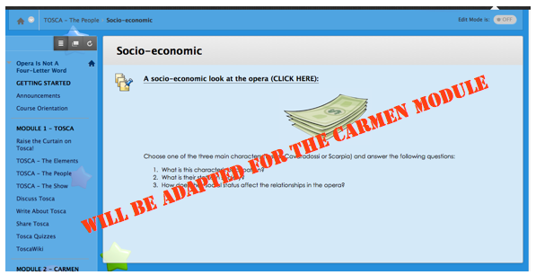
Figure 3.36 - Carmen - Socio-economic Home Page

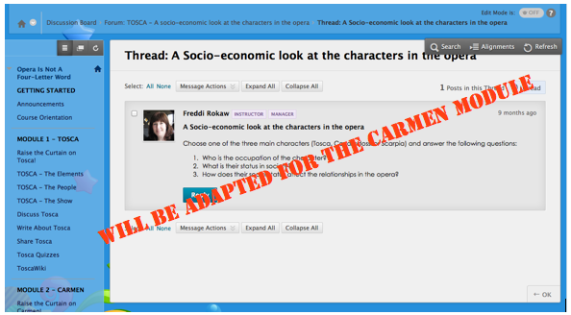
Figure 3.37 - Carmen - Socio-economic Discussion Thread
Carmen - The Show home page provides introduction text giving instructions for how to proceed with the “show” section and states the learning objective. All of the components (Audience Etiquette, Finding a Performance, and Critique) are accessed from this page. This page aligns with Learning Objective 6.0.

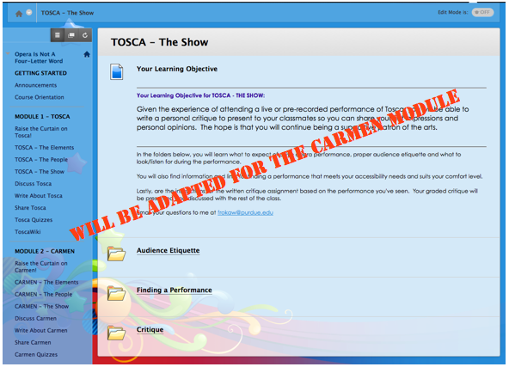
Figure 3.38 - Carmen - The Show Home Page

The Carmen - Audience Etiquette page gives instructions appropriate behavior that is expected when attending a live performance of Carmen. These instructions align with sub-objective 6.1. The assessment for this component is based upon the adherence to these rules of etiquette if they are applicable to the learner’s attendance experience.

Figure 3.39 - Carmen - Audience Etiquette

The Carmen - Finding a Performance page provides a list of links to famous opera companies where learners can find information about live performances, video on demand, and opera screenings of Carmen. These links will provide information about attending these performances, which is a requirement of the course. These instructions align with sub-objective 6.2. The assessment for this component is based upon the attendance of a performance of Carmen, which aligns with sub-objective 6.2.

Figure 3.40 - Carmen - Finding a Performance
The Carmen - Critique page provides instructions for the assignment “Write a Critique of Carmen”. These instructions align with sub-objective 6.3. The assessment for this component is based upon the presentation of this critique of Carmen to peers, which aligns with sub-objective 6.3.

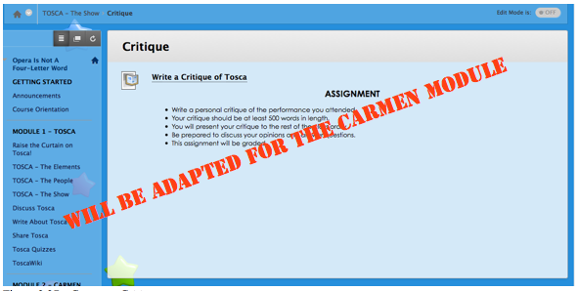
Figure 3.41 - Carmen - Critique page

In addition to the above pages, there will be pages where the learner can centrally access all of the discussions and quizzes for the Carmen Module:

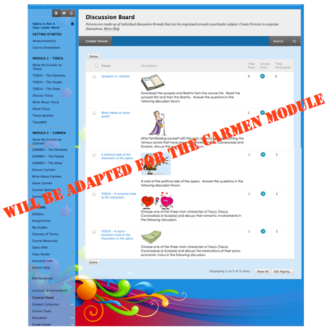
Figure 3.42 - Carmen - Central Discussion Board
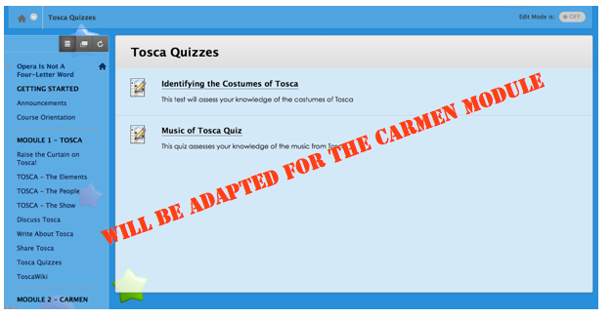
Figure 3.43 - Carmen - Carmen Quizzes page

Lastly, there will be a “Carmen Wiki” page. Based on the knowledge that has been gained throughout the entire course, the students will build this page. This CarmenWiki will serve as an on-going resource for the course and will not be graded.

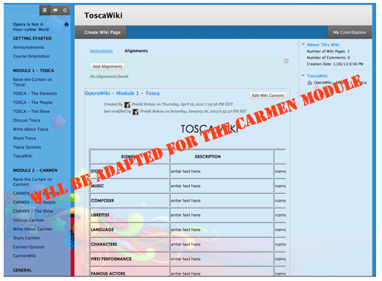
Figure 3.44 - Carmen - CarmenWiki

Overall Comparison
For objective 7.0 - CRITIQUE
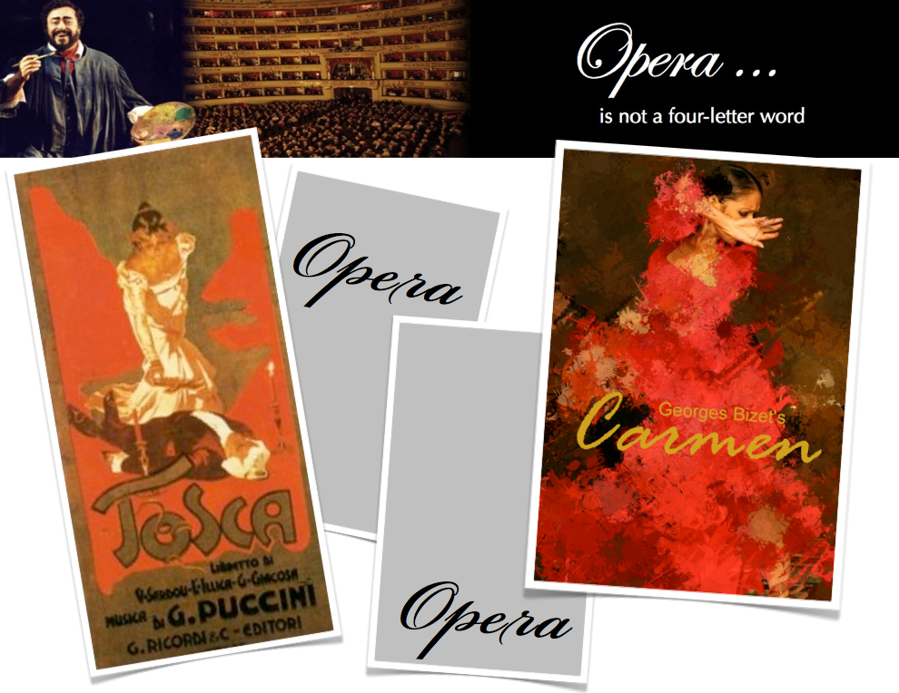
Figure 3.45 - Overall Comparison Main Page

COMPONENTS - objective 7.1
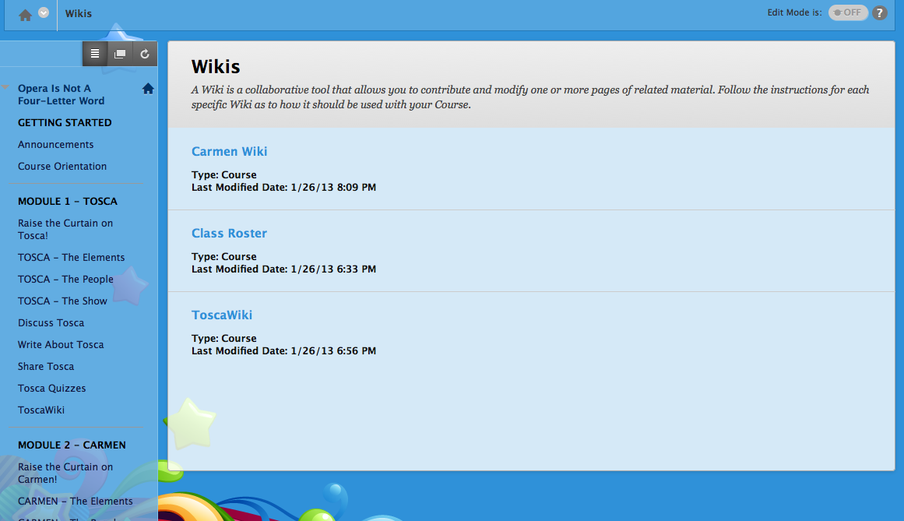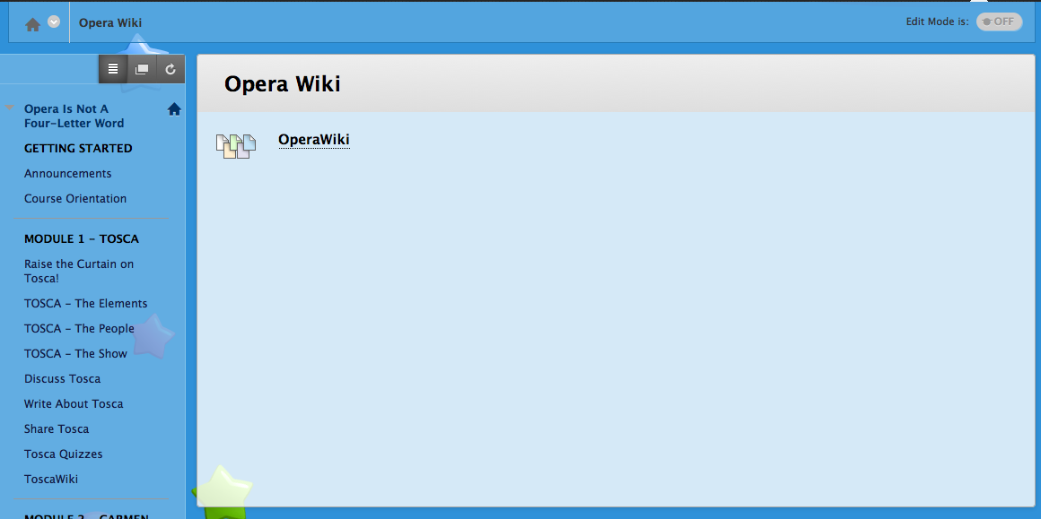
Figures 3.46 and 3.47 - Overall Comparison - All Wikis, Opera Wiki

POLITICS - Objective 7.2
Figure 3.48 - Overall Comparison - Overall Discussion Board

PRESENT - Objective 7.3
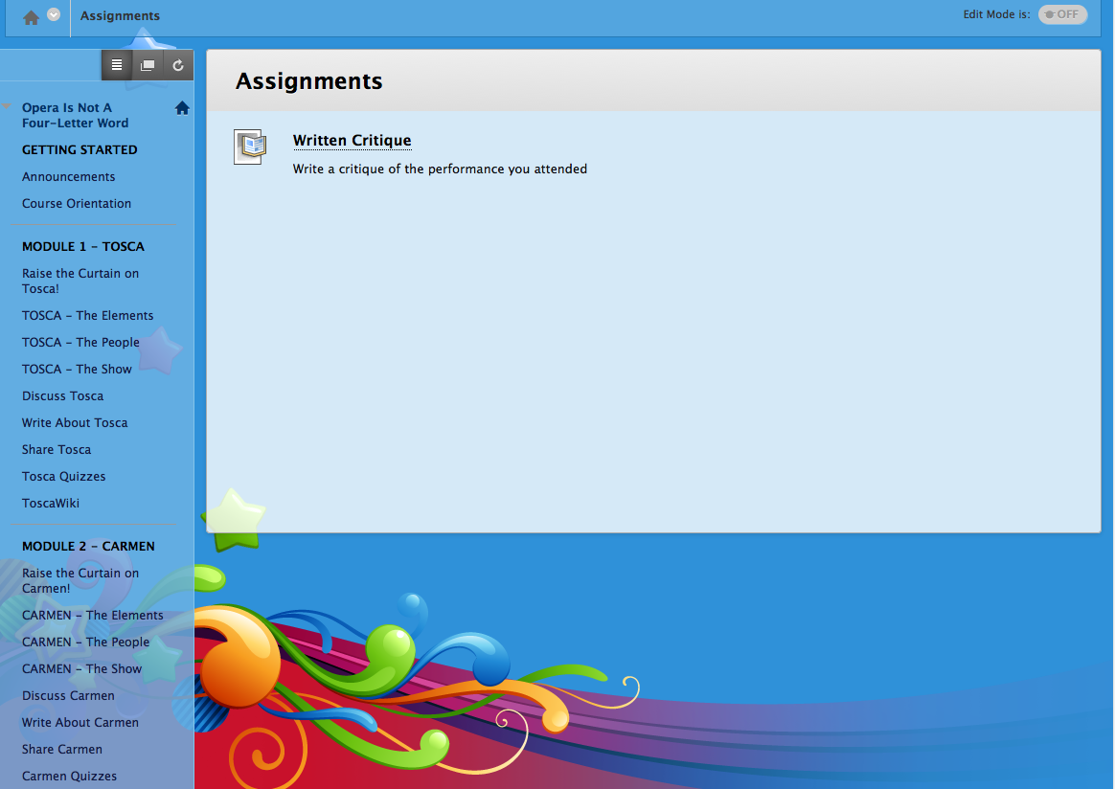
Figure 3.49 - Overall Comparison - Written Critique

Other
The Syllabus page will be displayed on the page as a scrollable image as well as a downloadable .pdf document.

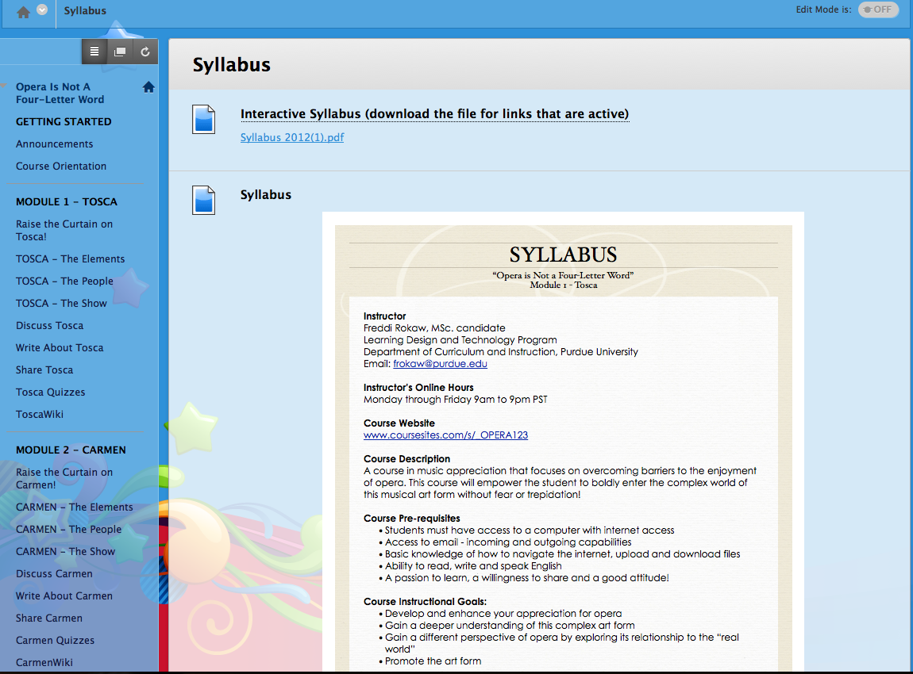
Figure 3.50 - Other – Syllabus (see appendix for full text)

The Glossary page has a list of terms to be used within the course as well as general opera terms.

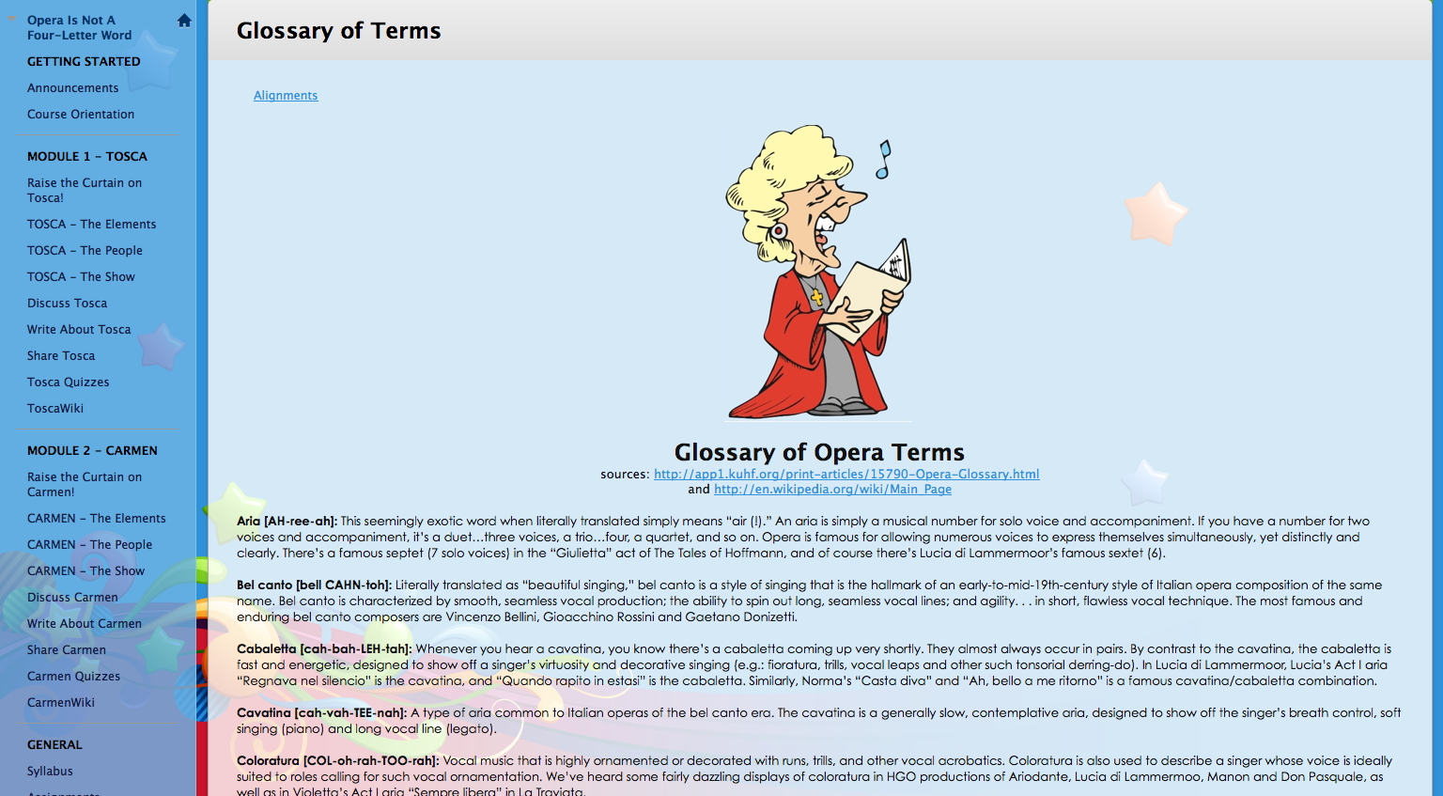
Figure 3.51 - Other – Glossary (see appendix for full text)

The Class Roster page allows space for learners to introduce themselves, thereby beginning a social opportunity to create relationships and form a community of learns from within the class.

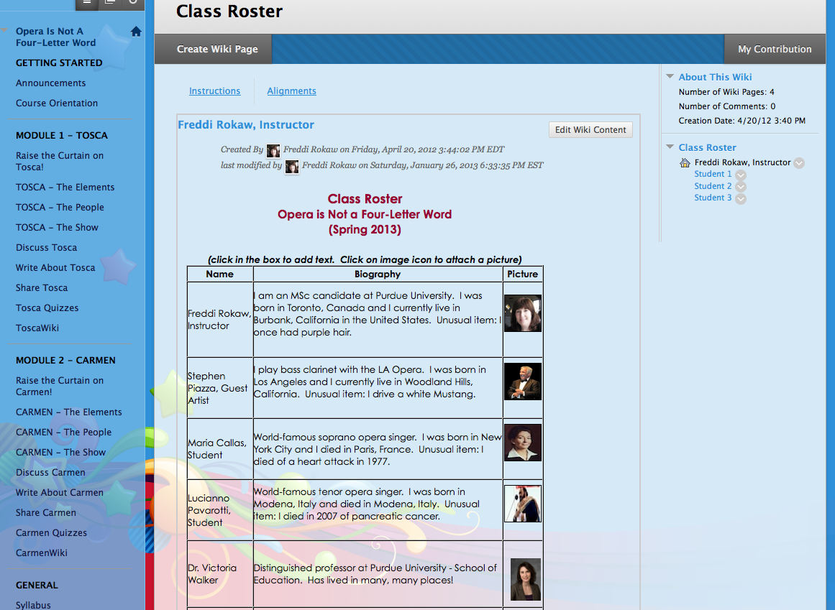
Figure 3.52- Other - Class Roster

The Course Resources page gives links and specifics for books, CDs, DVDs and websites that will be used in the course. Learners can also find links to other useful information here.

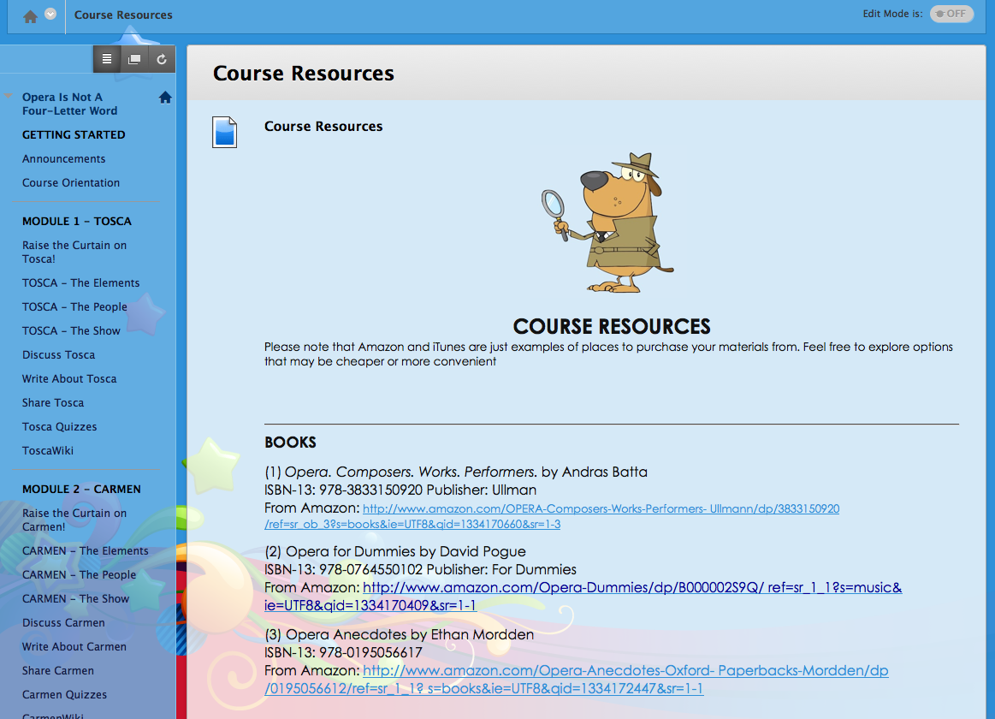
Figure 3.53 - Other - Course Resources (see appendix:“additional resources” for full text)

The Instructor Information page gives contact information, biographical notes, photos and office hours for the instructor, as well as any guest lecturers/artists and other special guests.

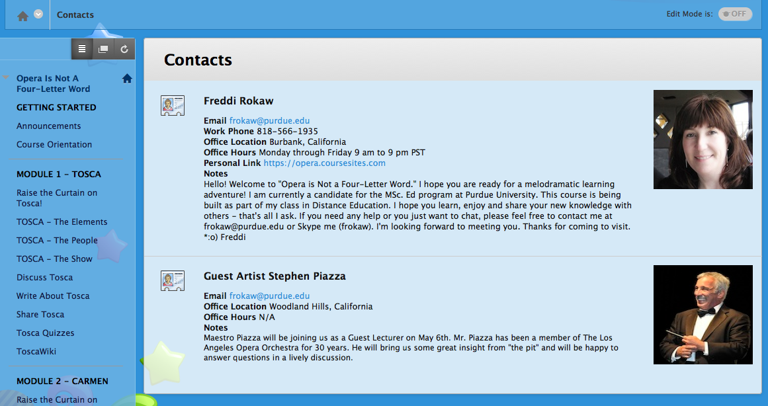
Figure 3.54 - Other - Instructor Info

The System Help page is a link to the Blackboard help system which exists outside of the course content. It also provides news and updates for the learning management system.

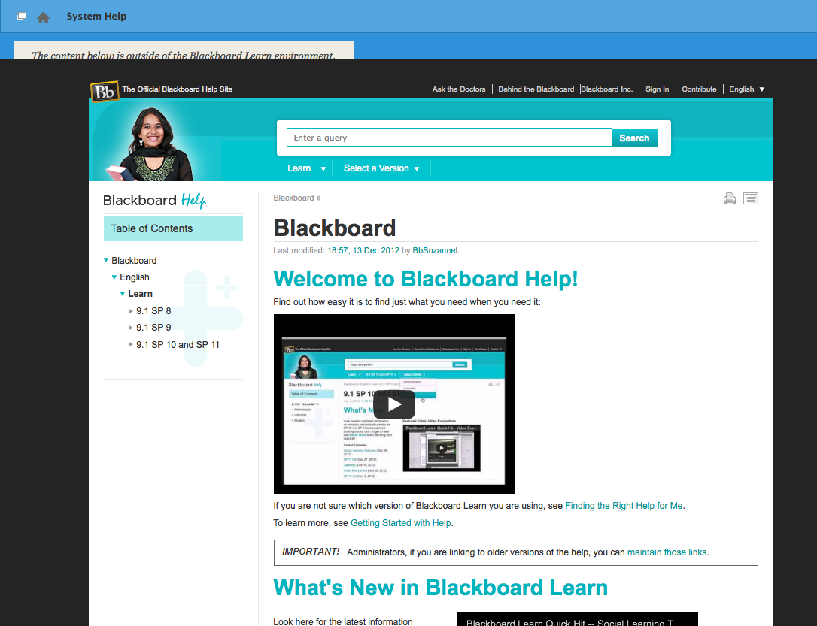
Figure 3.55 - Other - System Help

4. CONTENT

TASK CHARTS
Following is the Task Chart outlining the context and pre-requisite skills for Learning Objective #1.0 (Tosca - The Elements):
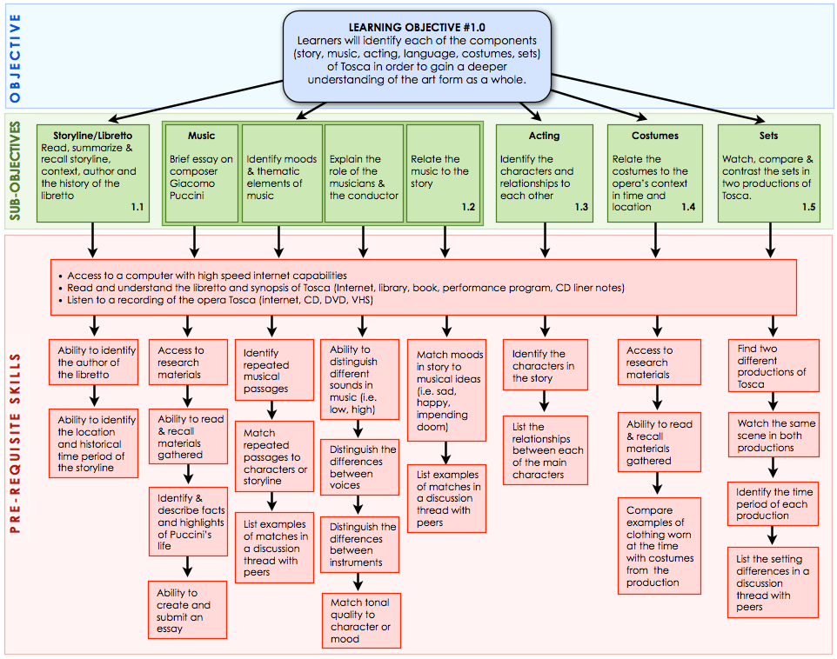
Figure 4.1 - Learning Objective #1.0 (Tosca - The Elements) Task Chart with Pre-requisite skills
See appendix for full-sized chart

Following is the Task Chart outlining pre-requisite skills for Learning Objective #2.0 (Tosca - The People):
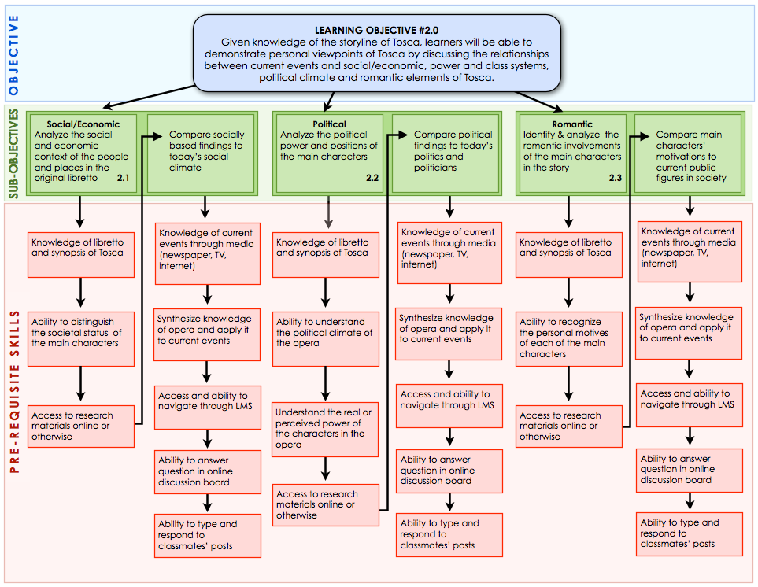
Figure 4.2 - Learning Objective #2.0 (Tosca - The People) Task Chart with Pre-requisite skills
See appendix for full-sized chart

Following is the Task Chart outlining pre-requisite skills for Learning Objective #3.0 (Tosca - The Show):
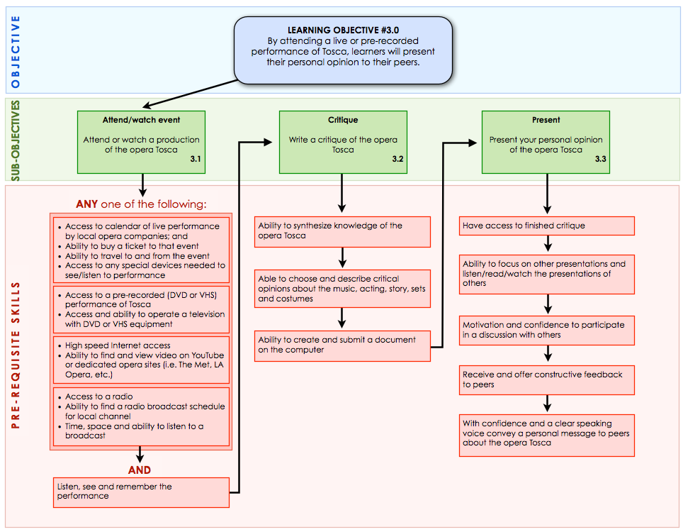
Figure 4.3 - Learning Objective #3.0 (Tosca - The Show) Task Chart with Pre-requisite skills
See appendix for full-sized chart

Following is the Task Chart outlining pre-requisite skills for Learning Objective #4.0 (Carmen - The Elements):
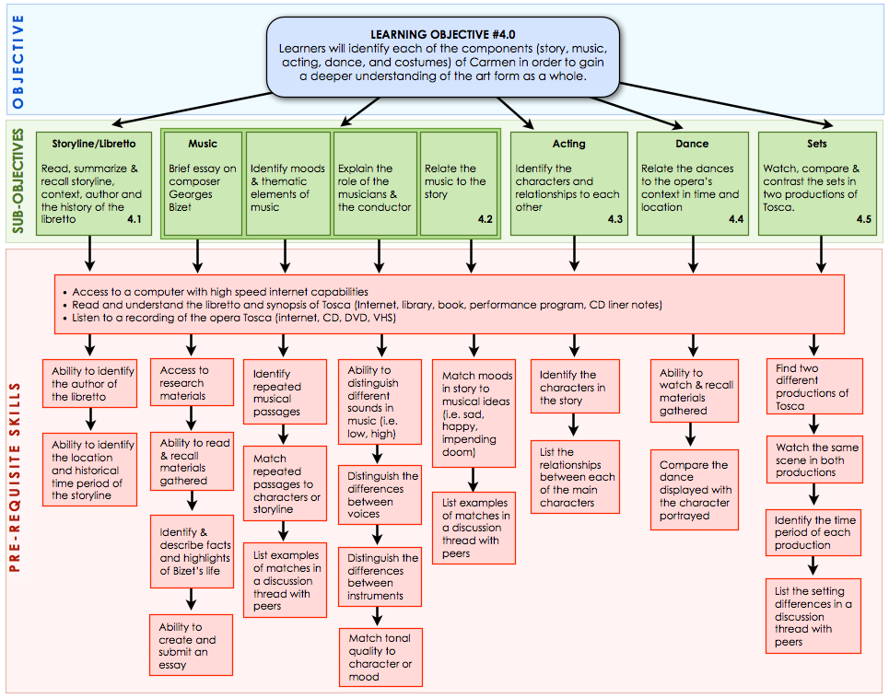
Figure 4.4 - Learning Objective #4.0 (Carmen - The Elements) Task Chart with Pre-requisite skills
See appendix for full-sized chart
Following is the Task Chart outlining pre-requisite skills for Learning Objective #5.0 (Carmen - The People):

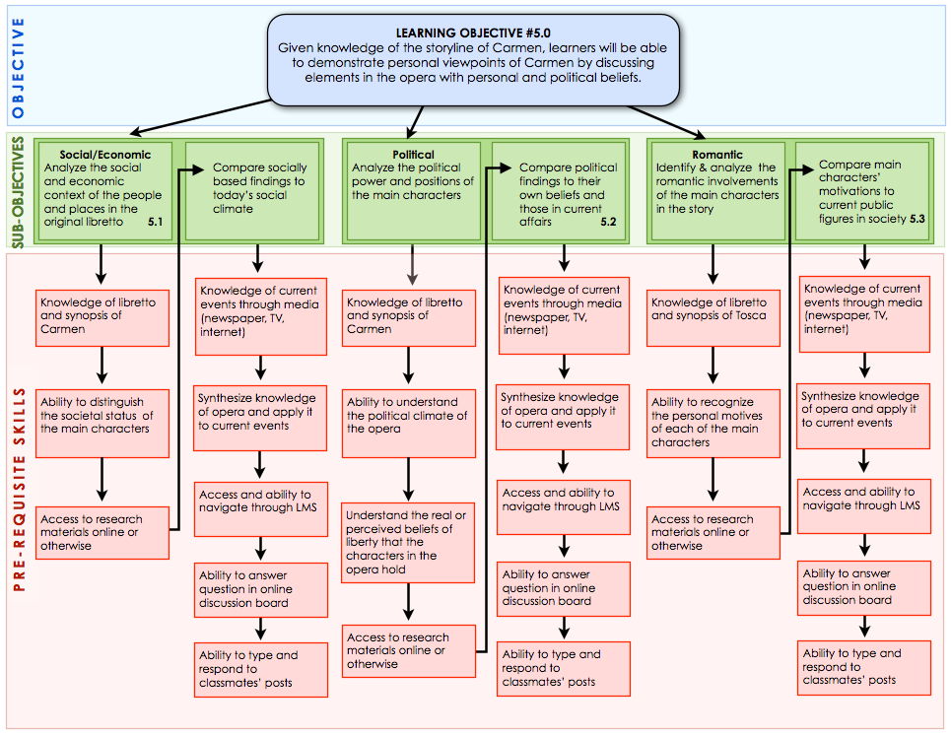
Figure 4.5 - Learning Objective #5.0 (Carmen - The People) Task Chart with Pre-requisite skills
See appendix for full-sized chart

Following is the Task Chart outlining pre-requisite skills for Learning Objective #6.0 (Carmen - The Show):
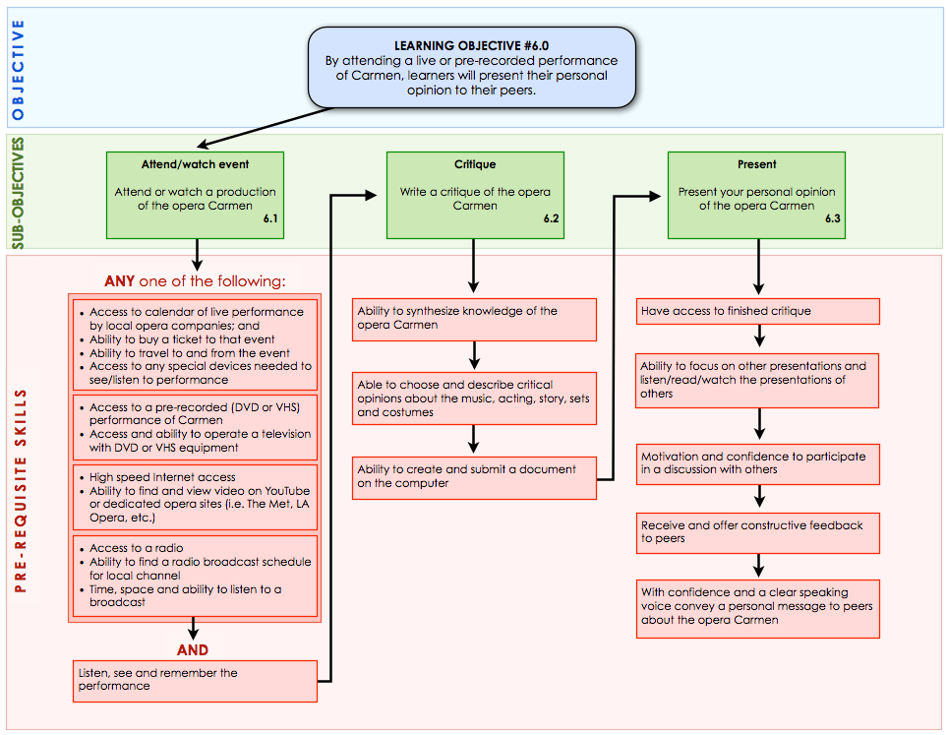
Figure 4.6 - Learning Objective #6.0 (Carmen - The Show) Task Chart with Pre-requisite skills
See appendix for full-sized chart

Following is the Task Chart outlining pre-requisite skills for Learning Objective #7.0 (Overall Comparison):
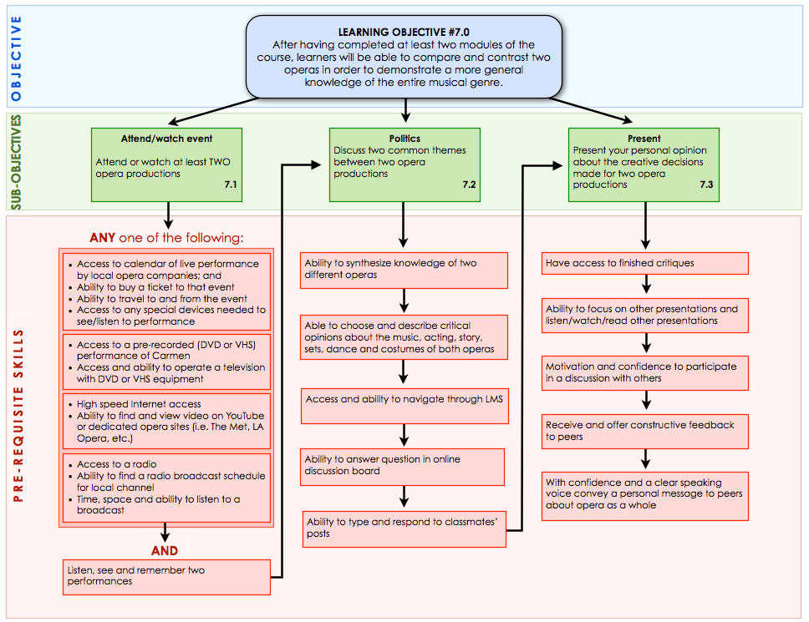
Figure 4.7 - Learning Objective #7.0 (Overall Comparison) Task Chart with Pre-requisite skills
See appendix for full-sized chart

CONTENT SPECIFICATIONS

Content Specifications for Learning Objective #1:
Instructional  Events | Prescription/Instructional Strategy | Final Media Choice | Rationale for Media Choice
Attention | Dramatic video of the final aria at the end of the dramatic storyline will be presented first to spark the learner’s interest. | Embedded (?) YouTube video of final scene of Tosca with Angela Gheorghiu & Alagna: http://www.youtube.com/watch?v=n6kTmWYIAcw&feature=youtube_gdata_player  AND  Embedded (?) YouTube video of final scene of Tosca with Domingo & Kabaivanska:  http://www.youtube.com/watch?v=8XBGeXVnfNA | - It’s only 4 minutes long to avoid cognitive overload  - Dramatic, romantic and well produced, so easy to identify personalities of character  - Classic production, sets and costumes for easy identification of elements  - Beautiful people, superior acting and singing for intrigue & drama, so it should motivate the learner to watch (and not scare them)  - Domingo version has the subtitles for those not familiar with the opera  - The Domingo version setting is authentic – filmed at the actual Castel Sant'Angelo  - Domingo version is also available for purchase as a DVD for offline viewing
Purpose of attention getter | To lure the learner into the intrigue of the story and motivate their curiosity to find out whom the characters are and how the story develops. | See above | See above
Interest/motivation | Presenting the dramatic end of the storyline first will add intrigue and heighten curiosity. | See above | See above
Preview | - Read, summarize & recall the storyline  - Identify moods in the music & themes  - Compare costumes to modern dress in Rome in the 1800’s | - A downloadable .pdf and a graphic image in LARGE PRINT with the storyline and actual words from the libretto (to follow along with the video)  - Link to http://www.metoperafamily.org/metopera/history/stories/synopsis.aspx?id=25 for the Met’s opera synopsis  - CD or DVD liner notes | - .pdf documents can be printed, highlighted and images of documents can be made large for learners that might have vision loss  - The printed word will be a supplement to any aural issues with the video  - Printed libretto will show characters & related dialogue in multiple languages and organized as the music  - Synopsis gives a general overview of the story line – usually only read once
Prior Knowledge | - No previous knowledge of opera required  - Learners have basic computer skills, can type and navigate the internet  - Command of the English language (writing, reading, speaking, listening & understanding) | Getting started on Blackboard Learn? Perhaps links to the Blackboard help, but hopefully more organized and tailored to the learners’ needs. Icons must make sense and be universal. | Help functions need to be accessible from all levels of the LMS. It will be important that the different KINDS of help can be differentiated – based on representative icons
Information & Examples | - Read, summarize & recall the storyline  - Identify moods in the music & themes  - Compare costumes to modern dress in Rome in the 1800’s | - Links to online & downloadable versions of libretto & synopsis http://www.metoperafamily.org/metopera/history/stories/synopsis.aspx?id=25  - Links to resources (i.e. http://www.metoperafamily.org/metopera/index.aspx)  - Suggested reading list of textbooks (list):  - Opera for Dummies by David Pogue  - 100 Great Operas And Their Stories: Act-By-Act Synopses by Henry W. Simon  - OPERA: Composers. Works. Performers by Ullman | - .pdf documents can be printed, highlighted and images of documents can be made large for learners that might have vision loss  - The printed word will be a supplement to any aural issues with the video  - Printed libretto will show characters and their related dialogue in multiple languages and organized as the music is  - Synopsis gives a general overview of the story line – usually only read once  - Books, textbooks and etextbooks can be used asynchronously, kept for reference and annotated.
Attention | Attention will be gained and maintained by incorporating visual and musical examples that relate to the storyline. | - .mp3 sound bites that are related to the characters’ themes  - Images of costumes and maps in 1800’s Rome  - .mp3 samples of moods – horror, love, power, religion, death  - Guest artist musician by video conference (live and recorded for later reference) – Steve Piazza, bass clarinet Los Angeles Opera | - One of the most prominent elements of opera is the music. Sound bites from .mp3 files are most accessible and are the best way to realize an aural experience  - Chunking the audio samples into specific “bites” avoids cognitive and aural overload  - An interview with a guest artist will add the reality and localization to interaction for motivational effect.
Learning Strategies | By using inquiry-based collaborative knowledge construction, learners will identify and contribute written and/or visual descriptions of their findings to an OperaWiki, building an online database of components accessible to the entire class for the duration of the course. | Blackboard Learn’s Wiki pages | - Bb’s wiki pages are already within the established learning environment – just another component  - All have access  - Collaboration is implicit
Summarize & Review | Learners will be able to deconstruct, discuss and identify the components that go in to making the whole art form of opera in general. | Discussion forum on Blackboard Learn’s LMS | - To learn from peers  - Ongoing feedback from peers  - Guided instruction and inquiry from facilitator  - Asynchronous interaction opportunities
Transfer | Given the identification of all the components of an opera, learners will be able to distinguish the unique qualities of each component as it relates specifically to the opera Tosca. | Discussion forum on Blackboard Learn’s LMS | - To learn from peers  - Ongoing feedback from peers  - Guided instruction and inquiry from facilitator  - Asynchronous interaction opportunities
Remotivate/ Close | Given the knowledge of the components of an opera, learners will be able to compare unique and similar qualities between two or more different productions of the same opera. | Any two of the following videos, or whatever resources the learner already has on hand (DVD, broadcast, etc.), has accessibility to (an actual full performance) or can find:  http://www.youtube.com/watch?v=tj_SDOAM3_A  http://www.youtube.com/watch?v=n6kTmWYIAcw&feature=youtube_gdata_player  http://www.youtube.com/watch?v=8XBGeXVnfNA  http://www.youtube.com/watch?v=ePf-oaAlZwI (at 3:50)  http://www.youtube.com/watch?v=IhDGlNG_Fow  http://www.youtube.com/watch?v=dIwdILRjSgM | - Found resources can be shared  - Different videos of various productions will present unique artistic styles, direction, acting, singing, costumes, sets, and even languages (one of the videos is in English and one has Japanese sub-titles)
Assess Performance | - Weekly grades will be given for participation and quality of responses in discussion forums.  - Quizzes will be used throughout the course to identify correct vs. incorrect samples for each component to assess learner accuracy and knowledge.  - An overall grade will be given for this objective based on the learner’s knowledge and ability to identify and discuss components. The test will occur at the end of the topic. | - Online quiz through Blackboard learn  - Discussion forums  - Test online | - The quizzes and tests on Blackboard Learn are already within the established learning environment – just another component  - Already incorporated into the existing grading system
Feedback/ Remediation | Feedback will be given from the instructor at the end of each week of relevant instruction. | Feedback from the instructor will be provided through the grading center in Blackboard, video chats or email, depending on what the learner prefers and is most comfortable with. | Giving the learner options as to the method of feedback adds to the ownership experience of the learner and puts them more at ease.
Table 4.8 – Content Specifications for Learning Objective #1

Content Specifications for Learning Objective #2:
Instructional  Events | Prescription/Instructional Strategy | Final Media Choice | Rationale for Media Choice
Attention | Dramatic video of Scarpia’s aria that passionately elucidates this powerful man’s thirst for power, lust for Tosca and lack of scruples. | Embedded (?) YouTube video of scene in which Scarpia lusts over Tosca while in the church. The dichotomy of his evil while the music of the catholic mass is taking place is a wonderful and intriguing contrast in emotions.  Domingo & Kabaivanska version: http://www.youtube.com/watch?v=jeEbVnsY4MQ  Or the Gheorghiu version:  http://www.youtube.com/watch?v=jm02AkKkCcs&feature=results_video&playnext=1&list=PL025F1B4594F7679C  AND:  .mp3 file of the aria that will be embedded on the website. This aural only version will be less distracting and more pure in form to the video version. The sounds of church organs in the church background while Scarpia plans and describes how he will have his way with Tosca is actually quite disturbing. | - Videos are four minutes long to avoid cognitive overload  - Same productions as the ones from objective #1, so learners are familiar with the production, actors, etc.
Purpose | The shock factor of the aria will create intrigue, show unscrupulousness of characters and spark curiosity as to what actions the characters (specifically Scarpia) might take to get what he wants. | See above | See above
Interest/ motivation | - Discover the internal passions and motivation of each of the characters, their values, passion for power and romantic ideals.  - Learn the interplay between these values and relationships what affect they have on each other | - A downloadable .pdf and a graphic image in LARGE PRINT with the storyline and actual words from the libretto (to follow along with the video and music)  - .pdf and link to: http://www.metoperafamily.org/metopera/history/stories/synopsis.aspx?id=25 for the Met’s opera synopsis  - Synopsis can also be obtained from any other source available to the learner  - Liner notes from CD or DVD | - pdf documents can be printed, highlighted and images of documents can be made large for learners that might have vision loss  - The printed word will be a supplement to any aural issues with the video  - Printed libretto will show characters and their related dialogue in multiple languages and organized as the music is  - Synopsis gives a general overview of the story line – usually only read once
Preview | - Discuss the characters in the opera and predict their fate at the end of the story  - Recall and summarize the political history and economic climate of Rome in the early 1800’s | Discussion forum on Blackboard Learn’s LMS | - To experience many different perspectives & ideas  - Ongoing feedback from peers  - Guided instruction and inquiry from facilitator  - Asynchronous interaction opportunities
Prior Knowledge | - Prior knowledge of the storyline and libretto of Tosca  - Able to identify the characters in the story  - Knowledge of current affairs | - Reference back to previous discussions and course content through LMS  - Current affairs to be obtained through whatever media are most comfortable and accessible to the learner. Traditional newspaper, digital news, Internet, radio, television or conversation. | Ownership of previous knowledge and collaborative construction based on information database built by class from previous week(s) of discussions and OperaWiki
Information & Examples | - Discuss the motivations of the characters in the opera  - Recognize and discuss the interplay between characters based on their personal motives and socio-economic status  - Compare similarities and differences in today’s political climate in the U.S. with that of Europe in the 1800’s | Discussion forum on Blackboard Learn’s LMS | - Interactivity with and learning from peers  - Any place, any time asynchronous learning  - Guided discussion questions  - Feedback from instructor  - Feedback, questions and further discussion topics from peers
Attention | - Predict the fate of each of the characters  - Applying their varied life experience in matters of love, power and beliefs will allow learners to compare their own values to the scenarios of characters in the opera | - I don’t know if there is a way, but I would like to have jigsaw-like pieces of a puzzle, an interactive flow chart, e-book or movie that would allow the learner to pick pieces of a story and re-arrange them into a complete storyline for each character  - Guided discussion with given questions in the LMS discussion forum | - This would be a completely interactive, but still guided in that the “pieces” would be provided, but the final arrangement would be a creation of the learner. It would open possibilities for their creativity  - Discussion forums would provide asynchronous interactivity with from peers  - Opportunity to learn from and be inspired by peers  - Feedback in discussion
Learning Strategies | - By using inquiry-based learning to create discussions, the learners will discuss how they might personally deal with similar situations as the characters (role-play)  - Using the Constructive and CIP learning theories, the instructor will build scenarios for learners to synthesize their knowledge of character motivation with personalities in today’s current events | - Specific discussion questions for teams divided by characters in the opera to have an online debate in the LMS discussion forum regarding their personal judgments and opinions  - Discussion forum in Blackboard LMS to apply character motivation with today’s public personalities | - Collaboration between peers to create a body of experiences (database) based on personal opinion and life-experience  - Discussion forum will allow learners to provide real-world examples to each other, which will create connections with characters and story lines in the opera
Summarize & Review | - Differentiate the motivations of each of the characters in discussion  - Apply knowledge of character motivation to compare with examples in today’s current events and public figures | Discussion forum on Blackboard Learn’s LMS | - To learn from peers  - Ongoing feedback from peers  - Guided instruction and inquiry from facilitator  - Asynchronous interaction opportunities
Transfer | Learners will be able to successfully compare and contrast examples of people in today’s society with characters in the opera. | Discussion forum in Blackboard LMS | - Discussion forum will allow learners to provide real-world examples to each other, which will create connections with characters and storylines in the opera
Remotivate/ Close | Learners will be able to create a fictional new ending for the opera and share it with their peers in a discussion. | In the LMS discussion thread, the learners would thread together a new story - by alphabetically (for example) writing about an event, then someone taking over for the next person to tie together the next event. | Collaborative, intrigue, surprise, dependency on each other, motivation, peer pressure.
Assess Performance | Learners will conduct a self assessment at the end of the module based on their ability to identify, analyze, compare and synthesize their knowledge of the social, economic, political and romantic elements of Tosca. | Reflective essay submitted to the assignments area of the LMS to recall what has been learned and describing the highlights and surprises in the learning experience | Time to think about and reflect offline while writing a reflective essay  Time and notice will be given to learner to ensure responsibility for accuracy and ownership of information
Feedback/ Remediation | Feedback will be given from the instructor at the end of each week of relevant instruction. | Feedback from the instructor will be provided through the grading center in Blackboard, video chats or email, depending on what the learner prefers and is most comfortable with. | Giving the learner options as to the method of feedback adds to the ownership experience of the learner and puts them more at ease.
Table 4.9 – Content Specifications for Learning Objective #2

Content Specifications for Learning Objective #3:
Instructional  Events | Prescription/Instructional Strategy | Final Media Choice | Rationale for Media Choice
Attention | Anecdotes from live performances of Tosca throughout the years. (Specifically, a famous performance when Tosca jumps off the castle wall at the end of the opera and, being rather large, visibly bounces back up from the safety net placed behind the set much to the shock of the audience!) | Links to readings on the internet:  http://www.coc.ca/PerformancesAndTickets/1112Season/Tosca/EssaysAndFurtherReading/ActionPackedTosca.aspx  http://opera.stanford.edu/Puccini/Tosca/backgd.html  http://operaspoofa.wordpress.com/opera-anecdotes/  http://blog.al.com/entertainment-press-register/2011/03/tosca_mobile_opera_stages_pucc.html  Sources can also come from textbooks on suggested reading list and found sources | The best we can do is to read about the experiences other people have reported for accidents that have happened during production. No videos publicly exist for mistakes in production (out-takes, bloopers).
Purpose | Anything can happen during a live performance - good or bad. No matter what performance they choose, the situation will be unique to every production and every audience. | See above. | See above.
Interest/ motivation | This is the culmination of the learning that has gone on from the beginning of the course, where learners can apply their knowledge to an actual performance. Whatever happens, the learner will own that experience personally. | - Attendance of a live performance of Tosca  - And/or watching an entire performance on DVD, in a movie theatre, on TV or listening to a CD or radio broadcast | Will be individual, based on learner’s ability to attend a performance
Preview | - Identify the qualities of a respectful audience  - Clarify what to listen for, look for and remember  - Write a critique  - Present critique to class  - Discuss in a forum | - How to behave at an opera: http://www.ehow.com/how_2050029_behave-opera.html  - What to expect: http://listverse.com/2007/11/03/top-10-tips-for-your-first-opera-or-ballet/  - Classical audience etiquette: http://www.camasb.org/yad/yad-etiquette.shtml  http://www.operapacifica.org/pg_oracle.htm  http://bryce-westervelt.suite101.com/opera-etiquette-101-a12243  - Discussion forum on LMS  - Assignment folder on LMS  - Face-to-face or recorded presentation of critique  - Video conference chat for post-critique discussion http://www.skype.com/ | - Website links are for reference only  - Use LMS for threaded discussion and for submission of critique assignment  - This meeting will be the last meeting of the module and an opportunity for summary of the Tosca, real interaction and feedback  - Video conference (Skype) or face-to-face discussions for real-time conversations
Prior Knowledge | - Knowledge of the setting and storyline of the opera Tosca  - Knowledge of the characters, their motivations, social status and romantic entanglements | Based on previous knowledge and resources from the course – notes, databases, discussions, books, CD, DVD, etc. | Previous knowledge provides for ownership of learning, familiarity with content and connections
Information & Examples | - Find and choose a live, broadcast or pre-recorded performance to attend  - Compare actual performance to previous expectations  - Present a critique of personal impressions of the performance the learner | - Written notes and critique in essay form to be submitted through the Assignments on LMS  - Face-to-face or video conferenced presentation of critique | - Assignment module on LMS is connected to the grading system  - Face-to-face and video conferencing environments are real time, highly interactive and conducive to giving and receiving feedback
Attention | - Listen for musical themes and moods, languages and singing.  - Identify highlights and key points of acting, stage direction, costumes, sets and venue (if applicable).  - Remember the above plus storyline deviations, setting and audience reactions. | - Attendance at a live performance of Tosca  - And/or watching an entire performance on DVD, in a movie theatre, on TV or listening to CD or radio broadcast | Live attendance is best because the experience is unique to the learner – learner owns the experience.
Learning Strategies | The Constructivist theory of learning will be used because the learners will be creating their own experience while attending a performance and sharing their critique with classmates. | Discussion after presentation of critiques will build indirect experiences for all learners | Collaboratively build a collection of information from the experience of others
Summarize & Review | - Review the printed program  - Discuss personal opinions with classmates that have attended the same or other versions of Tosca | Face-to-face meeting or video conferencing with Skype: http://www.skype.com/ | Collaboratively build a collection of information from the experience of others
Transfer | - Recall the highlights and key moments in the performance plus any unexpected occurrences  - Able to create personal opinions based on the identification of specific elements in the performance | Live summary discussions | Face-to-face and video conferencing environments are real-time, highly interactive and conducive to giving and receiving feedback
Remotivate/ Close | - Explore availability of other operas to attend/watch  - Create a plan to attend/watch another opera | Local opera websites for season calendars (for example): http://www.laopera.com/tickets/pdf/12-13_calendar.pdf  http://www.metoperafamily.org/metopera/season/calendar.aspx)  Live HD Movie broadcast schedules:  http://www.metoperafamily.org/metopera/liveinhd/LiveinHD.aspx  Viewing on demand:  http://www.metoperafamily.org/ondemand/index.aspx  Satellite Radio:  http://www.siriusxm.com/metropolitanopera  Radio Broadcasts:  http://www.metoperafamily.org/metopera/broadcast/hd_events_template.aspx?id=16946 | - Choices of viewing/listening options based on accessibility, interest and availability.  - Incentive to explore different productions, costs and choices of venues
Assess Performance | - A grade will be given for the participation in discussions with others and quality of challenges made  - An overall grade will be given to assess the written critique of the opera  - Extra points will be given to those that show research and a plan to attend or watch another opera | - LMS Grading system for critique assignments and overall grades  - Email or phone for more specific details if needed/desired | - Learner can view grades any time, any place  - Flexibility of private and public feedback for student and facilitator
Feedback/ Remediation | Feedback will be given from peers during the week of instruction and from the instructor at the end of each week. | Feedback from the instructor will be provided through the grading center in Blackboard, video chats or email, depending on what the learner prefers and is most comfortable with. | Giving the learner options as to the method of feedback adds to the ownership experience of the learner and puts them more at ease.
Table 4.10 – Content Specifications for Learning Objective #3

Content Specifications for Learning Objective #4:
Instructional  Events | Prescription/Instructional Strategy | Final Media Choice | Rationale for Media Choice
Attention | Dramatic videos of Carmen’s opening aria (“Habanera”) and one cartoon of the overture will be shown on the from three different versions of the opera. This will spark the learner’s interest in the opera by having the learner make immediate connections with the familiar music and timeless story. | Embedded video clip of the opening scene of The Met production of Carmen with Elina Garnaca & Roberto Alagna (temporary YouTube video): http://www.youtube.com/watch?v=OV-ZfCWM3qo  AND  Embedded video clip of the opening scene of Carmen Jones with Dorothy Daindridge and Harry Belafonte. (temporary YouTube video): http://www.youtube.com/watch?v=xO5udGCZ3Yo  AND  Embedded video clip of the opening scene of Carmen - A Hip Hopera with Beyonce and Mekhi Pfifer. (temporary YouTube video): http://www.youtube.com/watch?v=Zo-aZUjXV8k  AND  Embedded video clip of a Tom & Jerry cartoon of an orchestra performing the overture to Carmen: http://www.youtube.com/watch?v=TbnSYQX2Pmw | - Videos are only 5 minutes long to avoid cognitive overload  - Dramatic and well produced, so easy to identify personalities of the characters  - Similar characters in different productions, for easy identification of elements  - Beautiful people, superior acting, and singing for intrigue & drama, so it should motivate the learner to watch  - The classic Met version is sung in French but has subtitles for those not familiar with the language or opera  - The Carmen Jones version is in English and has characters the learners can relate to. The setting is authentic but dated. DVD is available for purchase for offline viewing  - The Beyonce Hip Hopera version is very current (Beyonce is popular after her recent participation in the presidential inauguration and Superbowl in 2013) and the music is of the hip hop genre. DVD is available for purchase for offline viewing
Purpose of attention getter | To lure the learner into the intrigue of the story and motivate their curiosity to find out whom the characters are and how the story will develop. | See above | See above
Interest/motivation | Presenting Carmen’s personality and beliefs will add intrigue and heighten curiosity. | See above | See above
Preview | - Read, summarize & recall the storyline  - Identify moods in the music & themes | - A downloadable .pdf and a graphic image in LARGE PRINT with the storyline and actual words from the libretto (to follow along with the video)  - Link to http://www.metoperafamily.org/metopera/history/stories/synopsis.aspx?customid=299 for the Met’s opera synopsis  - CD or DVD liner notes | - .pdf documents can be printed, highlighted and images of documents can be made large for learners that might have vision loss  - The printed word will be a supplement to any aural issues with the video  - Printed libretto will show characters & related dialogue in multiple languages and organized as the music  - Synopsis gives a general overview of the story line – usually only read once
Prior Knowledge | - No previous knowledge of opera required  - Learners have basic computer skills, can type and navigate the internet  - Command of the English language (writing, reading, speaking, listening & understanding) | Getting started on Blackboard Learn? Link to Blackboard system help. | Help functions will be accessible from all levels of the course. It will be important that the different KINDS of help can be differentiated – based on title
Information & Examples | - Read, summarize & recall the storyline  - Identify moods in the music & themes  - Compare costumes to modern dress in Rome in the 1800’s | - Links to online & downloadable versions of libretto & synopsis http://www.metoperafamily.org/metopera/history/stories/synopsis.aspx?customid=299  - Links to resources (i.e. http://www.metoperafamily.org/metopera/index.aspx)  - Suggested reading list of textbooks (list):  - Opera for Dummies by David Pogue  - 100 Great Operas And Their Stories: Act-By-Act Synopses by Henry W. Simon  - OPERA: Composers. Works. Performers by Ullman | - .pdf documents can be printed, highlighted and images of documents can be made large for learners that might have vision loss  - The printed word will be a supplement to any aural issues with the video  - Printed libretto will show characters and their related dialogue in multiple languages and organized as the music is  - Synopsis gives a general overview of the story line – usually only read once  - Books, textbooks and etextbooks can be used asynchronously, kept for reference and annotated.
Attention | Attention will be gained and maintained by incorporating visual and musical examples that relate to the storyline. | - .mp3 sound bites that are related to the characters’ themes  - Images of costumes and actors  - .mp3 samples of moods – characters, ethnic backgrounds and occupations  - Guest artist musician by video conference (live and recorded for later reference) – Steve Piazza, bass clarinet Los Angeles Opera | - One of the most prominent elements of opera is the music. Sound bites from .mp3 files are most accessible and are the best way to realize an aural experience  - Chunking the audio samples into specific “bites” avoids cognitive and aural overload  - An interview with a guest artist will add the reality and authenticity to interaction for motivational effect.
Learning Strategies | By using inquiry-based collaborative knowledge construction, learners will identify and contribute written and/or visual descriptions of their findings to a Wiki, building an online database of components accessible to the entire class for the duration of the course. | Blackboard Learn’s Wiki pages | - Bb’s wiki pages are already within the established learning environment – just another component  - All have access  - Collaboration is implicit
Summarize & Review | Learners will be able to deconstruct, discuss and identify the components that go in to making the whole art form of opera in general. | Discussion forum on Blackboard Learn’s LMS | - To learn from peers  - Ongoing feedback from peers  - Guided instruction and inquiry from facilitator  - Asynchronous interaction opportunities
Transfer | Given the identification of all the components of an opera, learners will be able to distinguish the unique qualities of each component as it relates specifically to the opera Carmen. | Discussion forum on Blackboard Learn’s LMS | - To learn from peers  - Ongoing feedback from peers  - Guided instruction and inquiry from facilitator  - Asynchronous interaction opportunities
Remotivate/ Close | Given the knowledge of the components of an opera, learners will be able to compare unique and similar qualities between two or more different productions of the same opera. | Any two of the following videos, or whatever resources the learner already has on hand (DVD, broadcast, etc.), has accessibility to (an actual full performance) or can find:  http://www.youtube.com/watch?v=OV-ZfCWM3qo  http://www.youtube.com/watch?v=xO5udGCZ3Yo  http://www.youtube.com/watch?v=Zo-aZUjXV8k | - Found resources can be shared  - Different videos of various productions will present unique artistic styles, direction, acting, singing, costumes, sets, and even languages (one of the videos is in French, two are in English, music ranges from classic Bizet to hip-hop)
Assess Performance | - Weekly grades will be given for participation and quality of responses in discussion forums.  - Quizzes will be used throughout the course to identify correct vs. incorrect samples for each component to assess learner accuracy and knowledge.  - An overall grade will be given for this objective based on the learner’s knowledge and ability to identify and discuss components. The test will occur at the end of the topic. | - Online quiz through Blackboard learn  - Discussion forums  - Test online | - The quizzes and tests on Blackboard Learn are already within the established learning environment – just another component  - Already incorporated into the existing grading system
Feedback/ Remediation | Feedback will be given from the instructor at the end of each week of relevant instruction. | Feedback from the instructor will be provided through the grading center in Blackboard, video chats or email, depending on what the learner prefers and is most comfortable with. Peer-to-peer feedback will be provided throughout the discussion forums. | Giving the learner options as to the method of feedback adds to the ownership experience of the learner and puts them more at ease.
Table 4.11 – Content Specifications for Learning Objective #4

Content Specifications for Learning Objective #5:
Instructional  Events | Prescription/Instructional Strategy | Final Media Choice | Rationale for Media Choice
Attention | Dramatic video of Carmen’s aria that passionately elucidates her beliefs about life and freedom of spirit. | Embedded video of the scene in which Carmen explains that she is like a bird and her approach to love and men - if a man wants her, she doesn’t want him, and if she wants a man, he’ll be sorry!  The Met version (temporary YouTube clip): http://www.youtube.com/watch?v=OV-ZfCWM3qo  OR:  Carmen Jones (temporary YouTube clip): http://www.youtube.com/watch?v=xO5udGCZ3Yo  AND:  .mp3 file of the aria that will be embedded on the website. This aural only version will be less distracting and more pure in form to the video version. | - Videos are four minutes long to avoid cognitive overload  - Same productions as the ones from objective #4, so learners are familiar with the production, actors, etc.
Purpose | The modernity of the aria will create intrigue, show the possible moral conflict of characters and spark curiosity as to what actions the characters (specifically Carmen) might take to get what she wants. | See above | See above
Interest/ motivation | - Discover the internal passions and motivation of each of the characters, their values, beliefs and romantic ideals.  - Learn the interplay between these values and relationships what affect they have on each other | - A downloadable .pdf and a graphic image in LARGE PRINT with the storyline and actual words from the libretto (to follow along with the video and music)  - .pdf and link to: http://www.metoperafamily.org/metopera/history/stories/synopsis.aspx?customid=299 for the Met’s opera synopsis  - Synopsis can also be obtained from any other source available to the learner  - Liner notes from CD or DVD | - pdf documents can be printed, highlighted and images of documents can be made large for learners that might have vision loss  - The printed word will be a supplement to any aural issues with the video  - Printed libretto will show characters and their related dialogue in multiple languages and organized as the music is  - Synopsis gives a general overview of the story line – usually only read once
Preview | - Discuss the characters in the opera and predict their fate at the end of the story  - Recall and summarize events and people in current times that seem to have the same belief systems or stories. | Discussion forum on Blackboard Learn’s LMS | - To experience many different perspectives & ideas  - Ongoing feedback from peers  - Guided instruction and inquiry from facilitator  - Asynchronous interaction opportunities
Prior Knowledge | - Prior knowledge of the storyline and libretto of Carmen  - Able to identify the characters in the story  - Knowledge of current affairs | - Reference back to previous discussions and course content through LMS  - Current affairs to be obtained through whatever media are most comfortable and accessible to the learner. Traditional newspaper, digital news, Internet, radio, television or conversation. | Ownership of previous knowledge and collaborative construction based on information database built by class from previous week(s) of discussions and Wiki
Information & Examples | - Discuss the values and beliefs of the characters in the opera  - Recognize and discuss the interplay between characters based on their beliefs and socio-economic status  - Compare similarities and differences with people in today’s news in the U.S. with characters in the opera | Discussion forum on Blackboard Learn’s LMS | - Interactivity with and learning from peers  - Any place, any time asynchronous learning  - Guided discussion questions  - Feedback from instructor  - Feedback, questions and further discussion topics from peers
Attention | - Predict the fate of each of the characters if the romantic choices were to change  - Applying their varied life experience in matters of love and beliefs will allow learners to compare their own values to the scenarios of characters in the opera | - Guided discussion with given questions in the LMS discussion forum | - Discussion forums would provide asynchronous interactivity with from peers  - Opportunity to learn from and be inspired by peers  - Feedback in discussion
Learning Strategies | - By using inquiry-based learning to create discussions, the learners will discuss how they might personally deal with similar situations as the characters (role-play)  - Using the Constructive and CIP learning theories, the instructor will build scenarios for learners to synthesize their knowledge of character motivation with personalities in today’s current events | - Specific discussion questions for teams divided by characters in the opera to have an online debate in the LMS discussion forum regarding their personal judgments and opinions  - Discussion forum in Blackboard LMS to apply character motivation with today’s public personalities | - Collaboration between peers to create a body of experiences (database) based on personal opinion and life-experience  - Discussion forum will allow learners to provide real-world examples to each other, which will create connections with characters and story lines in the opera
Summarize & Review | - Differentiate the motivations of each of the characters in discussion  - Apply knowledge of character motivation to compare with examples in today’s current events and public figures | Discussion forum on Blackboard Learn’s LMS | - To learn from peers  - Ongoing feedback from peers  - Guided instruction and inquiry from facilitator  - Asynchronous interaction opportunities
Transfer | Learners will be able to successfully compare and contrast examples of people in today’s society with characters in the opera. | Discussion forum in Blackboard LMS | - Discussion forum will allow learners to provide real-world examples to each other, which will create connections with characters and story-lines in the opera
Remotivate/ Close | Learners will be able to create a fictional new ending for the opera and share it with their peers in a discussion. | In the LMS discussion thread, the learners would thread together a new story - by alphabetically (for example) writing about an event, then someone taking over for the next person to tie together the next event. | Collaborative, intrigue, surprise, dependency on each other, motivation, peer pressure.
Assess Performance | Learners will conduct a self assessment at the end of the module based on their ability to identify, analyze, compare and synthesize their knowledge of the social, economic, political and romantic elements of Carmen. | Reflective essay submitted to the assignments area of the LMS to recall what has been learned and describing the highlights and surprises in the learning experience | Time to think about and reflect offline while writing a reflective essay  Time and notice will be given to learner to ensure responsibility for accuracy and ownership of information
Feedback/ Remediation | Feedback will be given from the instructor at the end of each week of relevant instruction. | Feedback from the instructor will be provided through the grading center in Blackboard, video chats or email, depending on what the learner prefers and is most comfortable with. | Giving the learner options as to the method of feedback adds to the ownership experience of the learner and puts them more at ease.
Table 4.12 – Content Specifications for Learning Objective #5

Content Specifications for Learning Objective #6:
Instructional  Events | Prescription/Instructional Strategy | Final Media Choice | Rationale for Media Choice
Attention | Anecdotes from live performances of Carmen throughout the years. | Links to readings on the internet:  http://operaspoofa.wordpress.com/category/anecdotes/  http://www.funtrivia.com/en/Music/Carmen-4266.html  http://operalively.com/forums/content.php/646-Carmen-The-Opera-in-the-Opera-House  Sources can also come from textbooks on suggested reading list and found sources | The best we can do is to read about the experiences other people have reported for accidents that have happened during production. No videos publicly exist for mistakes in production (out-takes, bloopers).
Purpose | Anything can happen during a live performance - good or bad. No matter what performance they choose, the situation will be unique to every production and every audience. | See above. | See above.
Interest/ motivation | This is the culmination of the learning that has gone on from the beginning of the course, where learners can apply their knowledge to an actual performance. Whatever happens, the learner will own that experience personally. | - Attendance of a live performance of Carmen  - And/or watching an entire performance on DVD, in a movie theatre, on TV or listening to a CD or radio broadcast | Will be individual, based on learner’s ability to attend a performance
Preview | - Identify the qualities of a respectful audience  - Clarify what to listen for, look for and remember  - Write a critique  - Present critique to class  - Discuss in a forum (or possibly a face-to-face with video chat depending on learner availability and time zones) | - How to behave at an opera: http://www.ehow.com/how_2050029_behave-opera.html  - What to expect: http://listverse.com/2007/11/03/top-10-tips-for-your-first-opera-or-ballet/  - Classical audience etiquette: http://www.camasb.org/yad/yad-etiquette.shtml  http://www.operapacifica.org/pg_oracle.htm  http://bryce-westervelt.suite101.com/opera-etiquette-101-a12243  - Discussion forum on LMS  - Assignment folder on LMS  - Face-to-face or recorded presentation of critique  - Video conference chat for post-critique discussion http://www.skype.com/ | - Website links are for reference only  - Use LMS for threaded discussion and for submission of critique assignment  - This meeting will be the last meeting of the module and an opportunity for summary of Carmen, real interaction and feedback  - Video conference (Skype) or face-to-face discussions for real-time conversations
Prior Knowledge | - Knowledge of the setting and storyline of the opera Carmen  - Knowledge of the characters, their motivations, social status and romantic entanglements | Based on previous knowledge and resources from the course – notes, databases, discussions, books, CD, DVD, etc. | Previous knowledge provides for ownership of learning, familiarity with content and connections
Information & Examples | - Find and choose a live, broadcast or pre-recorded performance to attend  - Compare actual performance to previous expectations  - Present a critique of personal impressions of the performance the learner | - Written notes and critique in essay form to be submitted through the Assignments on LMS  - Face-to-face or video conferenced presentation of critique | - Assignment module on LMS is connected to the grading system  - Face-to-face and video conferencing environments are real time, highly interactive and conducive to giving and receiving feedback
Attention | - Listen for musical themes and moods, languages, dancing and singing.  - Identify highlights and key points of acting, stage direction, costumes, sets and venue (if applicable).  - Remember the above plus storyline deviations, setting and audience reactions. | - Attendance at a live performance of Carmen  - And/or watching an entire performance on DVD, in a movie theatre, on TV or listening to CD or radio broadcast | Live attendance is best because the experience is unique to the learner – learner owns the experience.
Learning Strategies | The Constructivist theory of learning will be used because the learners will be creating their own experience while attending a performance and sharing their critique with classmates. | Discussion after presentation of critiques will build indirect experiences for all learners | Collaboratively build a collection of information from the experience of others
Summarize & Review | - Review the printed program  - Discuss personal opinions with classmates that have attended the same or other versions of Carmen | Face-to-face meeting or video conferencing with Skype: http://www.skype.com/ | Collaboratively build a collection of information from the experience of others
Transfer | - Recall the highlights and key moments in the performance plus any unexpected occurrences  - Able to create personal opinions of artistic and creative decisions of producers and directors based on the identification of specific elements in the performance | Synchronous or asynchronous summary discussions | Face-to-face and video conferencing environments are real-time, highly interactive and conducive to giving and receiving feedback
Remotivate/ Close | - Explore availability of other operas to attend/watch  - Create a plan to attend/watch another opera | Local opera websites for season calendars (for example): http://www.laopera.com/tickets/pdf/12-13_calendar.pdf  http://www.metoperafamily.org/metopera/season/calendar.aspx)  Live HD Movie broadcast schedules:  http://www.metoperafamily.org/metopera/liveinhd/LiveinHD.aspx  Viewing on demand:  http://www.metoperafamily.org/ondemand/index.aspx  Satellite Radio:  http://www.siriusxm.com/metropolitanopera  Radio Broadcasts:  http://www.metoperafamily.org/metopera/broadcast/hd_events_template.aspx?id=16946 | - Choices of viewing/listening options based on accessibility, interest and availability.  - Incentive to explore different productions, costs and choices of venues
Assess Performance | - A grade will be given for the participation in discussions with others and quality of challenges made  - An overall grade will be given to assess the written critique of the opera  - Extra points will be given to those that show research and a plan to attend or watch another opera | - LMS Grading system for critique assignments and overall grades  - Email or phone for more specific details if needed/desired | - Learner can view grades any time, any place  - Flexibility of private and public feedback for student and facilitator
Feedback/ Remediation | Feedback will be given from peers during the week of instruction and from the instructor at the end of each week. | Feedback from the instructor will be provided through the grading center in Blackboard, video chats or email, depending on what the learner prefers and is most comfortable with. | Giving the learner options as to the method of feedback adds to the ownership experience of the learner and puts them more at ease.
Table 4.13 – Content Specifications for Learning Objective #6

Content Specifications for Learning Objective #7:
Instructional  Events | Prescription/Instructional Strategy | Final Media Choice | Rationale for Media Choice
Attention | Colorful images of many opera posters - old and new for the modules covered in the entire course and representative of the body of knowledge collected by the participants. | Embedded slideshow of opera posters. | Shows the scope and variety of the body of knowledge collected by the learners over the duration of the entire course
Purpose | By showing a visual representation of the the scope and variety of knowledge, the learners will take pride and be motivated to share their knowledge with others. | See above. | See above.
Interest/ motivation | This is the culmination of the learning that has gone on from the beginning of the course, where learners can apply their knowledge by comparing two opera productions. Whatever happens, the learner will own that experience personally. | - Attendance of at least two different operas  - And/or watching two entire performances on DVD, in a movie theatre, on TV or listening to a CD or radio broadcast | Will be individual, based on learner’s ability to attend the performances
Preview | - Write a critique comparing and contrasting the elements of two different operas  - Present critique to class  - Discuss in a forum (or possibly a face-to-face with video chat depending on learner availability and time zones) | - Discussion forum on LMS  - Assignment folder on LMS  - Face-to-face or recorded presentation of critique  - Video conference chat for post-critique discussion http://www.skype.com/ | - Website links are for reference only  - Use LMS for threaded discussion and for submission of critique assignment  - This meeting will be the final meeting of the course and an opportunity for summation, real interaction and feedback  - Video conference (Skype) or face-to-face discussions for real-time conversations
Prior Knowledge | - Knowledge of the setting and storyline of the operas attended  - Knowledge of the characters, their motivations, social status and romantic entanglements | Based on previous knowledge and resources from the course – notes, databases, discussions, books, CD, DVD, etc. | Previous knowledge provides for ownership of learning, familiarity with content and connections
Information & Examples | - Find and choose live, broadcast or pre-recorded performances to attend  - Compare actual performances to previous expectations  - Present a critique of personal impressions of the performances | - Written notes and critique in essay form to be submitted through the Assignments on LMS  - Face-to-face or video conferenced presentation of critique | - Assignment module on LMS is connected to the grading system  - Face-to-face and video conferencing environments are real time, highly interactive and conducive to giving and receiving feedback
Attention | - Listen for musical themes and moods, languages, dancing and singing.  - Identify highlights and key points of acting, stage direction, costumes, dance, languages, sets and venue (if applicable).  - Remember the above plus storyline deviations, setting and audience reactions. | - Attendance at live opera performances  - And/or watching entire performances on DVD, in a movie theatre, on TV or listening to CD or radio broadcast | Live attendance is best because the experience is unique to the learner – learner owns the experience.
Learning Strategies | The Constructivist theory of learning will be used because the learners will be creating their own experience while attending a performance and sharing their critique with classmates. | Discussion after presentation of critiques will build indirect experiences for all learners | Collaboratively build a collection of information from the experience of others
Summarize & Review | - Review the printed programs  - Discuss personal opinions with classmates that have attended the same or other versions of the same operas | Face-to-face meeting or video conferencing with Skype: http://www.skype.com/ | Collaboratively build a collection of information from the experience of others
Transfer | - Recall the highlights and key moments in the performance plus any unexpected occurrences  - Able to create personal opinions of artistic and creative decisions of producers and directors based on the identification of specific elements in the performance | Synchronous or asynchronous summary discussions | Face-to-face and video conferencing environments are real-time, highly interactive and conducive to giving and receiving feedback
Remotivate/ Close | - Explore availability of other operas to attend/watch  - Create a plan to attend/watch another opera | Local opera websites for season calendars (for example): http://www.laopera.com/tickets/pdf/12-13_calendar.pdf  http://www.metoperafamily.org/metopera/season/calendar.aspx)  Live HD Movie broadcast schedules:  http://www.metoperafamily.org/metopera/liveinhd/LiveinHD.aspx  Viewing on demand:  http://www.metoperafamily.org/ondemand/index.aspx  Satellite Radio:  http://www.siriusxm.com/metropolitanopera  Radio Broadcasts:  http://www.metoperafamily.org/metopera/broadcast/hd_events_template.aspx?id=16946 | - Choices of viewing/listening options based on accessibility, interest and availability.  - Incentive to explore different productions, costs and choices of venues
Assess Performance | - A grade will be given for the participation in discussions with others and quality of challenges made  - An overall grade will be given to assess the written critique of opera  - Extra points will be given to those that show research and a plan to attend or watch another opera | - LMS Grading system for critique assignments and overall grades  - Email or phone for more specific details if needed/desired | - Learner can view grades any time, any place  - Flexibility of private and public feedback for student and facilitator
Feedback/ Remediation | Feedback will be given from peers during the week of instruction and from the instructor at the end of each week. | Feedback from the instructor will be provided through the grading center in Blackboard, video chats or email, depending on what the learner prefers and is most comfortable with. | Giving the learner options as to the method of feedback adds to the ownership experience of the learner and puts them more at ease.
Table 4.14 – Content Specifications for Learning Objective #7

ASSESSMENTS

Planning for Assessment
The purpose of this assessment is to determine if the learner can gain a deeper understanding of the art form of opera. Much of the criteria for assessment beyond actual testing will be subjective because of the nature of the topic. The overall objective of this course is to gain an appreciation of the art form. This objective is highly personal and requires self-assessment to determine success.

Pre-requisite skills | - Basic computer skills (operation, navigation, connectivity)  - Good language skills (reading, writing, listening and speaking in English)
Entry-level Skills | - Written email to instructor to reveal previous knowledge of opera and performing arts in general  - Self-assessment to determine and reveal any accessibility issues related to hearing, sight or memory loss that would require a need for the instructor to include additional forms of media
During instruction | - Weekly subjective grades will be given for participation and quality of discussions in discussion forums based on given rubric  - Identification quizzes to assess learner’s intellectual skill based on accuracy, knowledge and recall of concrete concepts  - Self-assessment to judge cognitive strategy and ability to identify, analyze, compare and synthesize knowledge of topic components  - Instructor and peer-to-peer feedback may be solicited and given in discussion forums.  - Extra points will be given to those who research and plan to attend another opera
After instruction | - Learner will have the ability to identify, synthesize, critique, personalize and discuss the topic of opera (intellectual skill, cognitive strategy, verbal information and attitude)
Table 4.15 – Planning for Assessment

Task Assessment Specifications

Assessment Items for Learning Objective #1
Given familiarity of the components of the opera Tosca (story, music, acting, sets, and costumes), learners will be able to identify, describe and distinguish the building blocks of opera with at least 80% accuracy, in order to gain a deeper understanding of the art form.

Assessment Form | Sample Items | Question Characteristics | Response Characteristics | Criteria
- Weekly subjective grades will be given for participation and quality of responses in discussion forums based on a given rubric  - Learners will be given true/false, fill in the blank and multiple choice quizzes to identify and distinguish between correct vs. incorrect samples for each component (story, music, acting, sets, language & costumes)  - An overall subjective grade will be given based on the learner’s knowledge and ability to orally identify and discuss components. | - Which image typifies the setting of the opera Tosca?  - Which of these two images describes the feelings Scarpia has for Tosca?  - Which of these professions does Cavaradossi practice?  - How does the music change when Tosca finds out her true love really IS dead?  Sample discussion question:  - What effect did Angelotti’s decision to hide in the church have on the rest of the storyline? | - Identification of elements by distinguishing and comparing correct and incorrect samples  - Knowledge and recall of topic will be shown by the connections between components  - Multiple-choice questions will have one correct answer. Fill in the blank quizzes will have one answer  - All quizzes will have feedback that will give the correct answer and additional information to add interest. | - Choosing the correct image will identify the learner’s recognition and knowledge of the component. Feedback will come from final quiz score  - Knowledge and recall of topic will be shown by developing connections between the components  - Specific (private) feedback will be provided by the instructor on an on-going basis throughout the week of instruction through grading system, video chat and/or email. Instructor and peer feedback may be given within the discussion forum | - Quiz will have at least two sample pairs of images in each component of story, music, acting, sets, language and costumes.  - Mastery would be possible with a successful quiz percentage of 80-100%  - Subjective grades for discussions will range from 80-100% based on participation and quality of responses (nobody fails)
Table 4.16 – Assessment Items for Learning Objective #1

Assessment Items for Learning Objective #2:
Given the social/economic, political and romantic story elements of the opera Tosca, learners will be able to identify, analyze, compare and synthesize the relationships between those elements and current events in order to formulate a different and more complete perspective of opera in general.

Assessment Form | Sample Item | Question Characteristics | Response Characteristics | Criteria
- Weekly subjective grades will be given for participation and quality of responses in discussion forums based on a given rubric  - Learners will conduct a guided self assessment test at the end of the module based on their ability to identify, analyze, compare and synthesize their knowledge of the social, economic, political and romantic elements of the opera Tosca | Sample discussion questions:  What would an example be in today’s politics of a public figure that has broken the law to get the power they seek?  How does that compare to Scarpia’s motives in the opera?  What is Tosca’s motivation for killing Scarpia and what events led up to his stabbing?  How has society changed within the last 50 years in regard to the tolerance of honesty and deceit for personal gain?  To what extent would you be willing to bend or break the law to advance or impede a political cause? | - Questions will allow the learners to respond in a realistic and experientially based fashion  - The learner will be able to use specific instances in the opera and discuss how they relate to contemporary society  - The learner will be able to use specific instances in the opera and personalize the experience | - Learners will recognize the motivations of the characters in the response to the questions  - Learners will distinguish the relationships between the main characters. Guiding questions will aid in discovering any missing information  - With guiding questions, learners be able to apply the motivations of the characters to real-world or personal scenarios  - Specific (private) feedback will be provided by the instructor on an on-going basis throughout the week of instruction through grading system, video chat and/or email. Instructor and peer feedback may be given within the discussion forum | - Subjective grades for discussions will range from 80-100% based on participation and quality of responses (nobody fails)  - Questions will consist of topics from each element (social/economic, political and romantic)
Table 4.17 – Assessment Items for Learning Objective #2

Assessment Items for Learning Objective #3:
Given the experience of attending a live or pre-recorded performance of Tosca, learners will be able to write a critique, present and discuss their personal opinions of the opera. Learners will have gained the interest and desire to continue being supportive patrons of the arts.

Assessment Form | Sample Item | Question Characteristics | Response Characteristics | Criteria
- Learners will attend a live, broadcast or pre-recorded performance of Tosca  - Weekly subjective grades will be given for participation and quality of responses in discussion forums  - Learners will write a personal critique of the opera  - Learners will research a plan to attend another performance | - Learner will show a ticket stub, url or other evidence that they watched or attended a performance of Tosca  - A written critique of the opera will include personal opinions based on expectations and previous knowledge of the opera  - Evidence will be shown of the next opera the learner plans to attend (where, when, reason for choice)  Sample discussion questions:  - What were the highlights of the performance? How did the performance compare to your expectations? | - Questions should guide the learner to use their personal experience to critique the opera  - Foster confidence to present and share personal opinions in discussions  - Questions should incorporate previous knowledge from the course in their critique  - Questions should motivate learner to continue attending events | - They will use their personal experience and new knowledge to share their opinions of the opera  - Learners will receive feedback from their peers in the form of discussion after the presentation of their critique  - Specific (private) feedback will be provided by the instructor on an on-going basis throughout the week of instruction through grading system, video chat and/or email. Instructor and peer feedback may be given within the discussion forum | - Subjective grades for discussions will range from 80-100% based on participation and quality of responses (nobody fails)  - A grade will be given for the written critique based on clarity, connections to opera, personal experience and engagement. Mastery will come with a grade of 70% or higher  - Extra points will be given to those that show interest and evidence to attend, watch or listen to another opera performance or musical event
Table 4.18 – Assessment Items for Learning Objective #3

Assessment Items for Learning Objective #4:
Given familiarity of the components of the opera Carmen (libretto, music, acting, dance, and costumes), learners will be able to identify, describe and distinguish the building blocks of opera, with at least 80% accuracy, in order to gain a deeper understanding of the art form.

Assessment Form | Sample Items | Question Characteristics | Response Characteristics | Criteria
- Weekly subjective grades will be given for participation and quality of responses in discussion forums based on a given rubric  - Learners will be given true/false, fill in the blank and multiple choice quizzes to identify and distinguish between correct vs. incorrect samples for each component (story, music, acting, dance & costumes)  - An overall subjective grade will be given based on the learner’s knowledge and ability to orally identify and discuss components. | - Which audio clip typifies the character of Carmen? Don José?  - Which of these two images describes the feelings Don José has for Carmen?  - What is Carmen’s occupation?  - What language is the opera sung in? Where does it take place?  - Which image typifies the dance of a Toreador? A gypsy?  Sample discussion question:  What would have happened if Don José chose not to be involved with Carmen? What if Carmen didn’t choose the Toreador in the end? | - Identification of elements by distinguishing and comparing correct and incorrect samples  - Knowledge and recall of topic will be shown by the connections between components  - Multiple-choice questions will have one correct answer. Fill in the blank quizzes will have one answer  - All quizzes will have feedback that will give the correct answer and additional information to add interest. | - Choosing the correct image will identify the learner’s recognition and knowledge of the component. Feedback will come from final quiz score  - Knowledge and recall of topic will be shown by developing connections between the components  - Specific (private) feedback will be provided by the instructor on an on-going basis throughout the week of instruction through grading system, video chat and/or email. Instructor and peer feedback may be given within the discussion forum | - Quiz will have at least two sample pairs of still images, movies and/or audio clips in the components of story, music, acting, dance, and costumes.  - Mastery would be possible with a successful quiz percentage of 80-100%  - Subjective grades for discussions will range from 80-100% based on participation and quality of responses (nobody fails)
Table 4.19 – Assessment Items for Learning Objective #4

Assessment Items for Learning Objective #5:
Given the social/economic, political and romantic story elements of the opera Tosca, learners will be able to identify, analyze, compare and synthesize the relationships between those elements and current events in order to formulate a different and more complete perspective of opera in general.

Assessment Form | Sample Item | Question Characteristics | Response Characteristics | Criteria
- Weekly subjective grades will be given for participation and quality of responses in discussion forums based on a given rubric  - Learners will conduct a guided self assessment test at the end of the module based on their ability to identify, analyze, compare and synthesize their knowledge of the social, economic, political and romantic elements of the opera Carmen. | Sample discussion questions:  What are Carmen’s beliefs about personal freedom and liberty?  What are Don José’s feelings about duty and responsibility?  How do the beliefs of the two main characters affect the romantic decisions they make? How do they change during the course of the opera?  How might the plot have changed if Don José chose not to be involved with Carmen?  What similarities do the beliefs of Carmen and Don Jose seem to have between today’s teenagers? Current figures in the news? | - Questions will allow the learners to respond in a realistic and experientially based fashion  - The learner will be able to use specific instances in the opera and discuss how they relate to contemporary society and their own beliefs  - The learner will be able to use specific instances in the opera and personalize the experience | - Learners will recognize the motivations of the characters in the response to the questions  - Learners will distinguish the relationships between the main characters. Guiding questions will aid in discovering any missing information  - With guiding questions, learners be able to apply the motivations of the characters to real-world or personal scenarios  - Specific (private) feedback will be provided by the instructor on an on-going basis throughout the week of instruction through grading system, video chat and/or email. Instructor and peer feedback may be given within the discussion forum | - Subjective grades for discussions will range from 80-100% based on participation and quality of responses (nobody fails)  - Questions will consist of topics from each element (social/economic, political and romantic)
Table 4.20 – Assessment Items for Learning Objective #5

Assessment Items for Learning Objective #6:
Given the experience of attending a live or pre-recorded performance of Carmen, learners will be able to write a critique, present and discuss their personal opinions of the opera. Learners will have gained the interest and desire to continue being supportive patrons of the arts.

Assessment Form | Sample Item | Question Characteristics | Response Characteristics | Criteria
- Learners will attend a live, broadcast or pre-recorded performance of Carmen  - Weekly subjective grades will be given for participation and quality of responses in discussion forums based on a given rubric  - Learners will present and discuss their personal opinions about creative decisions made by the producers and directors of the performances  - Learners will research a plan to attend another performance | - Learner will show a ticket stub, url or other evidence that they watched or attended two opera performances  - A written critique of both operas will include personal opinions of the creative decisions made by the producers and directors of the performances  - Evidence will be shown of the next opera the learner plans to attend (where, when, reason for choice)  Sample discussion questions:  - What were the highlights of the performances? What are your expectations for the next opera performance you will attend? | - Questions should guide the learner to use their personal experience to compare the operas  - Foster confidence to present and share personal opinions in discussions  - Questions should incorporate previous knowledge from each opera experience in their critique  - Questions should motivate learner to continue attending events | - They will use their personal experience and new knowledge to share their opinions of opera in general  - Learners will receive feedback from their peers in the form of discussion after presentations  - Specific (private) feedback will be provided by the instructor on an on-going basis throughout the week of instruction through grading system, video chat and/or email. Instructor and peer feedback may be given within the discussion forum | - Subjective grades for discussions will range from 80-100% based on participation and quality of responses (nobody fails)  - A grade will be given for the written critique based on clarity, connections between operas, personal experience and engagement. Mastery will come with a grade of 70% or higher  - A grade will be given to those that show evidence to attend, watch or listen to another opera performance or any other musical event
Table 4.21 – Assessment Items for Learning Objective #6

Assessment Items for Learning Objective #7:
Given the module lessons, attendance and critique of at least two different operas, learners will be able to compare and contrast at least two operas in order to demonstrate a more general knowledge of the entire musical genre.

Assessment Form | Sample Item | Question Characteristics | Response Characteristics | Criteria
- Weekly subjective grades will be given for participation and quality of responses in discussion forums  - Learners will conduct a guided self assessment test at the end of the module based on their ability to identify, analyze, compare and synthesize their knowledge of two different operas | Sample discussion questions:  What would an example be in today’s politics of a public figure that has broken the law for personal gain? How does that compare to the motives of characters in opera?  How has society changed within the last 50 years in regard to the tolerance of honesty and deceit for personal gain?  How has society changed within the last 50 years in regard to beliefs in freedom, liberty and responsibility?  To what extent would you be willing to bend or break the law to advance or impede a political cause? | - Questions will allow the learners to respond in a realistic and experientially based fashion  - The learner will be able to use specific instances in opera and discuss how they relate to contemporary society  - The learner will be able to use specific instances in opera and personalize the experience | - Learners will recognize the motivations of characters in the response to the questions  - Learners will distinguish the relationships between main opera characters. Guiding questions will aid in discovering any missing information  - With guiding questions, learners be able to apply the motivations of the characters to real-world or personal scenarios  - Specific (private) feedback will be provided by the instructor on an on-going basis throughout the week of instruction through grading system, video chat and/or email. Public feedback may be given within the discussion forum | - Subjective grades for discussions will range from 80-100% based on participation and quality of responses (nobody fails)  - Questions will consist of topics from each element (social/economic, political and romantic)
Table 4.22 – Assessment Items for Learning Objective #7

Planning for Formative Evaluation
Course Goal: To develop an appreciation for opera by gaining a deeper understanding of this complex art form. The hope is that learners will continue to attend the performing arts, which will build audiences and ensure the survival and support of the arts.

Who | What | When | How
Experts:  Instructor, peer(s) | Experts will evaluate the accuracy, and instructional design of the information presented in the lesson, check for typographical or spelling errors, appropriate level of knowledge, flow of information, clearly stated objectives, depth. | Pre-course release, midway through the course and post-course evaluations. | - Expert will provide specific constructive feedback on preliminary written design activities and analytics  - Navigation through beta site as an enrolled student
Learners:  One-on-one | Learners will evaluate the quality of information, interface, presentation, availability of help, ease of use, navigation of resources, satisfaction, interest level, quantity and quality of interaction, amount learned. | Ongoing from one week before class officially begins for orientation to one week after class ends. | - As an enrolled student during the course through direct questions and anonymous surveys  - As a survey post-course  - Learners are encouraged to give suggestions for improvement with probing questions from instructor
Learners: Small group | Learners will specifically evaluate the quality and ease of interactions between instructor/student, student/student and student/resources, satisfaction and clarity of group activities, | Ongoing specific feedback throughout the course until one week after class ends. | - As an enrolled student during the course through direct questions and anonymous surveys  - As a survey post-course
Learners:  Field test | Determine the effectiveness of the revisions made during previous evaluations (Smith and Ragan, 2005, p. 337), administrative problems. | Ongoing specific feedback throughout the course until one week after class ends. | - As an enrolled student during the course through direct questions and anonymous surveys  - As a survey post-course
Table 4.23 – Planning for Formative Evaluation

5. MERRILL’S FIVE STAR RATING SYSTEM

TYPE OF INSTRUCTION: The “Opera is not a Four-Letter Word” course would be considered an experiential course with a basis in the tutorial method. Problem solving will occur by guiding the learners through content in order to construct their own knowledge and experiences, share with others and assess their transfer of knowledge through thoughtful discussions, informed decision making, creative role-playing, hypothesizing plot outcome, and through visual and aural tests.

PROBLEM

Stage | Criteria | Explanation
PROBLEM  Is the courseware presented in the context of real world problems? | Does the courseware show learners the task they will be able to do or the problem they will be able to solve as a result of completing a module or course? | The course does not show the learners how problems will be solved as there are no real-world problems associated with the entire module. There are, however, real problems to be solved within the modules themselves, for example: providing personal viewpoints of an opera by discussing the relationship between current events and operatic story lines. Levels of complexity will be represented by first analyzing given concrete elements of an opera, then analyzing more complicated elements of character and behavior and politics, and finally by synthesizing all of that knowledge and applying it to a critique of a foreign production.
 | Are students engaged at the problem or task level not just the operation or action levels?
 | Does the courseware involve a progression of problems rather than a single problem?
RATING FOR PROBLEM STAGE: SILVER

ACTIVATION

Stage | Criteria | Explanation
ACTIVATION  Does the courseware attempt to activate relevant prior knowledge or experience? | Does the courseware direct learners to recall, relate, describe, or apply knowledge from relevant  past experience that can be used as a foundation for new knowledge? | This course directs learners to recall, relate, describe, and apply knowledge from relevant past experience and current events and use it as a foundation for discussing the characters, behaviors and plot lines throughout each of the operas. Previous knowledge of the performing arts is asked implicitly by the instructor at the beginning of the course. Previous knowledge, as it builds in complexity, quantity and quality is used to elucidate more complicated scenarios at the end of the course - during the “Overall Comparison” module. Learners will be able to showcase their previous knowledge through guided questions in discussion forums.
 | Does the courseware provide relevant experience that can be used as a foundation for the new knowledge?
 | If learners already know some of the content are they given an opportunity to demonstrate their previously acquired knowledge or skill.
RATING FOR ACTIVATION STAGE: GOLD

DEMONSTRATION

Stage | Criteria | Explanation
DEMONSTRATION  Are the demonstrations (examples) consistent with the content being taught? | Are the demonstrations (examples) consistent with the content being taught?  - Examples and non-examples for concepts?  - Demonstrations for procedures?  - Visualizations for processes?  - Modeling for behavior? | Examples and non-examples for elemental concepts will be used in the assessment phases of the modules. Demonstration and visualization will be seen by learners when attending the productions of their choice. Especially in the Carmen module, three representations of the same opera will be compared. Differences and similarities between each will be the focus of the learning in this module. There will be no modeling of behavior, except for the hopeful adherence to etiquette rules and expectations for attending a live performance. Learners are directed to current, timely and relevant information throughout the course and may be guided by a glossary of terms, course resources, orientation instructions, help functions and will always have instructor access.
Are at least some of the following learner guidance techniques employed?
- Learners are directed to relevant information?
- Multiple representations are used for the demonstrations?
- Multiple demonstrations are explicitly compared?
 | Is media relevant to the content and used to enhance learning?
RATING FOR DEMONSTRATION STAGE: SILVER

APPLICATION

Stage | Criteria | Explanation
APPLICATION  Are the application (practice) and the posttest consistent with the stated or implied objectives? | Are the application (practice) and the posttest consistent with the stated or implied objectives?  - Information-about practice requires learners to recall or recognize information.  - Parts-of practice requires the learners to locate, name, and/or describe each part.  - Kinds-of practice requires learners to identify new examples of each kind.  - How-to practice requires learners to do the procedure.  - What-happens practice requires learners to predict a consequence of a process given conditions, or to find faulted conditions given an unexpected consequence. | This course asks the learners explicitly to name, identify, locate and describe each component that makes up an opera in each module. Assessment is based on the success of this “Parts-of” practice. “Kinds-of” practice is consistent with the final critique where learners compare two operas and their inherent components. “How-to” practice is applied if the learner is attending a live performance, but is learner dependent. “What-happens” practice is applied in two ways. Firstly, it is covered when learners are asked to hypothesize about different plot outcomes. Secondly, each performance of an opera is different, therefore the conditions will change depending on the attendance of the learner. Learners will receive feedback from the instructor and will also give and receive peer-to-peer feedback. Course resources are available at all times. Decreased usage is expected as knowledge of the topic increases.
 | Does the courseware require learners to use new knowledge or skill to solve a varied sequence of problems and do learners receive corrective feedback on their performance?
 | In most application or practice activities, are learners able to access context sensitive help or guidance when having difficulty with the instructional materials? Is this coaching gradually diminished as the instruction progresses?
RATING FOR THE APPLICATION STAGE: GOLD

INTEGRATION

Stage | Criteria | Explanation
INTEGRATION  Does the courseware provide techniques that encourage learners to integrate (transfer) the new knowledge or skill into their everyday life? | Does the courseware provide an opportunity for learners to publicly demonstrate their new knowledge or skill? | The integration of the knowledge learned in this course is demonstrated in the final overall comparison when the learner has the opportunity to take all the knowledge learned and reflect, discuss and defend their personal decisions and opinions about opera events and their relation to what was learned in the course. The courseware provides the encouragement and resources for the learner to venture out on their own to attend more performances of the arts after the completion of the class. Success will be highly dependent on the personal choices the learners make for themselves and the opportunities they wish to explore.
 | Does the courseware provide an opportunity for learners to reflect-on, discuss, and defend their new knowledge or skill?
 | Does the courseware provide an opportunity for learners to create, invent, or explore new and personal ways to use their new knowledge or skill?
RATING FOR THE INTEGRATION STAGE: BRONZE

APPENDIX

SITE MAPS

Overall Site Map
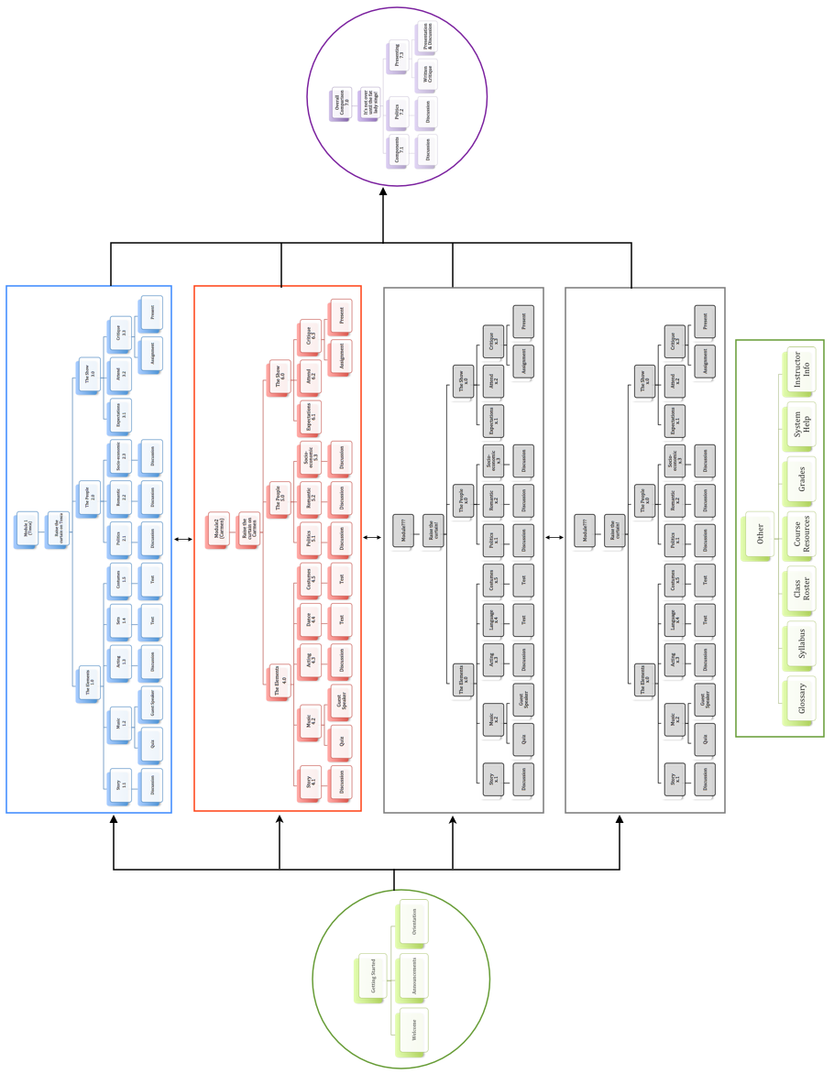

Tosca Module Site Map
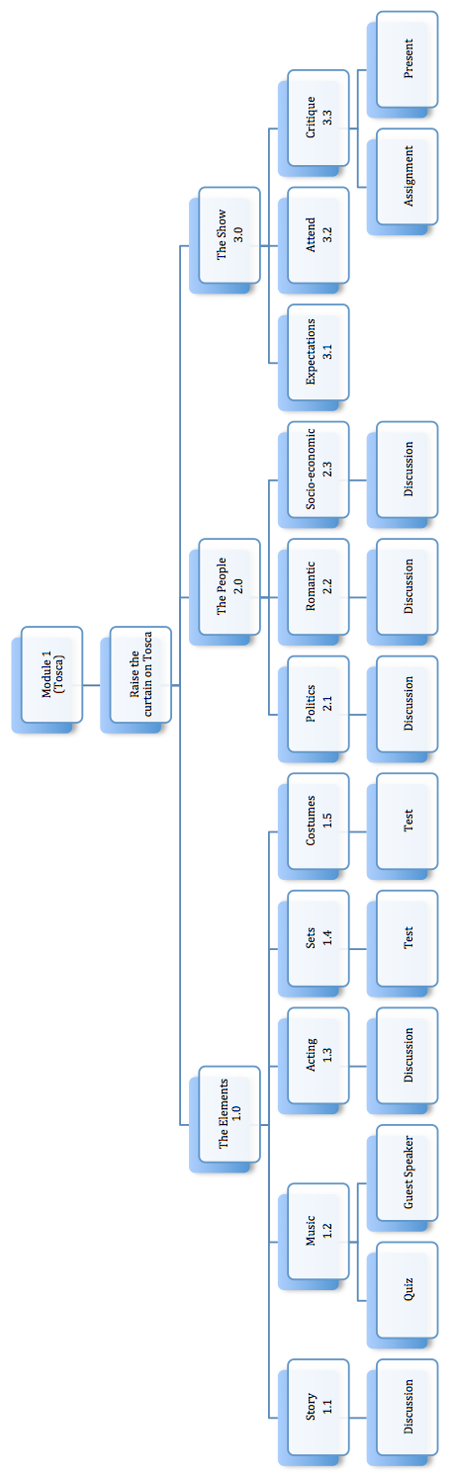

Carmen Module Site Map
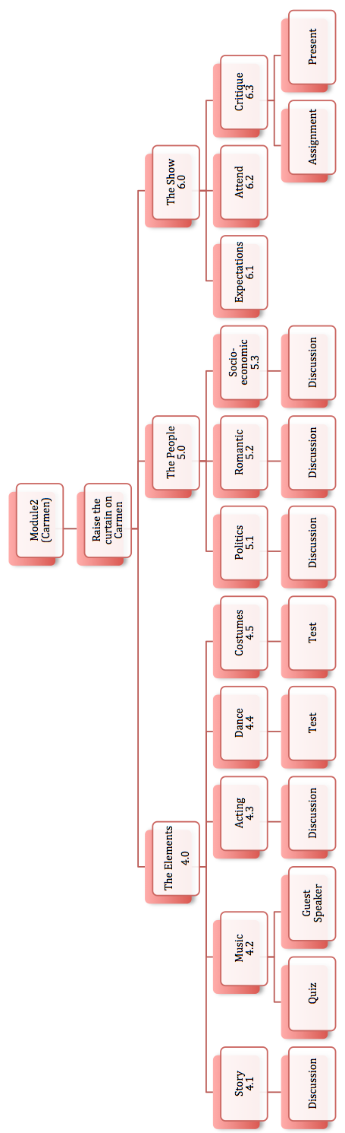

TASK CHARTS

Task chart 1
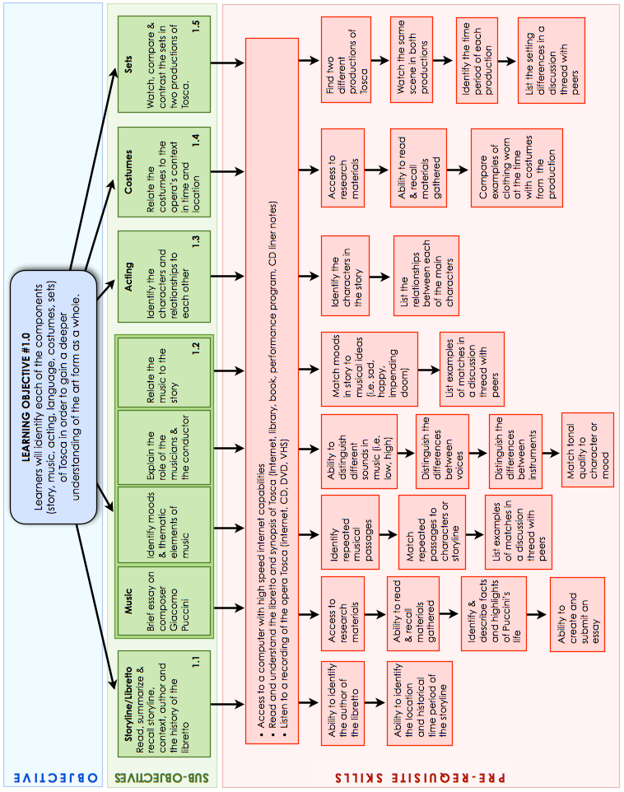

Task chart 2
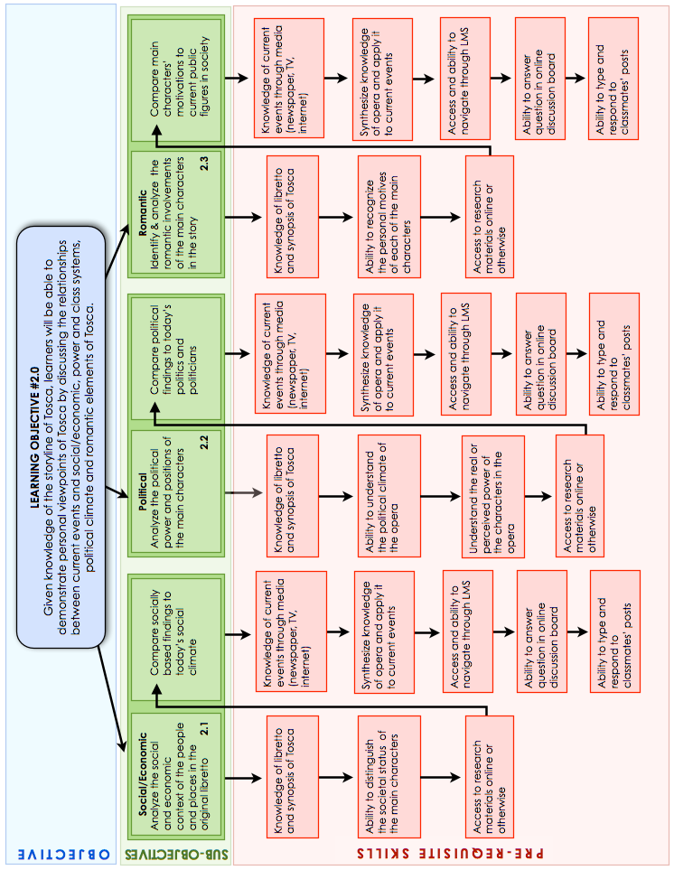

Task chart 3
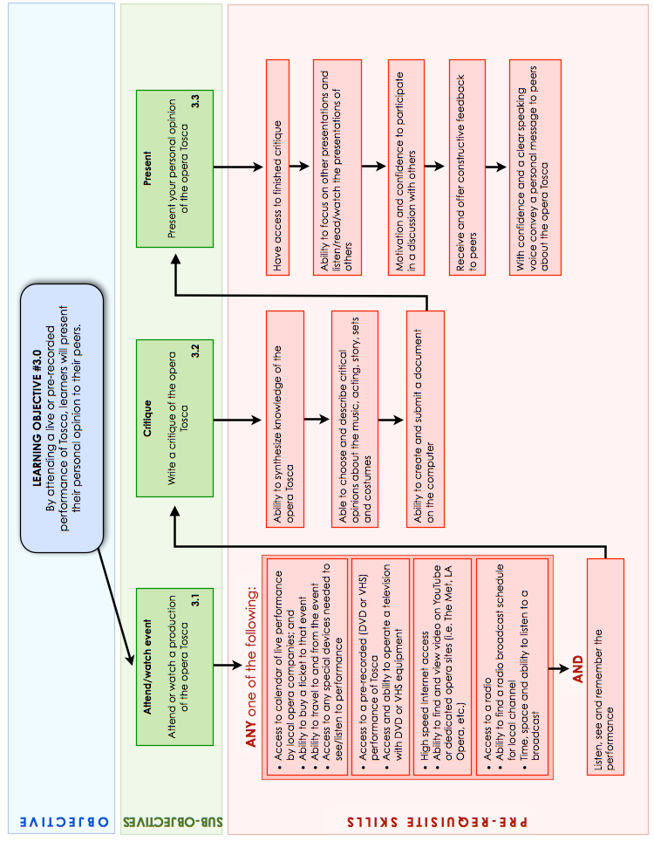

Task chart 4
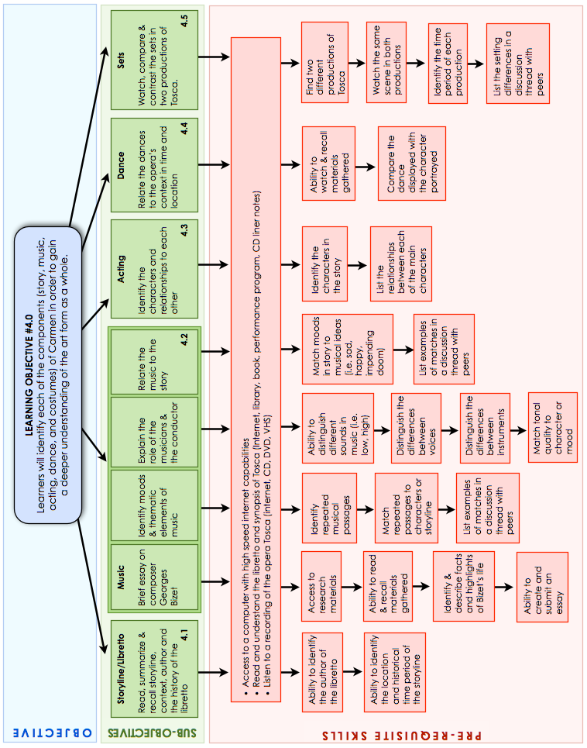

Task chart 5
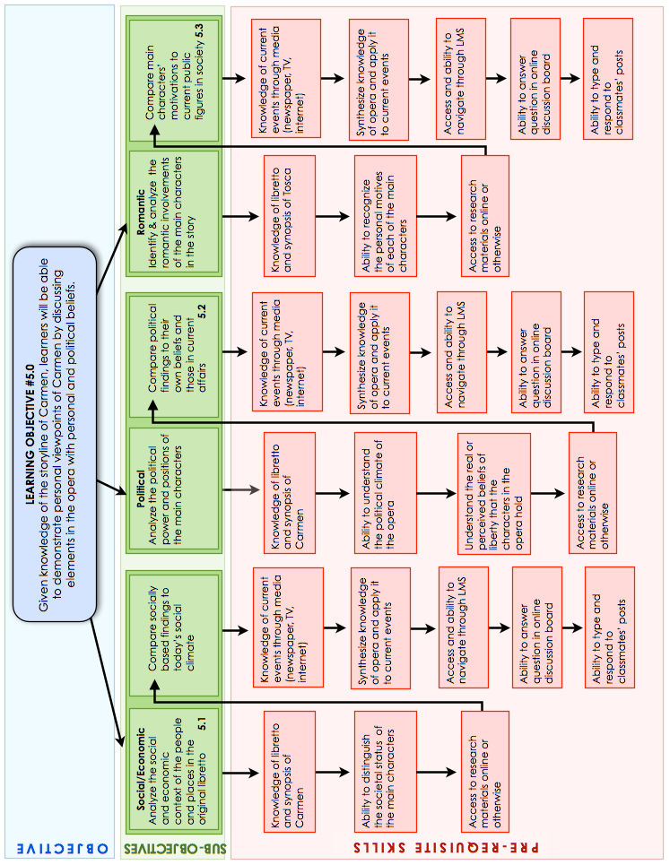

Task chart 6
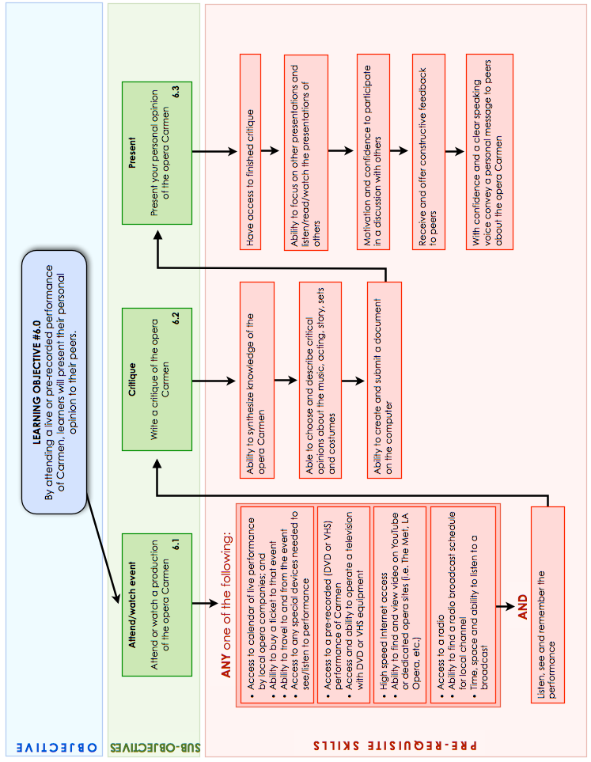

Task chart 7
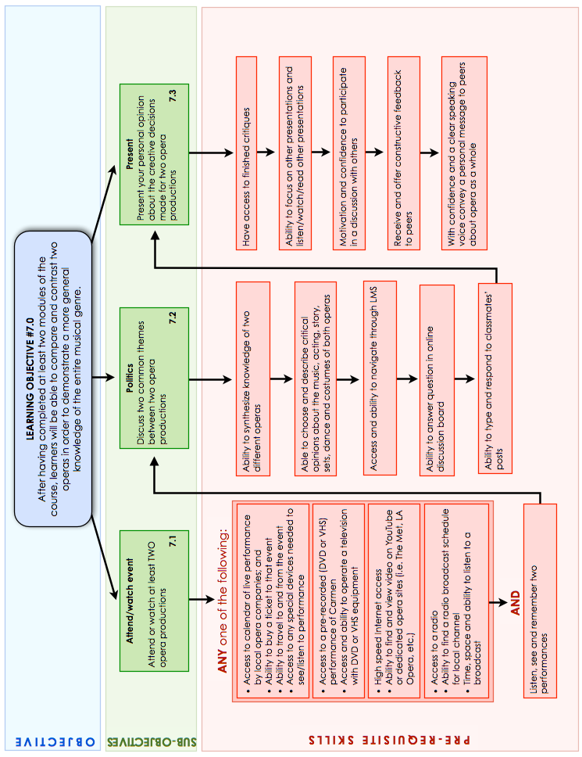

Syllabus
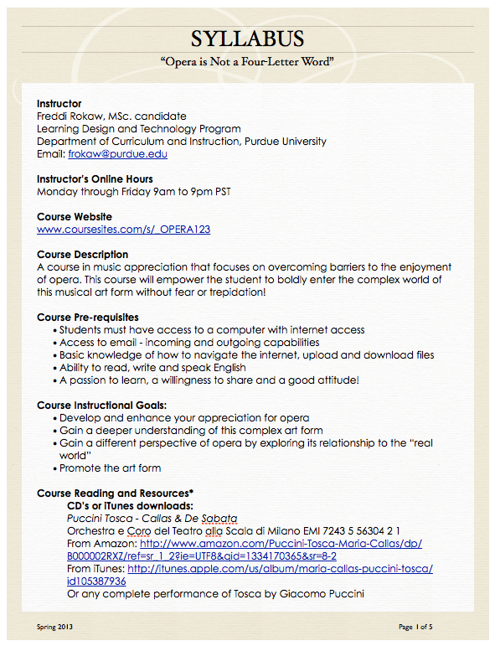

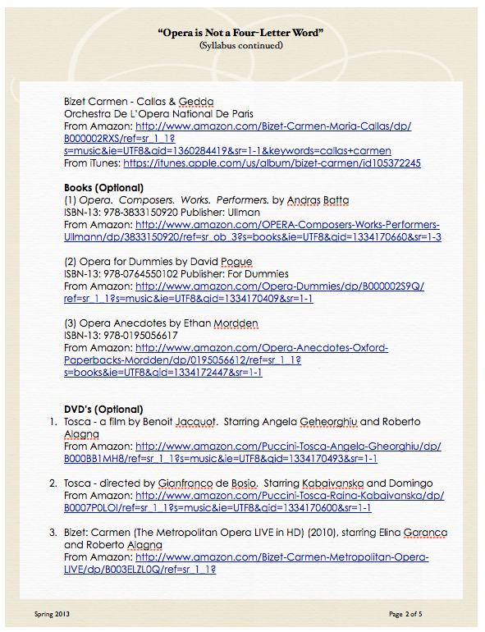

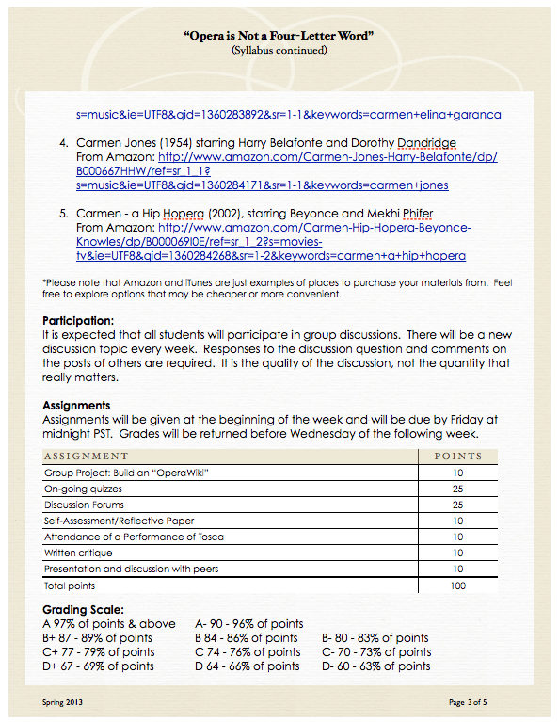

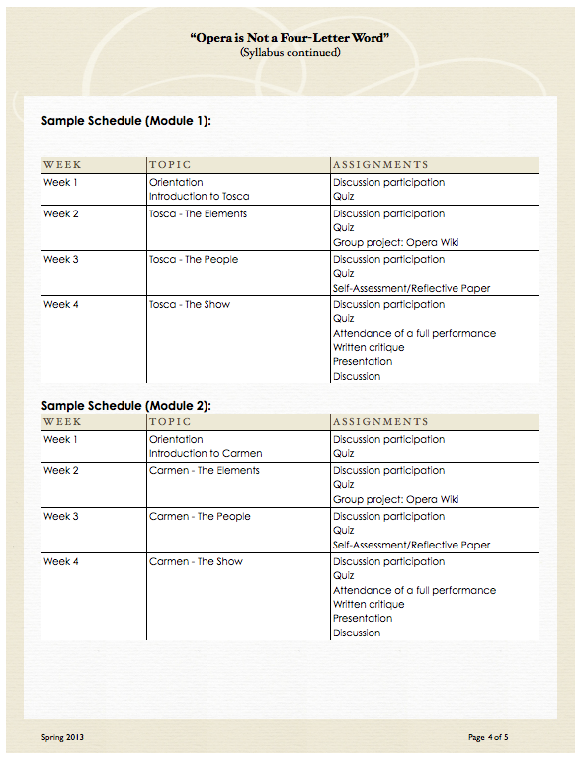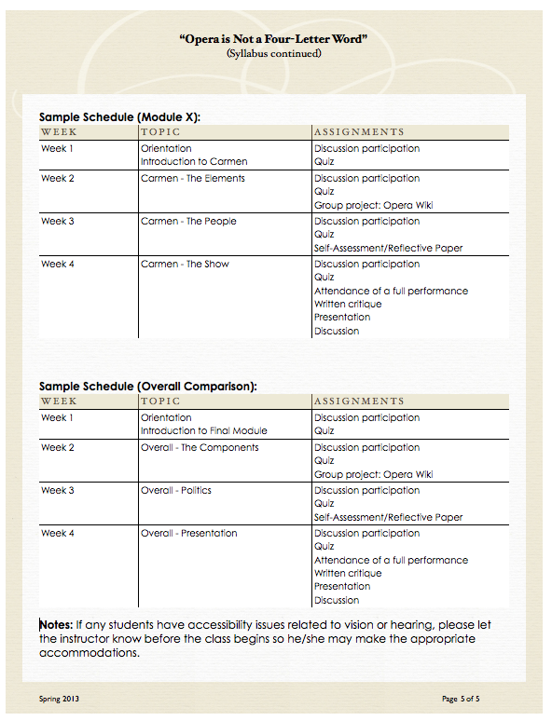

Course Orientation
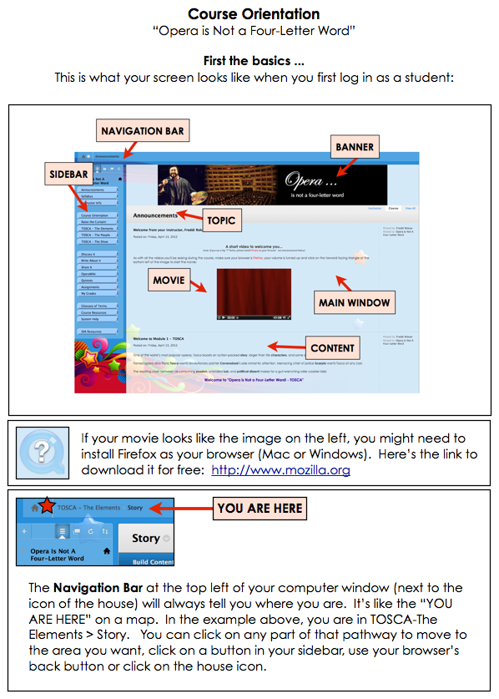
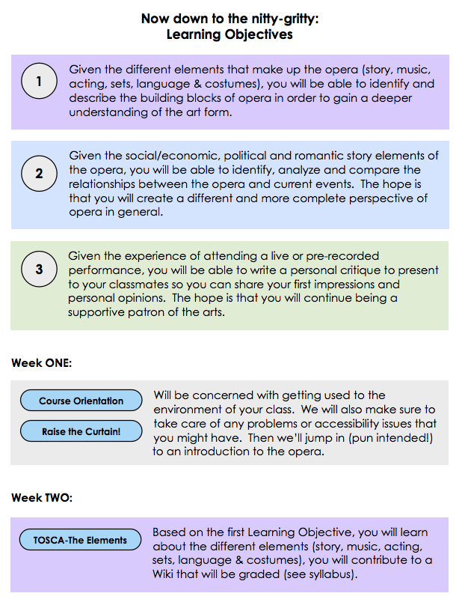

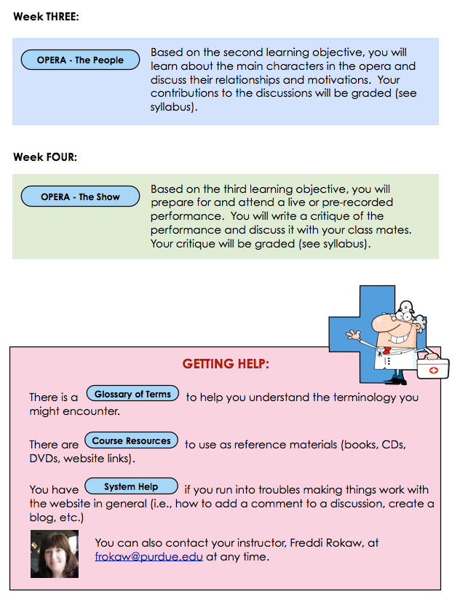

Glossary
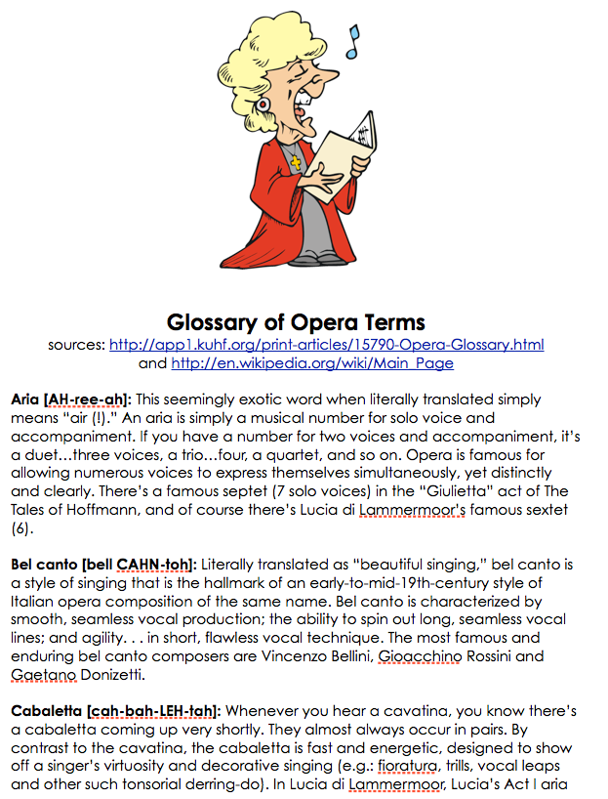

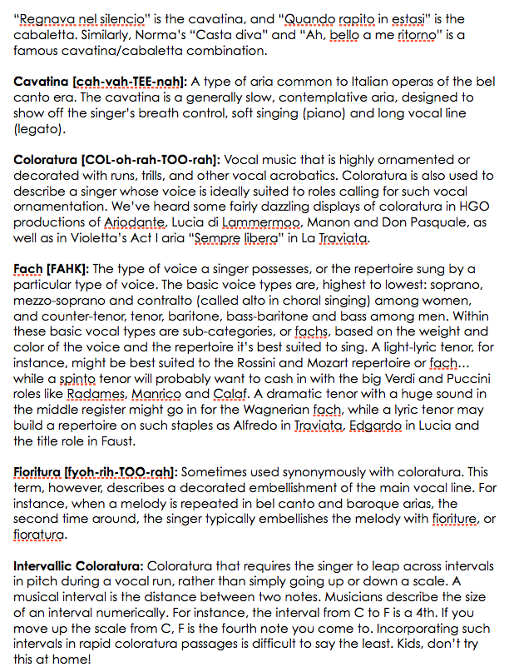

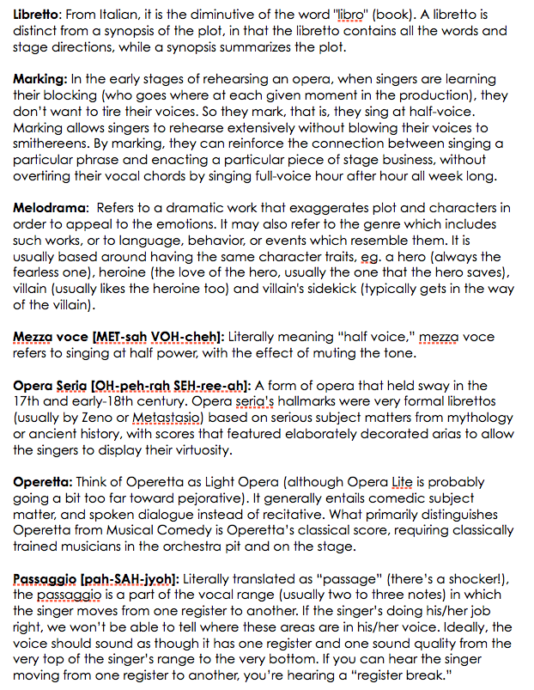

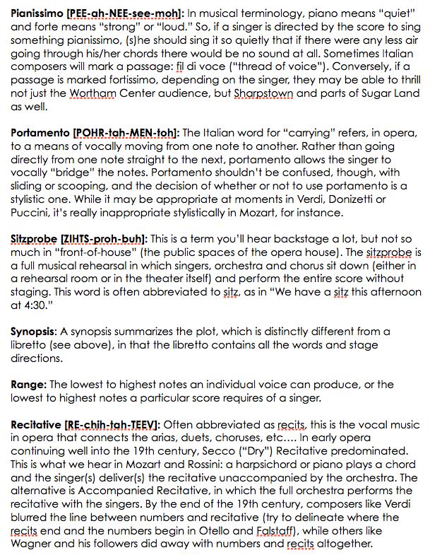

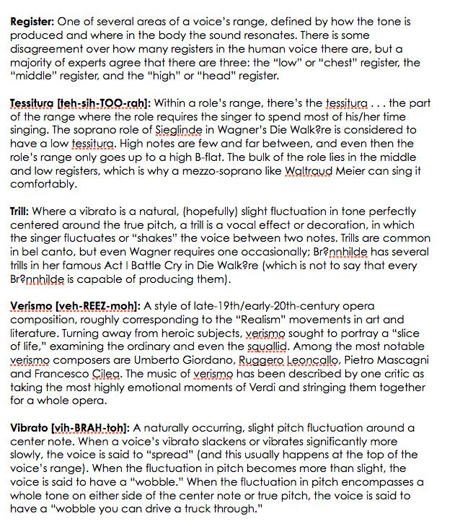

Audience Etiquette
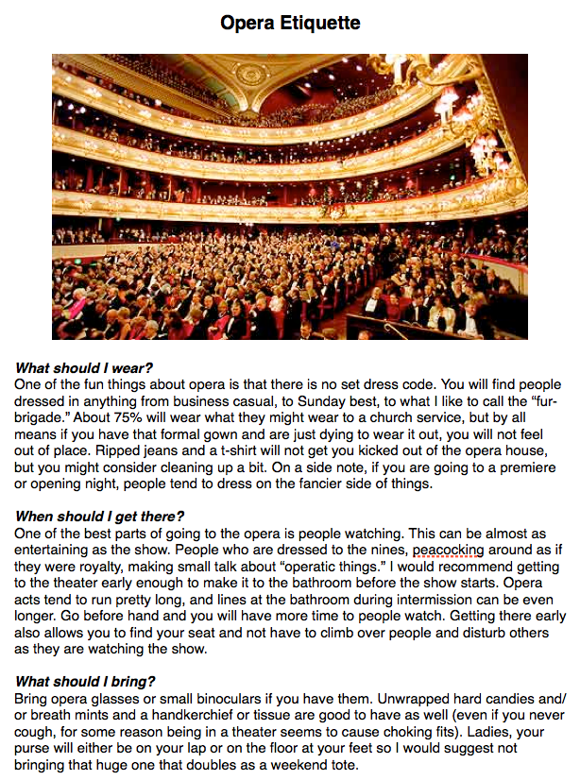
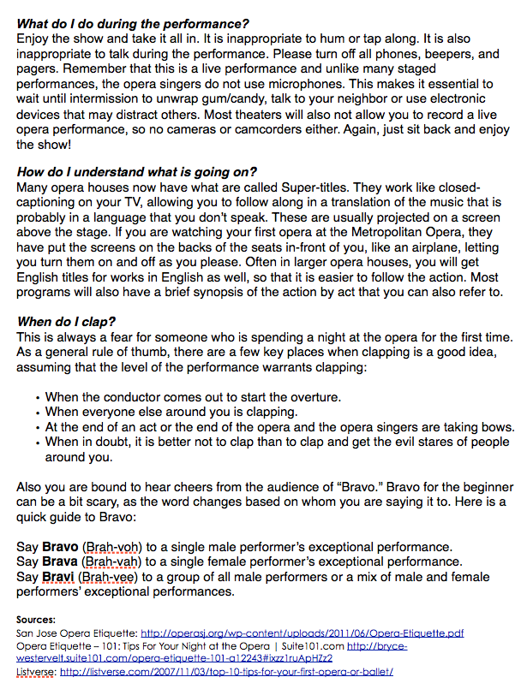

INDEX

List of Figures
Figure 2.0 - Top Site Map 10
Figure 2.1 - Module 1 (Tosca) Map 11
Figure 2.2 - Module 2 (Carmen) Map 11
Figure 2.3 - Overall Comparison Map 11
Figure 2.4 - Getting Started Map 12
Figure 2.5 - Resources Map 12
Figure 2.6- Possible Future Modules Map 12
Figure 3.1 - Sidebar 14
Figure 3.2 - Course Orientation Page 15
Figure 3.3 - Raise the Curtain on Tosca! page 16
Figure 3.4 - Tosca - The Elements Home Page 17
Figure 3.5 - Tosca - The Story Main page, Synopsis & Libretto & Discussion Thread. 18
Figure 3.6 - Tosca - The Music Main page, 19
Figure 3.7 - Tosca - The Acting Main page, Acting Slideshow & Discussion Thread 20
Figure 3.8 - Tosca - The Sets Main page, Sets Slideshow, Instructions for test, Sets Test 21
Figure 3.9 - Tosca - The Costumes Main page, Costume Slideshow, Test Instructions, Test 22
Figure 3.10 - Tosca - The People Home Page 23
Figure 3.11 - Tosca - The Politics Home Page 24
Figure 3.12 - Tosca - The Politics Discussion Thread 24
Figure 3.13 - Tosca - Romantic Home Page 25
Figure 3.14 - Tosca - Romantic Discussion Thread 25
Figure 3.15 - Tosca - Socio-economic Home Page 26
Figure 3.16 - Tosca - Socio-economic Discussion Thread 26
Figure 3.17 - Tosca - The Show Home Page 27
Figure 3.18 - Tosca - Audience Etiquette 28
Figure 3.19 - Tosca - Finding a Performance 28
Figure 3.20 - Tosca - Critique page 29
Figure 3.21 - Tosca - Central Discussion Board 29
Figure 3.22 - Tosca - Tosca Quizzes page 30
Figure 3.23 - Tosca - ToscaWiki 30
Figure 3.24 - Raise the Curtain on Carmen! page 31
Figure 3.25 - Carmen - The Elements Home Page 32
Figure 3.26 - Carmen - The Story Main page, Synopsis & Libretto, & Discussion Thread. 33
Figure 3.27 - Carmen - The Music Main page, 34
Figure 3.28 - Carmen - The Acting Main page, Acting Slideshow & Discussion Thread 35
Figure 3.29 - Carmen - The Dance Main page, Dance Movie, Test Instructions, Test 36
Figure 3.30 - Carmen - The Costumes Main page, Costumes Slideshow, Test Instr, Test 37
Figure 3.31 - Carmen - The People Home Page 38
Figure 3.32 - Carmen - The Politics Home Page 39
Figure 3.33 - Carmen - The Politics Discussion Thread 39
Figure 3.34 - Carmen - Romantic Home Page 40
Figure 3.35 - Carmen - Romantic Discussion Thread 40
Figure 3.36 - Carmen - Socio-economic Home Page 41
Figure 3.37 - Carmen - Socio-economic Discussion Thread 41
Figure 3.38 - Carmen - The Show Home Page 42
Figure 3.39 - Carmen - Audience Etiquette 43
Figure 3.40 - Carmen - Finding a Performance 43
Figure 3.41 - Carmen - Critique page 44
Figure 3.42 - Carmen - Central Discussion Board 44
Figure 3.43 - Carmen - Carmen Quizzes page 45
Figure 3.44 - Carmen - CarmenWiki 45
Figure 3.45 - Overall Comparison Main Page 46
Figures 3.46 and 3.47 - Overall Comparison - All Wikis, Opera Wiki 46
Figure 3.48 - Overall Comparison - Overall Discussion Board 47
Figure 3.49 - Overall Comparison - Written Critique 47
Figure 3.50 - Other - Syllabus 48
Figure 3.51 - Other - Glossary 48
Figure 3.52- Other - Class Roster 49
Figure 3.53 - Other - Course Resources 49
Figure 3.54 - Other - Instructor Info 50
Figure 3.55 - Other - System Help 50
Figure 4.1 - Learning Objective #1.0 Task Chart with Pre-requisite skills 67
Figure 4.2 - Learning Objective #2.0 Task Chart with Pre-requisite skills 67
Figure 4.3 - Learning Objective #3.0 Task Chart with Pre-requisite skills 68
Figure 4.4 - Learning Objective #4.0 Task Chart with Pre-requisite skills 68
Figure 4.5 - Learning Objective #5.0 Task Chart with Pre-requisite skills 69
Figure 4.6 - Learning Objective #6.0 Task Chart with Pre-requisite skills 69
Figure 4.7 - Learning Objective #7.0 Task Chart with Pre-requisite skills 70

List of Tables
Table 1.0 - Learner Analysis 6
Table 4.8 – Content Specifications for Learning Objective #1 76
Table 4.9 – Content Specifications for Learning Objective #2 79
Table 4.10 – Content Specifications for Learning Objective #3 83
Table 4.11 – Content Specifications for Learning Objective #4 88
Table 4.12 – Content Specifications for Learning Objective #5 92
Table 4.13 – Content Specifications for Learning Objective #6 96
Table 4.14 – Content Specifications for Learning Objective #7 99
Table 4.15 – Planning for Assessment 100
Table 4.16 – Assessment Items for Learning Objective #1 101
Table 4.17 – Assessment Items for Learning Objective #2 102
Table 4.18 – Assessment Items for Learning Objective #3 103
Table 4.19 – Assessment Items for Learning Objective #4 104
Table 4.20 – Assessment Items for Learning Objective #5 105
Table 4.21 – Assessment Items for Learning Objective #6 106
Table 4.22 – Assessment Items for Learning Objective #7 107
Table 4.23 – Planning for Formative Evaluation 108

REFERENCES

Barber, D. W. (1990). When the Fat lady Sings. Toronto, ON, Canada: Metrolitho Inc.

Batta, A. (2005). Opera. Composers. Works. Performers. Koln, Germany: Tandem Verlag GmbH.

Canadian Opera Company. (2013). Retrieved January 2013, from http://www.coc.ca

Dick, W., Carey, L., & Carey, J. O. (2009). The Systematic Design of Instruction. Upper Saddle River, NJ: Pearson.

Dobkin, M. (2000). Getting Opera. New York, NY: Pocket Books.

Driscoll, M. P. (2005). Psychology of Learning for Instruction (3rd ed.). Boston, MA: Pearson.

Horton, W. (2012). E-Learning by Design. San Fancisco, CA: Pfeiffer.

Los Angeles Opera. (2013). Retrieved January 2013, from http://www.laopera.com

Mager, R. F. (1997). Preparing Instructional Objectives. Atlanta, GA: CEP Press.

Merrill, M. D. (2001, April 27). 5 Star Instructional Design Rating. Utah State University.

Merrill, M. D. (2002). First Principles of Instruction. Educational Technology Research and Development , 50 (3), 43-59.

Mordden, E. (1985). Opera Anecdotes. New York, NY: Oxford University Press.

Opera San Jose. (2013). Retrieved January 2013, from http://www.operasj.org

Pogue, D., & Speck, S. (1997). Opera for Dummies. Hoboken, NJ: Wiley Publishing, Inc.

Smith, Patricia L. & Ragan, Tillman J. (2005). Instructional Design (3rd ed.). Hoboken, NJ: John Wiley & Sons, Inc.

Simon, H. W. (1989). 100 Great Operas and Their Stories. New York, NY: Doubleday.

The Metropolitan Opera. (2013). Retrieved January 2013, from http://www.metoperafamily.org/metopera/index.aspx?

Additional Resources

CD’s:

Puccini Tosca - Callas & De Sabata
Orchestra e Coro del Teatro alla Scala di Milano EMI 7243 5 56304 2 1
From Amazon: http://www.amazon.com/Puccini-Tosca-Maria-Callas/dp/B000002RXZ/ref=sr_1_2?ie=UTF8&qid=1334170365&sr=8-2
From iTunes: http://itunes.apple.com/us/album/maria-callas-puccini-tosca/id105387936

Bizet Carmen - Callas & Gedda
Orchestra De L’Opera National De Paris From Amazon: http://www.amazon.com/Bizet-Carmen-Maria-Callas/dp/B000002RXS/ref=sr_1_1?s=music&ie=UTF8&qid=1360284419&sr=1-1&keywords=callas+carmen From iTunes: https://itunes.apple.com/us/album/bizet-carmen/id105372245

DVD’s:
Tosca - a film by Benoit Jacquot. Starring Angela Geheorghiu and Roberto Alagna
From Amazon: http://www.amazon.com/Puccini-Tosca-Angela-Gheorghiu/dp/B000BB1MH8/ref=sr_1_1?s=music&ie=UTF8&qid=1334170493&sr=1-1

Tosca - directed by Gianfranco de Bosio. Starring Kabaivanska and Domingo
From Amazon: http://www.amazon.com/Puccini-Tosca-Raina-Kabaivanska/dp/B0007P0LOI/ref=sr_1_1?s=music&ie=UTF8&qid=1334170600&sr=1-1

Bizet: Carmen (The Metropolitan Opera LIVE in HD) (2010), starring Elina Garanca and Roberto Alagna From Amazon: http://www.amazon.com/Bizet-Carmen-Metropolitan-Opera-LIVE/dp/B003ELZL0Q/ref=sr_1_1?s=music&ie=UTF8&qid=1360283892&sr=1-1&keywords=carmen+elina+garanca

Carmen Jones (1954) starring Harry Belafonte and Dorothy Dandridge From Amazon: http://www.amazon.com/Carmen-Jones-Harry-Belafonte/dp/B000667HHW/ref=sr_1_1?s=music&ie=UTF8&qid=1360284171&sr=1-1&keywords=carmen+jones

Carmen - a Hip Hopera (2002), starring Beyonce and Mekhi Phifer From Amazon: http://www.amazon.com/Carmen-Hip-Hopera-Beyonce-Knowles/dp/B000069I0E/ref=sr_1_2?s=movies-tv&ie=UTF8&qid=1360284268&sr=1-2&keywords=carmen+a+hip+hopera

