The Missing Piece: Knowledge Transfer from Instructional Designer to Facilitator
Francine (“Freddi”) Rokaw
Purdue University

Abstract

The purpose of this paper is to focus on the transfer of knowledge from the instructional designer to the facilitator. It is a very challenging piece of the puzzle that I have experienced first-hand in my work, as a “train-the-trainers” scenario in the corporate environment. I feel that this transfer of knowledge is a missing piece from the literature I have read so far. The hope is to begin research into the creation of a system/model that will structure the thoughts and methods of instructional design implementation in order to benefit the instructional designer, facilitator and the original stakeholder. With such a system in place it will create a well structured, comprehensive and engaging learning experience for the intended participants and satisfy the needs of all three stakeholders.

Keywords: Implementation, hand-off, missing piece, installation, preparation, instructor support, facilitation materials, facilitator, collaboration, user’s manual, facilitator’s guide, common ground, partnership, transfer knowledge, concept mapping, thought transfer, course presentation, curriculum implementation, facilitation planning, curriculum mapping, innovations, graphic organization/architecture/management, delivery, visual implementation, stakeholder, subject matter expert.

The Missing Piece: Knowledge Transfer from Instructional Designer to Facilitator

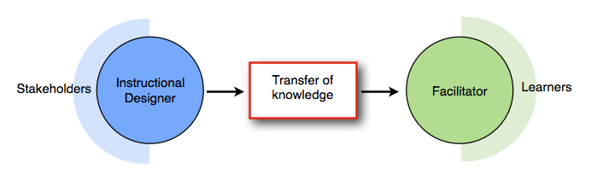

Common instructional design models (for example: Dick & Carey (Dick, Carey, & Carey, 2009), Kemp (Kemp, 1977), Layers-of-Necessity (Tessmer M. W., 1990), Gerlach & Ely (Gerlach & Ely, 1980), and Rapid Prototyping (Tripp & Bichelmeyer, 1990)), include stages of the model that include implementation. Implementation has differing meanings within various instructional design models. The implementation phase of the process generally refers to the way in which the course design is to be adopted. In my research I have found that most of these instructional design models fail to include an additional (final) stage that describes and details transferring the planned implementation or “innovation (Smith & Ragan, 2005, p. 304),” to the facilitator of the curriculum. For the purposes of this paper I would like to distinguish the difference between implementation of the prescribed curriculum for evaluative purposes and the preparation of materials for a “hand-off” to a facilitator. This paper will include the transfer of knowledge from the perspectives of the instructional designer, facilitator and the original stakeholder or subject matter expert.

From the instructional designer’s perspective:
As Eruditio Loginquitas mentions in his blog (Loginquitas, 2006) that instructional designers “build for the hand-off. Every project is only ours for a time.”

Much information needs to be conveyed to the facilitator in order to meet the intended outcome of the stakeholders and consequently, the needs of the learners. Meetings and/or briefings between instructional designer, subject matter expert and facilitator would be the best opportunity to discuss content. Collaboration between facilitator and instructional designer during the assessment and evaluation of delivery is critical to the overall effectiveness of future revisions and the overall learning experience.

In order to aid the facilitator in processing and preparing for delivery, a “facilitator’s guide” might be created by the instructional designer and approved by the subject matter expert. A facilitator’s guide, according to the American Society for Training & Development (ASTD, 2005), “is what the instructor needs to do. In the Facilitator Guide, you can include timing cues to sequence the instructional events, with references to material in the user guide.” When a guide (or user manual) is created, it is important for the creator of the guide to transfer the objectives of the learning experience to the facilitator in an organized way. As Longinquitas states, “There should be a design stylebook to describe the parameters of the project and the standards set for all the technologies and the contents. There should be logical and clear file naming protocols (Loginquitas, 2006).” If the end goal is to enable the facilitator to (1) know who the learners are; (2) get an overall perspective of the learning objectives; and (3) process the structure in a way that suits his/her style, the end result should be a successful learning experience in which the learners achieve the desired learning outcome.

In order for the transfer of knowledge to occur, the instructional designer should create a set of guidelines (or “cheat sheet”) for the facilitator. In a manner similar to what Driscoll describes in her chapter of “Meaningful Learning and Schema Theory” the guide needs to include an “inclusive concept or anchoring idea” that represents the learning objective in order to provide “cognitive economy” for the facilitator (Driscoll, 2005, pp. pp.136-137), (Bozarth, 2010). The material to be used needs to be designed in a way that is “chunked” well in order to avoid “cognitive overload (Driscoll, 2005, pp. pp. 136-137, 143).” It should flow efficiently and fit with the available resources, time and budget of the project. There are many ways in which a designer can codify the content. These methods can include memory aids such as mnemonics, graphic organization and architecture, visual management, the effective use of color, curriculum mapping (Molineaux, 2008), concept mapping (Soyanov & Kirschner, 2004), illustrations, and other visual explanations (Tufte, 1997). Also included might be prompts to promote discussion, suggested questions and target responses. This process would seem to be increasingly difficult as the subject becomes more complex.

Depending upon the pedagogical style desired, a facilitation guide might have different organizational structures. For example, if a behaviorist style of delivery is implemented the facilitator presents tasks to be learned, provides feedback to the learners’ responses and continues modifying instruction to reach the desired response. At the other end of the learning theory spectrum, if a constructivist style of delivery is implemented, a facilitator’s guide might be focused on overall concepts and contain only module topics with suggested prompts that allow learners the freedom to construct their own knowledge.

From the facilitator’s perspective:
The facilitator could be the designer, the stakeholder or completely removed from the whole design. No matter what role the facilitator has had in the development process, he/she needs to connect with, or learn the content and know why it was created, interpret it in a way that allows them the freedom to infuse their own style while maintaining the guidelines and objectives, and ultimately teach the concepts to the learners. The facilitator needs to know how to “identify the tasks required in a training project, estimate task duration” and have the ability to “create/modify a schedule that optimizes time and resources (Langevin, 2012)” in order to keep the project flowing smoothly.
If the facilitator has not been provided with a guide from the instructional designer, he/she should familiarize him/herself with the content, prioritize the information, and choose a pedagogical style for delivery. The facilitator can create a set of guidelines, memory aids, and/or a “cheat sheet” which would serve as an organizational and graphic interpretation to hit key points at specific times and provide a visual representation of the curriculum (see Table 1.0). It serves as a way to learn, sequence, structure and personalize the delivery experience.
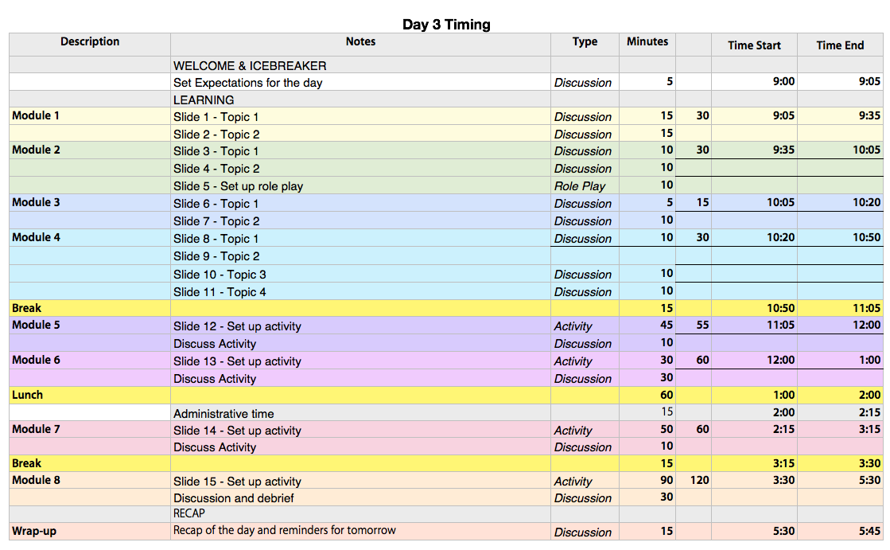
Table 1.0 Sample Timing Sheet

In addition, it is critical that the facilitator knows who the learners are, identifies available resources, and knows the timeframe allotted for instruction. Other tools for good facilitation include checklists that include materials such as audio-visual aids, room preparation, lists, participant involvement (assignments and groupings), and resources needed for instruction (see Tables 2.1 and 2.2 below). There should be a formal space for detailed notes to be kept throughout the delivery process that will be used later to provide feedback for instructional designers and questions for subject matter experts to be used in development, revision and modification.
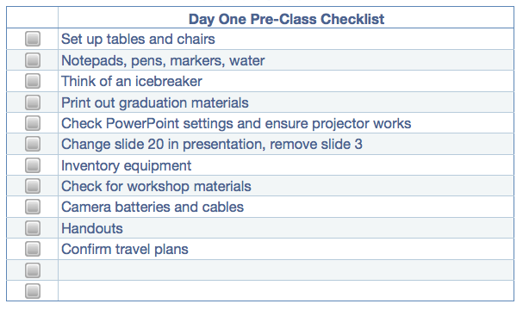
Table 2.1 Sample Pre-class Checklist

Table 2.2 Sample Post-class Checklist

Lastly, repetition of the training with many different participants can give a facilitator an over-arching view of the process of learning that occurs based on the goals set forth by the original stakeholders and instructional designer. Feedback is crucial to ongoing maintenance and revisions of a project. The facilitator needs to know what the managerial structure of the project is in order to know how course modifications should be handled. The facilitator needs to know who should receive any feedback and where comments should be directed.

From the original stakeholder’s/subject matter expert’s perspective:
The stakeholder knows and can envision the “big picture.” For the stakeholder, meetings with the instructional designer are crucial during the developmental stages of the design. Like the instructional designer and facilitator, it is important for the subject matter expert to present the content, prioritize it and identify the learners. Depending on the scenario, it might be advised for the stakeholder to meet with the facilitator during the “hand-off.”

The stakeholder needs to know how the transfer of knowledge will occur from the instructional designer to the facilitator in order to control resources and costs. The original stakeholder also ensures the integrity is maintained through the development and delivery of curriculum. The stakeholder will want to know that the transfer process is cost-efficient and that the return on investment is high. For example, is it cost-effective to bring 15 trainers to company headquarters from all around the country/world in order to be immersed in the hand-off process? Or could this be achieved by a coordinated webinar? The stakeholder needs to weigh the advantages and disadvantages of all scenarios.

Lastly, the original stakeholder will need to observe the delivery of the curriculum in addition to reviewing any notes, issues or concerns from the other parties in order to evaluate, modify, revise and/or update the content.
The following table (Table 3.0) summarizes the steps involved from the perspectives of each of the stakeholders:
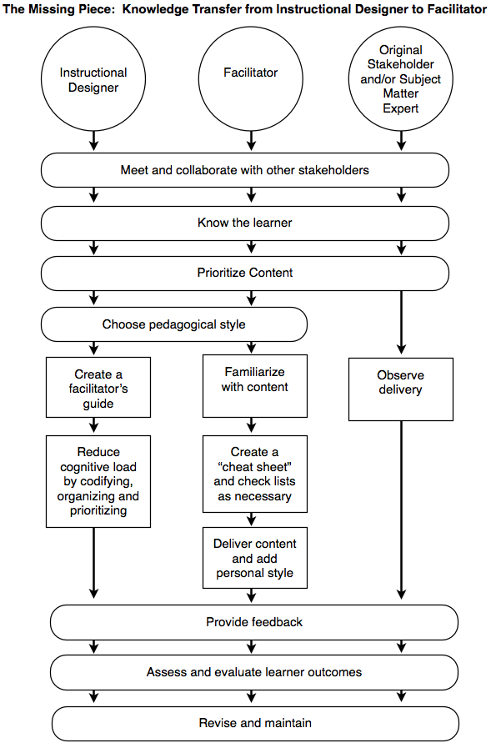
Table 3.0 Stakeholders

In conclusion:
According to Table 3.0 above, common areas of interest for all stakeholders are (1) collaboration with other stakeholders; (2) knowing the learners; and (3) the ability to prioritize and organize content. Through each stakeholder’s area of expertise, they each come out on the other side of the learning experience being able to (1) provide feedback; (2) assess and evaluate learner outcomes; and (3) revise and maintain an innovation.

Thoughts for future considerations and research:
Further research will help to define effective cognitive tools for creating schema from developing and finished instructional design products. Defining these tools for use in transferring knowledge to facilitators will need to take into consideration the environment, learners and pedagogical style. It will be interesting to see how differences between learning environments (e.g. academic, business, military, medical and distance education) change the methodology of the transference of knowledge between stakeholders.

Another question for further research is the developmental process of the facilitator. Factors that would affect the knowledge transfer to the facilitator would change based on their level of involvement in the research, design, evaluation and analysis of the innovation. The chosen pedagogical style would also have an impact on the method of transference.

Bibliography
ASTD. (2005, October 13). Facilitator Guide Vs. User Manual. Retrieved May 2012, from Community Forums: http://community.astd.org/eve/forums/a/tpc/f/5401062/m/65010404
Bozarth, J. (2010, August 03). Nuts and Bolts: Brain Bandwidth - Cognitive Load Theory and Instructional Design. Retrieved May 2012, from Learning Solutions Magazine: http://www.learningsolutionsmag.com/articles/498/nuts-and-bolts-brain-bandwidth---cognitive-load-theory-and-instructional-design
Crane, D. (1993). Graphic facilitation. Association for Computing Machinery. Communications of the ACM , 36 (6), 64-65.
Dick, W., Carey, L., & Carey, J. O. (2009). The Systematic Design of Instruction (7th Edition ed.). Upper Saddle River, NJ: Pearson Education.
Driscoll, M. P. (2005). Psychology of Learning for Instruction (3rd Edition ed.). Boston, MA: Pearson Education.
Ely, D. P. (1999). New Perspectives on the Implementation of Educational Technology Innovations. Syracuse: Syracuse University.
Ertmer, P. A., & Quinn, J. (2007). The ID CaseBook: Case Studies in Instructional Design (3rd Edition ed.). Upper Saddle River, NJ: Pearson Education.
Ertmer, P. A., York, C. S., & Gedik, N. (2009). Learning from the Pros: How Experienced Designers Translate Instructional Design Models into Practice. Educational Technology , 49 (1), 19-27.
Gerlach, V., & Ely, D. (1980). Teaching & Media: A systematic approach. Englewood Cliffs, NJ: Prentice-Hall, Inc.
Kemp, J. E. (1977). Instructional Design: A Plan for Unit and Course Development. Belmont, CA: Fearon Publishers/Lear Siegler, Inc.
Langevin. (2012). Retrieved May 2012, from Langevin Learning Services: http://www.langevin.com/
Loginquitas, E. (2006, May 09). Building for the Hand-off. Retrieved 2012, from IDOS - Instructional Design Open Studio: http://id.ome.ksu.edu/blog/2006/may/9/building_for_the_hand_off/
Molineaux, R. (2008). Curriculum Mapping. Alexandria: Educational Research Service.
Peterson, D. (2011, April 2). The Relationship of IT Professionals and Facilitators' joining together to emphasize Pedagogy with Technology.
Polly, D. (2011). Teachers’ learning while constructing technology-based instructional resources. British Journal of Educational Technology , 42 (6), 950-961.
Reiser, R. A., & Dempsey, J. V. (2012). Trends and Issues in Instructional Design and Technology (3rd Edition ed.). Boston, MA: Pearson Education.
Roytek, M. A. (2010). Enhancing instructional design efficiency: Methodologies employed by instructional designers. British Journal of Educational Technology , 41 (2), 170-180.
Sadler-Smith, E., & Smith, P. J. (2004). Strategies for accommodating individuals' styles and preferences in flexible learning programmes. British Journal of Educational Technology , 35 (4), 395-412.
Saint Louis Community College. (1997). Train the Trainer. Facilitator Guide Sample. Basic Blueprint Reading (Chapter One). Document Resume . Washington, DC: Office of Vocational and Adult Education (ED).
Smith, P. L., & Ragan, T. J. (2005). Instructional Design (3rd Edition ed.). Hoboken, NJ: John Wiley & Sons, Inc.
Soyanov, S., & Kirschner, P. (2004). Expert Concept Mapping Method for Defining the Characteristics of Adaptive E-Learning: ALFANET Project Case. Educational Technology Research and Development , 52 (2), 41-56.
Stepich, D. A., Ertmer, P. A., & Lane, M. M. (2001). Problem-Solving in a Case-Based Course: Strategies for Facilitating Coached Expertise. Educational Technology Research and Development , 49 (3), 52-69.
Tessmer, M. W. (1990). A Layers of Necessity Instructional Development Model. Educational Technology Research & Development , 38 (2), 77-85.
Tessmer, M., Wilson, B., & Driscoll, M. (1990). A New Model of Concept Teaching and Learning. Educational Technology Research and Development , 38 (1), 45-53.
Tufte, Edward R. (1997). Visual Explanations. Cheshire, CT: Graphics Press LLC,

Tripp, S., & Bichelmeyer, B. (1990). Rapid prototyping: An alternative instructional design strategy. Educational Technology Research and Development , 38 (1), 31-44.
Victor, G. I., Luisa, P. C., & Eduardo, A. S. (2010). Graphic design: A sustainable solution to manage the contents of teaching materials. US-China Education Review , 7 (11), 27-35.
Wildman, T. M., & Burton, J. K. (1981). Integrating Learning Theory with Instructional Design. Journal of Instructional Development , 4 (3), 5-14.
Wilson, B. G. (1997). Understanding the Design and Use of Learning Technologies. Denver: unknown.

